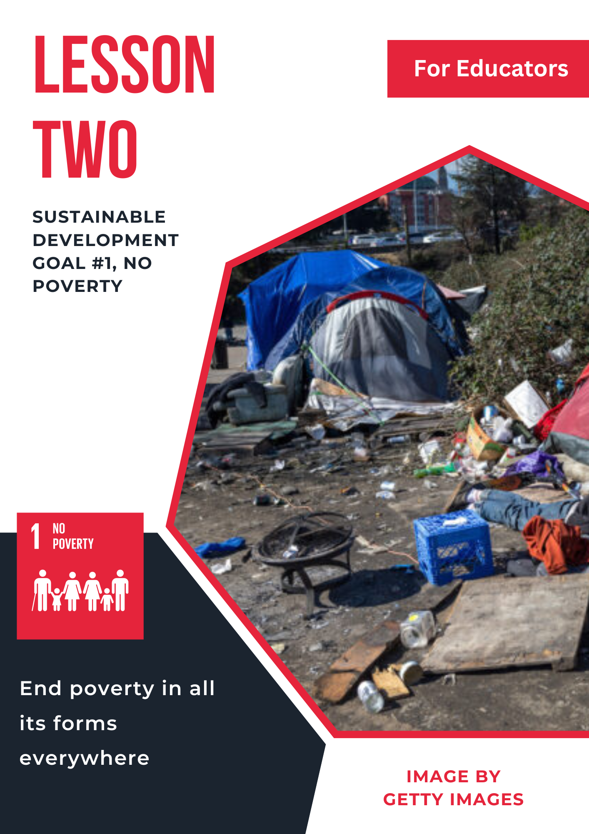

Lesson 2: Sustainable Development Goal #1: No Poverty

Student Handout

Module Driving Question: Lessons 1, 2, and 3
- How does human interaction with the environment affect individuals and communities in local, national, and global contexts?
Lesson Driving Questions:
- How do environmental conditions affect the poverty levels of individuals and societies?
- What actions can be taken to decrease the impact of environmental conditions on poverty levels across local, national, and global contexts?
Learning Targets: I Can:
- Identify how environmental issues have created increased poverty levels in local and/or global communities.
- Examine different sources to better explain how environmental issues affect poverty levels.
- Work collaboratively with my peers to come up with possible solutions to reducing poverty rates.
Purpose:
In this lesson, you will explore how environmental conditions can affect poverty levels in different local and global contexts. As part of these different learning activities, you will investigate the ways in which human interaction with the environment can enhance poverty and what can be done to address this concern. You will work with other students to identify and discuss how environmental conditions such as deforestation or drought can affect people’s lives. You will engage in a think-pair-share activity to brainstorm what you know about this topic, watch some short video clips, and work with other students in a small group activity. You will share your ideas and learn from others by participating in a gallery walk to make connections, discover different perspectives, and deepen your understanding. Finally, you will conduct research using primary and secondary sources to examine a specific place that has seen increased poverty due to environmental factors.
Lesson Vocabulary:
Poverty, Biodiversity, Climate Change, Sustainability, Food Insecurity, Drought, Air Pollution, Water Pollution, Population Growth, Environmental Justice, Climate Refugees, Ecosystems, Inequality
Lesson Steps
- Reflect and respond to the following questions in your notebook: What is poverty and how should we define it? How do you think environmental conditions can impact a person’s quality of life (or, how do you think environmental factors could influence poverty levels)?
- Watch video clips to gain a better understanding of the link between environment conditions and poverty levels. After viewing, discuss with a partner what you noticed in the videos and what questions came up for you. You can also explore the goals and targets of SDG #1: No Poverty.
- In pairs or small groups, briefly research one specific environmental condition (for example, deforestation, drought, over-land use, etc.) and how it is impacting people’s lives. Use the chart paper (if on-line, you can use Google Doc in breakout rooms) to record and summarize your findings (see directions).
- Post your chart around the classroom and participate in a “gallery-walk” to make connections between your research and the conclusions of your classmates. Use the gallery walk notes sheet as a reflection tool to identify and analyze similarities, differences, and questions. If on-line, share your Google Doc with your classmates in a large group. Participate in a large group discussion that shares gallery-walk conclusions with the rest of the class.
- In pairs or small groups, select a location (local or global) to explore/research how environmental factors are contributing to poverty in more depth. You will use 3 to 5 primary and secondary sources to explain the specific environmental condition, its impact on families and communities, and suggest two possible courses of action to address the issue.
- After completing your research and discussing it with your group members, create a 5 minute (approximate) podcast that reflects on your findings (include evidence), why it is an important issue, and provides ways for communities, nations, or international organizations to take action.
- Share your podcast with the rest of the class. Then, as a class, discuss and analyze the different case studies presented and reflect on the suggested solutions.
- Optional: Apply what you have learned about the connection between human interaction with the environment and poverty by completing one of the additional projects identified by your teacher.

Teacher Preparation Notes
Pacing and Strategy: The following outline provides a guide for teaching this lesson including approximate times (may vary), teaching strategies, suggested information for teacher created slides, and options for additional enrichment activities/summative assessments can be found at the end of the modules. This particular curriculum model was designed with teaching and learning strategies that could be adapted for in-person or virtual learning.
Lesson Timing: 120 (approximate)
Standards
Content | Standard
WA Social Studies | SSS1.6-8.1: Analyze positions and evidence supporting an issue or an event.  SSS3.6-8.1: Engage in discussion, analyzing multiple viewpoints on public issues.  G2.9-10.1: Analyze human interaction with the environment across the world in the past or present.  G2.9-10: Explain that humans cope with and adapt to environmental conditions.
WA World Language | 1.0 Communication: Communicate effectively in more than one language in order to function in a variety of situations and for multiple purposes.  1.1 Interpersonal Communication: Learners interact and negotiate meaning in spoken, signed, or written conversations to share information, reactions, feelings, and opinions.  1.2 Interpretive Communication: Learners understand, interpret, and analyze what is heard, read, or viewed on a variety of topics.  1.3 Presentational Communication: Learners present information, concepts, and ideas to inform, explain, persuade, and narrate on a variety of topics using appropriate media and adapting to various audiences of listeners, readers, or viewers.  3.0 Connections: Connect with other disciplines and acquire information and diverse perspectives in order to use the language to function in academic and career-related situations.  3.1 Making Connections: Learners build, reinforce, and expand their knowledge of other disciplines while using the language to develop critical thinking and to solve problems creatively.  3.2 Acquiring Information and Diverse Perspectives: Learners access and evaluate information and diverse perspectives that are available through the language and its cultures.
C3 Framework | D2.Geo.4.9-12: Analyze relationships and interactions within and between human and physical systems to explain reciprocal influences that occur among them.  D2. Geo.9.9-12: Evaluate the influence of long-term climate variability on human migration and settlement patterns, resource use, and land uses at local-to-global scales.

Lesson Resources
For Students | For Educators | Materials
- Gallery Walk Notes Sheet  - Research Exploration Sheet  - Podcast Maker Link | - Lesson Two Slides  - Gallery Walk Notes Sheet | - Gallery Walk Notes Sheet
Lesson Overview
In this lesson, students learn about United Nations Sustainable Development Goal #1: No Poverty. They will watch a series of short videos that will provide an introduction to the SDGs and the no poverty goal. This specific lesson has students explore the connection between environmental issues (one of the themes of this module series) poverty. Students will engage in small and large group activities that require them to analyze secondary sources and participate in collaborative discussions about the impact of environmental challenges, such as climate change, on poverty levels in different contexts. These learning activities include completing a graphic organizer, reflecting on the conclusions of their peers in a gallery walk, and researching efforts to alleviate poverty in a specific local, national, or global community. Finally, students will evaluate what is being done to address poverty and how they could take action individually and collectively to address the issue.
Teacher Preparation
For Step 1: For context and background information, examine the link between poverty and environmental conditions/factors by reading this short report from the International Institute for Sustainable Development (2021): “Merging the Poverty and Environment Agendas.”
Think about an example you can share with the students for each of the two warm-up questions. Here is one definition of poverty from the UN Committee for Social, Economic, and Cultural Rights: “Poverty may be defined as a human condition characterized by a sustained or chronic deprivation of resources, capabilities, choices, security, and power necessary for the enjoyment of an adequate standard of living and other civil, cultural, economic, political, and social rights.”
Alternative: You could provide this definition for students and have them reflect on what it means and/or compare it to the definitions they came up with. What examples could they come up with in the different categories mentioned in the definition?
For Step 2: Watch these two short video clips that give additional context on SDG #1 and the impact of climate change on poverty. Students will be viewing them as part of the two suggested warm-up activities.
“SDG #1: No Poverty: (Overview of SDG #1; Length – 1:11)
“Managing the Impact of Climate Change on Poverty” (Connection between climate change and poverty; World Bank; Length – 2:11)
Additional article from the World Bank: “When Poverty Change Meets Climate Change” (11/5/21)
For Step 3: Select the environmental factors or conditions that you would like students to explore in more depth (suggested topics: drought, deforestation, water pollution, over-land use, air pollution, climate change, overpopulation, conflict). Prepare to ask students what questions they think would be important to ask (what would be a good inquiry-based question). Decide how you will organize the groups and have students complete the activity specified in the detailed plans below (you’ll need chart paper).
For Step 4: After students have completed research and charted their learning, prepare for the gallery walk by posting student work and giving students the handout needed for exploring other students’ work. In preparation for a large group discussion after the gallery walk, think about the connections you would like to emphasize with students.
For Step 5: Prepare for the project-based learning activity by reviewing what you would like students to learn and review the instructions, etc.
For Step 6: Review the site for making podcasts. You could create your own podcast example to share with students. Students may be familiar with making podcasts, but discussing specific expectations and examples will be helpful.
For Step 7: Think about the connections you would like students to make between their different podcast presentations. In preparation, you could write down some of your own ideas and identify potential solutions to address the intersection of poverty and the environment.
For Step 8: If you are going to assign one of the summative activities, review the options and see what options you would like to make available to students.
Lesson Plan in Detail
Step One: Introduction and Brainstorming/Reflection Activity: 5-7 minutes
Purpose: Students are asked to brainstorm and reflect on the relationship between poverty and the environment. In addition, students were asked to consider possible definitions for poverty. This is an opportunity to begin the conversation and initial learning about SDG #1, No Poverty, with a specific focus on the environmental factors that have influenced poverty levels in different contexts around the world.
Slide 1: Essential brainstorming question that allows students to generate initial ideas about poverty and the impact of environmental conditions/factors on people’s lives.
Step Two: Video Clips and Discuss: 10 minutes
Purpose: Explain to students that they will be watching a couple of short video clips. The first one is a brief overview of the SDG #1: No Poverty. The second video is a World Bank video that highlights the connection between climate changes (one example of how environmental factors may impact poverty levels). After watching the two videos, discuss student reactions and questions in a large group discussion.
Slide 2: Video Clip links. You can reiterate the questions you posed in step one.
Step Three: Mini-Research Activity: 15-20 minutes
Purpose: Students will begin to explore one specific environmental condition and how it influences poverty levels. This activity is designed to prepare students for more in-depth research and allow students to share ideas in small and large groups. You can review with students the importance of looking at 2 of 3 reliable sources and have students summarize their findings on chart paper provided (or use a Google Doc).
Slide 3: Provide directions for students to complete this research activity, including which topics (deforestation, drought, over-land use, etc.) are available. You can assign students to specific topics or have a process for choosing.
Step Four: Gallery Walk Activity: 15-20 minutes
Purpose: Students will have an opportunity to share what they learned and explore other students’ research summaries. As students post their charts around the classroom (or if on-line, students can share their Google Doc with other groups), explain to students the purpose of the gallery walk activity. Students will be filling out the gallery-walk sheet and exploring similarities and differences across different topics. This will help students reflect on the theme of this lesson and analyze connections between poverty and the environment. After students have completed their gallery walk, have a large group discussion to identify student conclusions.
Slide 4: Provide directions for students to complete the gallery walk.
Step Five: Exploring the Connection between Poverty and the Environment in a Specific Context: 30 min.
Purpose: This activity allows students to work in pairs/small groups and investigate a specific context (local, national, or global) as it relates to the environment and poverty. In addition to learning more about this theme in a particular context, students will also develop their research skills by examining secondary and primary sources. Be sure to explain or review the differences between secondary and primary sources. This activity also asks students to use their critical thinking skills to propose potential solutions or courses of action.
Slide 5: Instructions for the research activity and possible contexts for students to choose from. Possible suggestions could include: Brazil, Mozambique, Vietnam, Bangladesh, Sahel region (several countries), small Pacific Island states (Kiribati and other countries), Mexico, Honduras, Afghanistan, Russia, etc.
Step Six: Create a Podcast that Shares Your Learning: 20 minutes
Purpose: Students have an opportunity to communicate what they have learned from their research by creating a podcast. This will provide students with diverse perspectives and to make connections between their research and others in the class. Students can explore connections, including similarities and differences, as they consider the conclusions of their classmates.
Slide 6: Provide instructions for student sharing of their research and how to make an effective podcast. Highlight with students the importance of communication skills and recognizing diverse perspectives.
Step Seven: Share your Podcast and Reflect on Possible Solutions: 20 to 30 minutes
Purpose: Students will share and discuss their podcasts with the rest of the class. A large group discussion (after viewing the podcasts) will allow students to learn more about different contexts and analyze their similarities and differences. In addition (similar to lesson one in this module), this lesson encourages students to consider solutions and take action.
Slide 7: Provide instructions for sharing Podcasts. You may include clarification on what you would like students to think about as they listen to each presentation.
Step Eight: Summative Assessments: Time Will Vary
Purpose: There are different summative assessment options that allow students to demonstrate their learning in an innovative way. Students can choose from one of the project-based assessments identified in the appendix of this document. These projects allow students to further reflect on their understanding of SDG #1: No Poverty and teachers can share this work with other students.
Slide 8: Give an overview of the summative assessments opportunities (project-based learning).

Attribution and License

Attribution
This Open Educational Resource, Cultivating Global Competence through the United Nations Sustainable Development Goals, was developed by Ryan Hauck, Michele Anciaux-Aoki, Julianna Patterson, Gloria Kuzmenko-Latmier, Ina Chong, and Global Classroom, World Affairs Council - Seattle.
Cover image by Julianna Patterson from Canva.
Sustainable Development Goals images copyright United Nations. All rights reserved. Used pursuant to fair use.
Translations by:
Larisa Shuvalova
Iryna Novachuk
Inna Shynshyn
Nathan Marks
Brandon Severance
Otilia Baraboi
Ileana Marin
Alexey Kuznetsov
Pedro Lopez-Chaves

License

Except where otherwise noted, Cultivating Global Competence through the United Nations Sustainable Development Goals, copyright World Affairs Council - Seattle, is available under a Creative Commons Attribution-NonCommercial License. All logos and trademarks are property of their respective owners. Sections used under fair use doctrine (17 U.S.C. § 107) are marked.
This resource may contain links to websites operated by third parties. These links are provided for your convenience only and do not constitute or imply any endorsement or monitoring by the World Affairs Council. Please confirm the license status of any third-party resources and understand their terms of use before reusing them.

