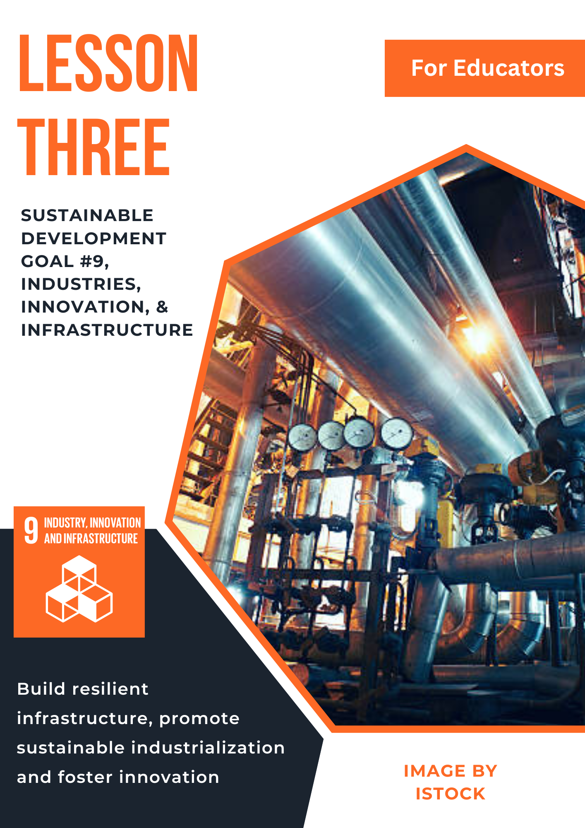

Lesson 3: Sustainable Development Goal #9:
Industries, Innovation, and Infrastructure

Student Handout

Module Driving Question: Lesson 1, 2, and 3
- How does human interaction with the environment affect individuals and communities in local, national, and global contexts?
Lesson Driving Questions:
- How can innovative technology and resilient infrastructure projects create sustainable communities?
- How can communities develop more efficient use of resources?
- What government policies would support the development of sustainable communities?
Learning Targets: I Can:
- Identify examples of green technologies and explain how they are being used to create sustainable cities.
- Research and communicate (to my peers) how innovative technology is being used to create sustainable infrastructure projects.
- Describe an innovative technology or policy that would lead to sustainability in a specific local, national, or global community.
Purpose:
In this lesson, you will explore United Nations Sustainable Development Goal #9: Industry, Innovation, and Infrastructure. The purpose of this specific goal is for local, national, and global communities to develop technology that increases the efficient use of resources, enhances green technology, and establishes sustainable industry. These lesson activities will give you a chance to explore how countries are taking action to design and implement innovative technologies that will improve infrastructure, manage limited resources, and promote sustainability. As many communities around the world are faced with increased populations, environmental challenges, and/or economic concerns, it is important to support new research, allocate funding support for efficient infrastructure projects, and work collaboratively within and across nations. Citizens must also have equal access to information and financial markets in society. You will have the opportunity to work with your peers to analyze how countries are developing innovative technologies and create some of your own ideas to promote inclusive and sustainable communities.
Lesson Vocabulary:
Green technology, infrastructure, innovation, industry, sustainability, technology justice, inclusive, economic development, policy
Lesson Steps:
- Warm-Up Activity #1: Reflect and respond to one or more of the following questions in your notebook. Be prepared to share your ideas with a partner or the class.
- How has new technology impacted the way people live their lives?
- Can you think of a specific innovation that has improved the way people live individually or as a society (and briefly describe how so)?
- How do you think addressing environmental challenges could create societies with more sustainable industries and infrastructure?
- Warm-Up Activity #2: Think-Pair-Share: As a class, you will view and discuss the following graphic on SDG #9: “Industry, Infrastructure, and Innovation: Why it Matters.” How would you describe one of the points in the graphic in your own words or write down a question that the graphic raises for you. After you have finished, share your ideas with a partner and be prepared to share with your class.
Think about: What are some of the challenges we face as a society as it relates to creating sustainable economic and social environments? What would an inclusive and sustainable economic and social environment look like in your own community? Examples?
You will discuss this question as a class after viewing the graphic and sharing your additional questions.
- Watch one or more of the following video clips to gain a better understanding of SDG #9: If you were to tell a friend one thing that you learned from the video and why it is important, what would you say? Briefly write down your idea in your notebook.
- Individually or in small groups, actively read the following one page overview about sustainable industrial development from the United Nations
As you read, circle or underline key ideas and terms in the text that help to answer these questions: “How does inclusive and sustainable industrial development contribute to better economic development? What examples can you cite from the text? Write any questions you have at the bottom of the page or in the margins. After you have finished your reading, discuss your ideas as a class and consider how individuals, organizations, and government could support the social and economic objectives described in the reading.
- In pairs, read, analyze, and discuss one of the principles and one of the commitments described in the (UN) Secretary General’s Strategy on New Technologies (see link below). Using sticky notes provided by your teacher (if online, you will use the Jamboard platform), identify different examples of how these principles and commitments could be used to promote sustainable industry, infrastructure, and/or innovation. Place your sticky notes under the category for each of the 5 principles and/or commitments identified.
Principles and Commitments
For a complete overview and more explanation
- As a class, share and discuss your conclusions of the UN Secretary’s General’s Strategy on New Technologies, what similar and/or different ideas did you and your classmates come up with?
- In your small group, you will participate in the following project scenario:
“You and your team have been hired to work with government officials to develop strategies for creating a sustainable community. Therefore, create a detailed plan that incorporates what you have learned about efficient-use of resources, innovative and green technologies, resilient industry, and is inclusive by design (for example, people have equal access to information and financial markets). You will use your new knowledge, explore the SDG 9 Targets for ideas (decide how many of the 8 targets will be doable), and conduct additional research. Using the poster board provided or an online program, please create a visual of your detailed plans and attach a written explanation of the improvements you are making and why (This could be done in outline form).
Targets Link
- Your team will present your finished project to the class. Be prepared to answer questions, ask questions of other groups, and look for similarities and differences among the plans.
- Optional: Apply what you have learned about the connection between human interaction with the environment and poverty by completing one of the additional projects identified by your teacher.

Teacher Preparation Notes
Pacing and Strategy: The following outline provides a guide for teaching this lesson including approximate times (may vary), teaching strategies, suggested information for teacher created slides, and options for additional enrichment activities/summative assessments can be found at the end of the modules. This particular curriculum model was designed with teaching and learning strategies that could be adapted for in-person or virtual learning.
Lesson Timing: 150 (approximate)
Standards
Content | Standards
WA Social Studies | SSS1.6-8.1: Analyze positions and evidence supporting an issue or an event.  SSS3.6-8.1: Engage in discussion, analyzing multiple viewpoints on public issues.  G2.9-10.1: Analyze human interaction with the environment across the world in the past or present.  E4.9-10.1: Evaluate how people across the world have addressed issues involved with the distribution of resources and sustainability
WA World Language | 1.0 Communication: Communicate effectively in more than one language in order to function in a variety of situations and for multiple purposes.  1.1 Interpersonal Communication: Learners interact and negotiate meaning in spoken, signed, or written conversations to share information, reactions, feelings, and opinions.  1.2 Interpretive Communication: Learners understand, interpret, and analyze what is heard, read, or viewed on a variety of topics.  1.3 Presentational Communication: Learners present information, concepts, and ideas to inform, explain, persuade, and narrate on a variety of topics using appropriate media and adapting to various audiences of listeners, readers, or viewers.  3.0 Connections: Connect with other disciplines and acquire information and diverse perspectives in order to use the language to function in academic and career-related situations.  3.1 Making Connections: Learners build, reinforce, and expand their knowledge of other disciplines while using the language to develop critical thinking and to solve problems creatively.  3.2 Acquiring Information and Diverse Perspectives: Learners access and evaluate information and diverse perspectives that are available through the language and its cultures
C3 Framework | D2.Geo.4.9-12: Analyze relationships and interactions within and between human and physical systems to explain reciprocal influences that occur among them.  D2.Geo.9.9-12: Evaluate the influence of long-term climate variability on human migration and settlement patterns, resource use, and land uses at local-to-global scales.  D2.Eco.15.9-12: Explain how current globalization trends and policies affect economic growth, labor markets, rights of citizens, the environment, and resource and income distribution in different nations.

Lesson Resources
For Students | For Educators | Materials
- Reading Link  - Instructions for Project  - Sticky Notes or Jamboard | - Lesson Three Slides  - Instructions for Project | - Instructions for Project  - Class Notebook  - Sticky Notes
Lesson Overview
In this lesson, students explore United Nations Sustainable Development Goal #9: Industries, Innovation, and Infrastructure. Students will examine readings, videos, and other online resources to learn about the use of new technologies and infrastructure projects to support sustainability. As part of these activities, students will analyze different green technologies, discuss the innovative strategies used by some communities to create sustainability, and evaluate local, national, and global policies that support scientific research and innovation. This lesson also encourages students to consider how to determine and provide equal access to information and financial markets for citizens in society. In addition, students will work as a group to develop a detailed plan for the design and implementation of innovative and sustainable community development projects. This activity will allow students to apply what they have learned about SDG #9, be innovative, and use problem-solving and critical thinking skills.
Teacher Preparation
For Step 1: For context and background information, examine the UN website on Sustainable Development Goal #9. Please take a look at the targets and indicators for the specifics to create resilient infrastructure, promote inclusive and sustainable industrialization, and foster innovation. Think about how you would answer the questions posed in warm-up activity one to inform how you approach the initial discussion with students.
Check out this link for Additional background information and resources
For Step 2: Analyze the graphic provided by United Nations for SDG #9. This will prepare you for your discussion with students. Pay particular attention to what the graphic indicates about the impact of the COVID-19 pandemic and why this particular goal is important for communities locally and globally. Consider using the “think about” question as a prompt either prior to looking at the graphic or afterwards. As part of your discussion, ask students to think about what sustainable economic and social environments would look like? Students could think about this in the context of their own community.
For Step 3: Watch the video clips (or the one you select) at this link to get a better understanding of SDG #9 and prepare for this part of the lesson. This will help you link the two previous activities and the next activities together.
For Step 4: Read the one page overview of sustainable industrial development by the United Nations. In your preparation, look at the examples that students can identify to create inclusive, accessible, and sustainable social and economic systems. For example, job creation, gender equality, poverty eradication, access to education, etc. What would that look like? How could those areas be addressed through innovative policies?
For Step 5: Prepare for this activity by reviewing the different principles and commitments described by the UN Secretary General’s Strategy on New Technology (Note: this is also available in Spanish and Russian).
Think about how you are going to have students select which principles and commitments they will analyze. Come up with a couple of examples in advance.
Decide whether you will do this using sticky notes on the online platform Jamboard. In addition, consider the connections you will make between these principles/commitments and the goals of SDG #9. If you are using sticky notes, create different columns on the board where students can post their ideas (for example, “foster inclusion and transparency”).
More detailed overview the UN Principles and Commitments on Technology
For Step 6: You will be having students share their ideas from the UN principles and commitments on technology activity. After students have explained some of their ideas during class discussion, ask students why these principles/commitments matter and identify the similarities/differences in their example. Additional discussion question: What would be the opportunities and challenges in addressing these technology principles and commitments?
For Step 7: Prepare students for the project scenario. You will decide how many students you would like to work together on this activity (suggestion: two to three). Show students the SDG 9 targets and discuss how they could reflect on them for ideas. Introduce the project and handout the instructions.
For Step 8: Students will be presenting their work to the rest of the class.
For Step 9: If you are going to assign one of the summative activities, review the options and see what options you would like to make available to students.
Lesson Plan in Detail
Step One: Introduction and Brainstorming/Reflection Activity: 5-7 minutes
Purpose: Students are asked to reflect on one or more of the questions identified in the teacher preparation notes. These questions are designed to get students thinking about the content, goals, and purpose of SDG #9.
Slide 1: Warm-Up Activity: Respond to one or more of the following questions:
- How has new technology impacted the way people live their lives?
- Can you think of a specific innovation that has improved the way people live individually or as a society (and briefly describe how so)?
- How do you think addressing environmental challenges could create societies with more sustainable industries and infrastructure?
Be prepared to share your answer with a partner and the class.
Step Two: UN Image Reflection and Discussion: 10 minutes
Purpose: Explain to students that they will be analyzing a graphic provided by the United Nations on SDG #9. This will help students identify some of the components of this particular goal and to raise questions. After discussing the image with students, have them think about the challenges faced by society in providing accessible and sustainable economic and social environments for citizens. What are some of these challenges and why do they matter?
Slide 2: Prepare your slide to include the questions described above.
Step Three: Video Clips and Discuss: 10 minutes
Purpose: Explain to students that they will be watching one or more video clips to give them greater context/background for SDG #9. After watching the videos, they will discuss student reactions and continue building background knowledge and perspectives on the topic/issue.
Slide 3: After watching the video(s), what is one thing you would tell a friend you learned? Why do you think this topic is important? Please respond in your notebook and be prepared to discuss.
Step Four: Close Read: 10-12 minutes
Purpose: Students will begin to explore one specific environmental condition and how it influences poverty levels. This activity is designed to prepare students for more in-depth research and allow students to share ideas in small and large groups. You can review with students the importance of looking at 2 of 3 reliable sources and have students summarize their findings on the chart paper provided (or use a Google Doc).
Slide 4: Provide the directions for students to complete this activity:
“As you read, circle or underline key ideas and terms in the text that help to answer these questions: “How does inclusive and sustainable industrial development contribute to better economic development? What examples can you cite from the text? Write any questions you have at the bottom of the page or in the margins.”
After you have finished your reading, discuss your ideas as a class and consider how individuals, organizations, and government could support the social and economic objectives described in the reading.
Step Five: UN Technology Principles and Commitments Small Group Activity: 10-12 minutes
Purpose: This activity will provide students with an opportunity to explore how the UN is making a commitment to new technologies. This commitment will help communities make progress toward the goals of SDG #9. Students are asked to analyze some of the guiding technology principles and commitments, including how they might lead to more equitable and environmentally sustainable societies. This is also an opportunity to encourage critical thinking skills as students generate ideas for how these new technology principles and commitments could make a difference in communities.
Slide 5: Provide the directions for students in this slide. Bring up the link to the principles and commitments and walk them through the 9 different categories. Provide an example in one of the principles or commitments to get them started. If doing this online, provide the Jamboard link.
Step Six: Discuss the UN Technology and Commitments Activity: 7 minutes
Purpose: Students will have an opportunity to share and discuss their ideas with other classmates. It will also provide the teacher with an opportunity to clarify the UN’s technological principles and commitments (and how they related to SDG #9).
Slide 6: Ask students to share some of their ideas and similar/different responses or examples across groups.
Step Seven: Project Scenario Activity: 45-55 minutes
Purpose: Students have an opportunity to apply some of what they have learned in a creative project. This scenario has students to take on the role of a government official who intends to design and implement reforms that will support the goals of SDG #9. This activity will foster collaboration, critical thinking, and creativity. It will also allow students to reflect on the important SDG #9 and how it may impact communities.
Slide 7: Provide instructions for student sharing of their research and how to make an effective podcast. Highlight with students the importance of communication skills and recognizing diverse perspectives.
Step Eight: Share Your Project Scenario Ideas: 30 minutes
Purpose: Students will share and discuss their design and implementation plans with the rest of the class. This provides an opportunity for students to communicate their ideas and consider other ideas and perspectives. It also allows students to ask and answer questions as they relate their project to the goals of SDG #9.
Slide 8: Provide expectations/instructions for presentations. You may include clarification on what you would like students to think about as they listen to each presentation.
Step Nine: Summative Assessments: Time Will Vary
Purpose: There are different summative assessment options that allow students to demonstrate their learning in an innovative way. Students can choose from one of the project-based assessments identified in the appendix of this document. These projects allow students to further reflect on their understanding of SDG #9: Industry, Innovation, and Infrastructure and teachers can share this work with other students.
Slide 9: Give an overview of the summative assessments opportunities (project-based learning)

Attribution and License

Attribution
This Open Educational Resource, Cultivating Global Competence through the United Nations Sustainable Development Goals, was developed by Ryan Hauck, Michele Anciaux-Aoki, Julianna Patterson, Gloria Kuzmenko-Latmier, Ina Chong, and Global Classroom, World Affairs Council - Seattle.
Cover image by Julianna Patterson from Canva.
Sustainable Development Goals images copyright United Nations. All rights reserved. Used pursuant to fair use.
Translations by:
Larisa Shuvalova
Iryna Novachuk
Inna Shynshyn
Nathan Marks
Brandon Severance
Otilia Baraboi
Ileana Marin
Alexey Kuznetsov
Pedro Lopez-Chaves

License

Except where otherwise noted, Cultivating Global Competence through the United Nations Sustainable Development Goals, copyright World Affairs Council - Seattle, is available under a Creative Commons Attribution-NonCommercial License. All logos and trademarks are property of their respective owners. Sections used under fair use doctrine (17 U.S.C. § 107) are marked.
This resource may contain links to websites operated by third parties. These links are provided for your convenience only and do not constitute or imply any endorsement or monitoring by the World Affairs Council. Please confirm the license status of any third-party resources and understand their terms of use before reusing them.

