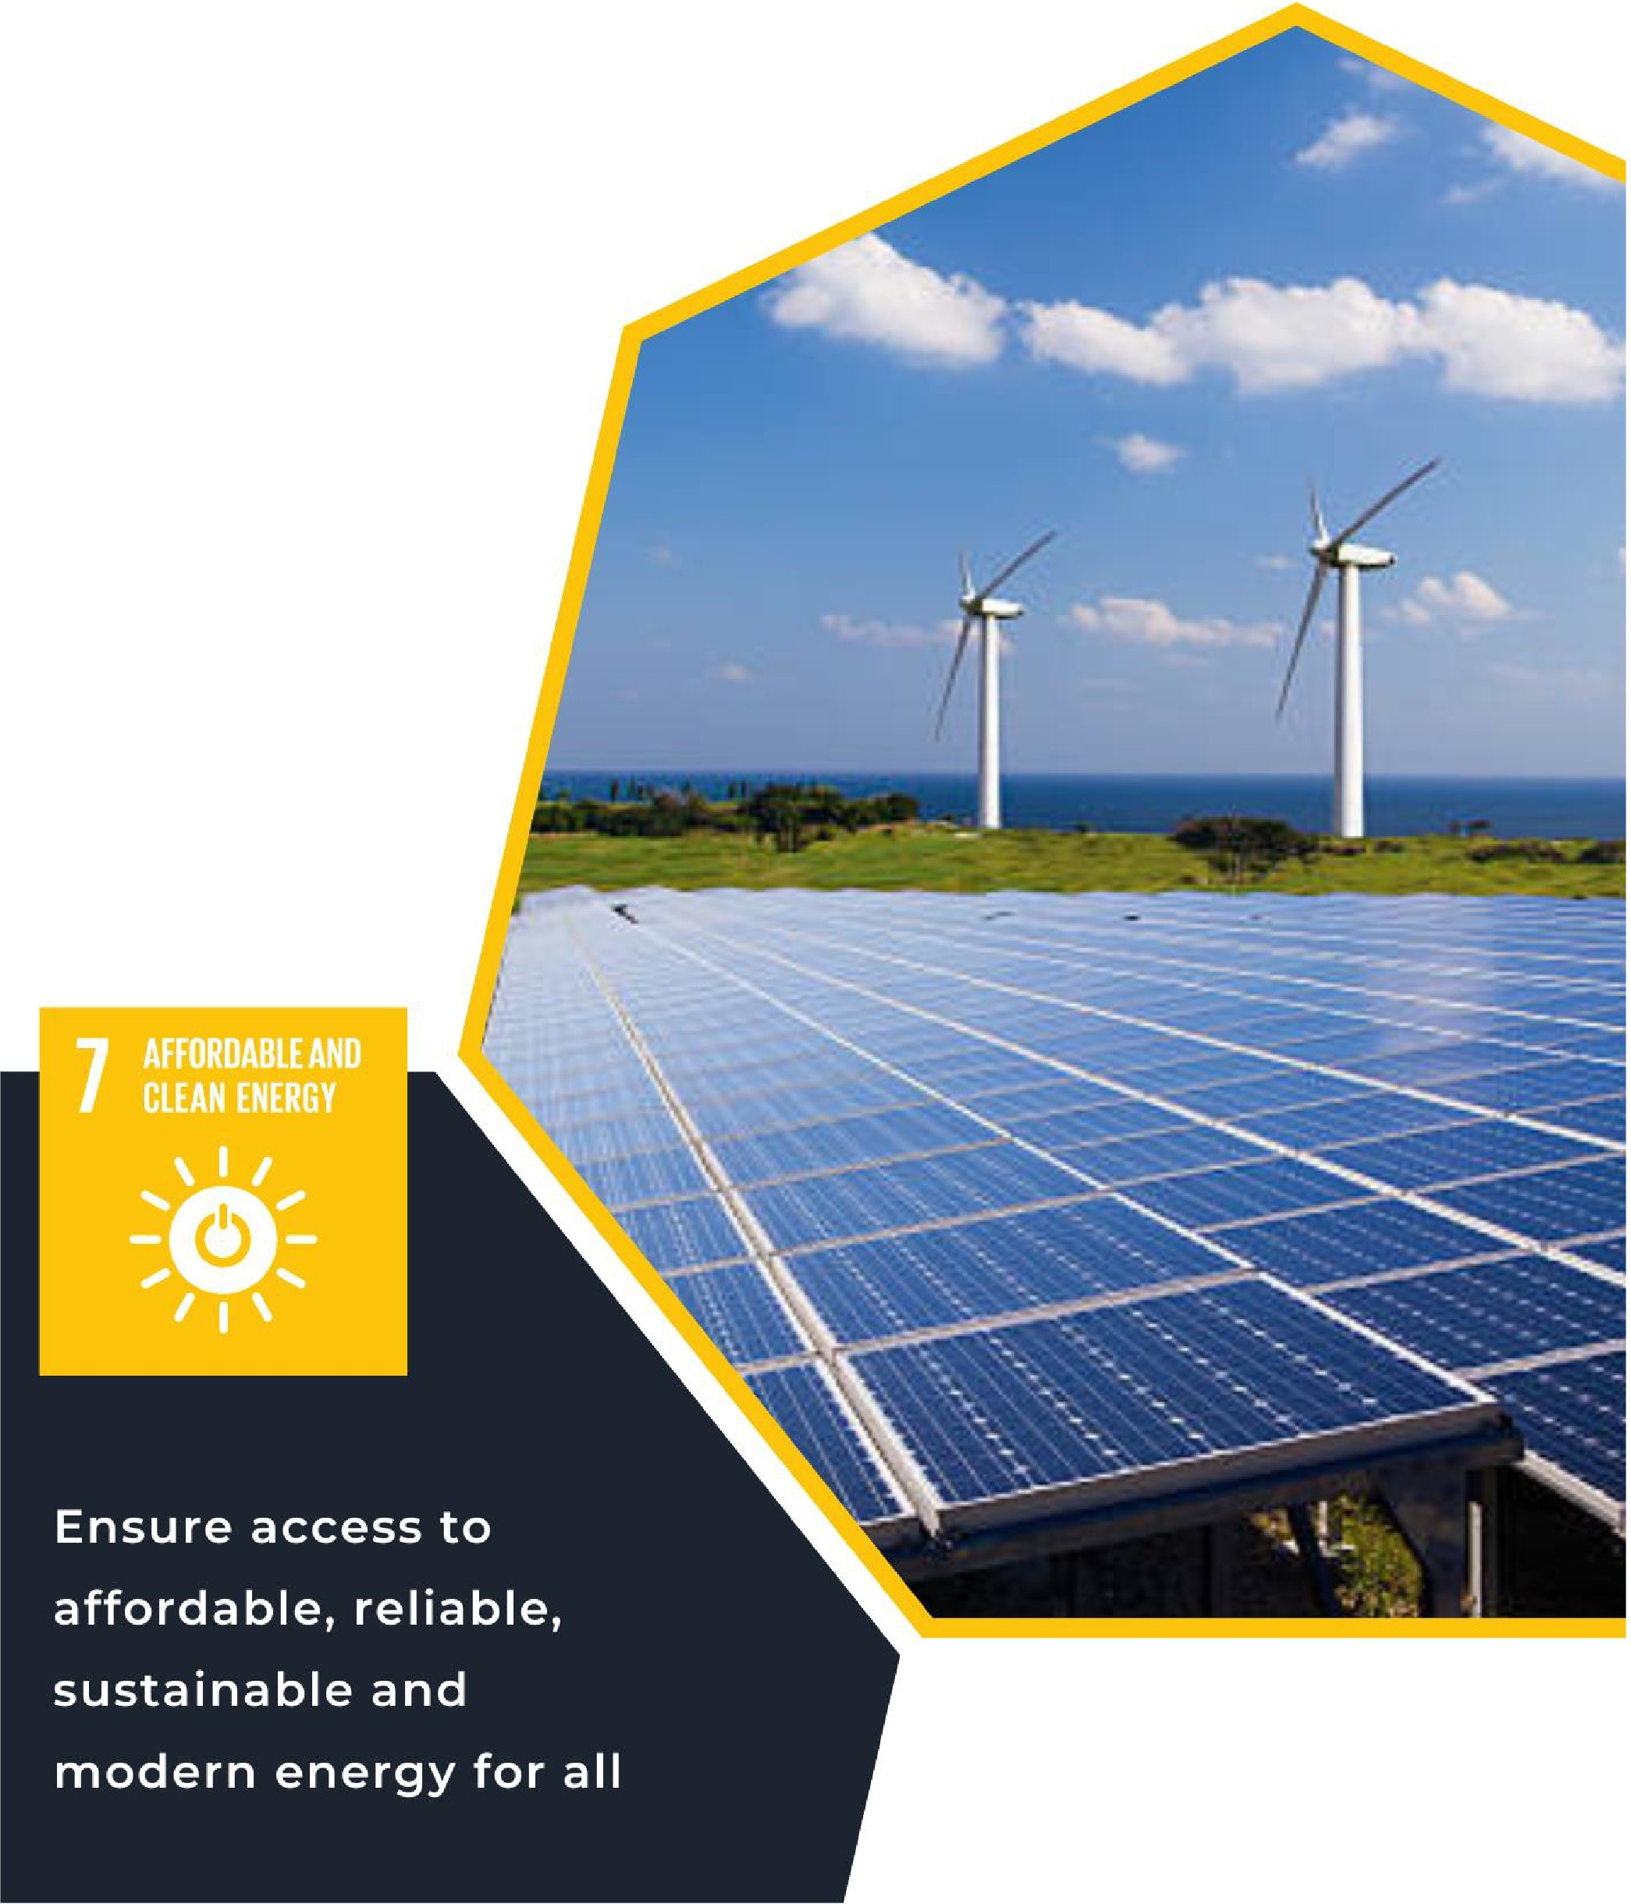
LESSON TEN
SUSTAINABLE DEVELOPMENT GOAL #7, AFFORDABLE AND CLEAN ENERGY

For Educators

IMAGE BY
ISTOCK

Lesson 10: Sustainable Development Goal #7: Affordable & Clean Energy Student Handout
Module Driving Questions: Lessons 10, 11, and 12
(Note: Choose one or both of the following module driving questions depending on your goals)
- How can individuals and communities develop sustainable practices and technologies to effectively protect the biodiversity of our planet?
- Why is it important for local and global communities to work together to address our world’s resource
and ecological needs?
Lesson Driving Questions
- How does access to clean and affordable energy contribute to the development of agriculture, business, communications, healthcare, and transportation?
- How can societies reduce their dependence on fossil fuels (coal, oil, or gas) and invest in renewable or alternative energy sources? How would this reduce the impact of climate change?
- How would reliable access to affordable and clean energy, including current global energy production, create more equitable and sustainable communities/societies? What solutions would you propose based on your learning?
Learning Targets – I Can:
- Identify examples of clean energy technologies and explain how they are being used (or could be) to create sustainable communities.
- Utilize research skills to evaluate affordable and clean energy policies and how they are (or could be)
incorporated into global, national, and/or local efforts to build sustainable communities.
- Design and describe an innovative technology or policy that could lead to clean and affordable energy resources that support a more equitable local and global communities.
Purpose
In this lesson, you will explore United Nations Sustainable Development Goal #7: Affordable and Clean Energy. You will learn about the efforts to provide universal access to clean and affordable energy through different sectors in society: agriculture, business, communications, healthcare, and transportation. You will identify and discuss the barriers faced by many communities in providing reliable access to energy resources and learn how sustainable energy policies can lead to positive health, economic, and social outcomes. In addition, you will evaluate how global greenhouse emissions are dominated by specific energy sources and evaluate how renewable sources such as wind, solar, and thermal energy can be used as viable alternatives. You will explore affordable and clean energy efforts through interactive activities, video clips, graphs and charts, and through an analysis of new, innovative technologies. Then, you will work collaboratively to develop a proposal for achieving greater access to affordable and clean energy in a specific local or global context. These learning activities will help you evaluate initiatives that aim to create more equitable societies and decrease the impact of climate change. Overall, you be able to explain how reliable and affordable access to clean energy can transform people’s lives around the world.

Lesson Vocabulary
Clean energy (solar, wind, thermal), green technology, climate change, sustainability, fossil fuels, greenhouse gas emissions, equity, electrification, disease prevention, hygiene, global health, energy efficiency, innovation, battery storage, climate assemblies.

Lesson Steps
- Learn about SDG #7: Affordable and Clean Energy by reflecting on a quote, UN graphic on SDG #7, and watching video clips. These warm-up activities will get you thinking about the importance of providing access to affordable, reliable, and clean energy for all communities around the world.

- Reflect and brainstorm (in your notebook) what you know about clean energy technology available in your own community, with in the United States, and across the world. Discuss what you know about the progress of these resources and how they might create greater access to affordable and clean energy. Think about how clean and affordable energy would contribute to more sustainable societies and be connected to the development of agriculture, business, education, communication, transportation, and healthcare. Your teacher may also have your convey ideas on the virtual platform Jamboard.

- Evaluate and discuss the Target Goals of SDG #7. As you examine the 5 targets in small groups, discuss how achieving each target would have a positive impact on a community. Consider the cause and effect of each target (should they be achieved) on a community. Be prepared to share your ideas in a large group discussion.

- Analyze U.S. and global energy supplies through the lens of the QFT strategy. This technique will get you engaged in generating essential questions related to energy supplies locally and globally. Be prepared to share and discuss your questions.

- In small groups, research how clean energy solutions could make a difference in one of the following categories: agriculture, business, education, communication, transportation, and healthcare.

  - First, you will choose local or global context to analyze.
  - Next, you will research the energy needs of that sector and explore how a clean energy resource (or action) could make a positive difference in the lives of individuals and communities. Identify and consider the economic, technological, environmental, political, and/or social/cultural impact of this clean energy resource or action.
  - Examine credible sources and use your research and critical thinking skills to analyze the clean energy needs of a specific context and what is currently being done (or could be done) to address those needs. In addition, what are some of the additional strategies that could be developed to decrease demand for traditional fossil fuels.
  - Finally, make recommendations that would address the energy needs of your specific context and explain how it would reduce environmental pollutants, decrease inequities, and provide greater

access to affordable, clean energy resources. Consider the analysis you completed in the previous step. This could support an existing action plan and/or your own recommendations.
  - Some of these action-orientated recommendations could be access to alternative transportation, electrification of buildings, access to renewal energy sources, etc. Consider exploring this additional climate resource called Project Drawdown, which provides different examples of climate solutions.

- Communicate your knowledge and learn from others by participating in a “jigsaw” activity. You will form new groups with different sectors (agriculture, education, etc.) represented. Identify similarities and differences (across sectors) through your discussion and consider each other’s recommendations. You will share some of these ideas in large group discussion.

- Apply what you have learned about clean energy and SDG #7 by creating a mini-website in pairs or small groups. This will provide an overview or synthesis of your learning (consider the previous learning activities) and include your recommendation(s). You can work with a new team of classmates or in one of your previous groups. In your website, include an overview of WHY affordable and clean energy matters and the economic, social/cultural, environmental, political, and/or technological impact of your recommendation(s). You can include evidence or examples in your website from sources to support your conclusions.

- Share your website with the rest of the class. Then, as a class, analyze and discuss your findings and steps that could be taken to achieve one or more of the goals of SDG #7. Optional: You could invite local officials, energy providers, or environmental organizations into your classroom to discuss your recommendations (especially those for your own community).

- Apply what you learned about clean energy climate by completing one of the projects identified by your teacher. For example, explore further by investigating how citizens can become involved in addressing affordable and clean energy concerns by joining a climate assembly. See below:

Going Further: Create a Climate Assembly:
Take action by creating a climate or clean energy club at your school. This club could explore ways to address the impact of climate change, explore clean energy technology, and assess what is being proposed by local climate plans. You can create a climate assembly that would deliberate on climate/energy related recommendations. Your club could review these recommendations and evaluate existing plans and develop their own mitigation or adaptation actions.
Note: Assemblies provide a way for citizens to become more engaged in our democracy by coming together for a common purpose. In this case, climate assemblies gather diverse groups of community members (or citizens) to discuss how to reduce climate pollution. For more information, explore this link about climate assemblies in Washington State.

Teacher Preparation Notes
Pacing and Strategy The following outline provides a guide for teaching this lesson including approximate times (may vary), teaching strategies, suggested information for teacher created slides, and options for additional enrichment activities/summative assessments can be found at the end of the modules. This curriculum model was designed with teaching and learning strategies that could be adapted for in-person or virtual learning. Note: In addition to connecting with themes of lessons 7, 8, and 9, lesson 1 on SDG 13, Climate Action, would be a complementary lesson.

Lesson Timing: 150 minutes (approximate)

Standards

Content | Standard
WA Social Studies | SSS1.6-8.1: Analyze positions and evidence supporting an issue or an event.  SSS3.6-8.1: Engage in discussion, analyzing multiple viewpoints on public issues.  G2.9-10.1: Analyze human interaction with the environment across the world in the past or present.  E4.9-10.1: Evaluate how people across the world have addressed issues involved with the distribution of resources and sustainability
Next Generation Science Standards | HS-PS4-4: Gather relevant information from multiple authoritative print and digital sources, using advanced searches effectively; assess the strengths and limitations of each source in terms of the specific task, purpose, and audience; integrate information into the text selectively to maintain the flow of ideas, avoiding plagiarism and overreliance on any one source and following a standard format for citation.  HS-ESS3-1. Construct an explanation based on evidence for how the availability of natural resources, occurrence of natural hazards, and changes in climate have influenced human activity  HS-ESS3-1: Cause and Effect: Empirical evidence is required to differentiate between cause and correlation and make claims about specific causes and effects.
C3 Framework | D4.1.9-12. Construct arguments using precise and knowledgeable claims, with evidence from multiple sources, while acknowledging counterclaims and evidentiary weaknesses.  D4.6.9-12. Use disciplinary and interdisciplinary lenses to understand the characteristics and causes of local, regional, and global problems; instances of such problems in multiple contexts; and challenges and opportunities faced by those trying to address these problems over time and place.

D4.7.9-12. Assess options for individual and collective action to address local, regional, and global problems by engaging in self-reflection, strategy identification, and complex causal reasoning

Lesson Resources

For Students | For Educators | Materials
- Class Notebook  - Graphic Organizer  - Research Notes Sheet  - SDG #7 links to infographics and videos (see lesson details) | - Lesson 10 Slide Outline  - SDG #7 links to infographics and videos (see lesson details)  - Links to background information on clean energy (see lesson details) | - Class Notebook  - Graphic Organizer  - Research Notes Sheet  - SDG #7 infographics and videos (see lesson details)  - Summative Assessment ideas.

Lesson Overview
In this lesson, students will explore United Nations Sustainable Development Goal #7: Affordable and Clean Energy. Students will learn about the efforts to provide universal access to clean and affordable energy through different sectors in society: agriculture, business, communications, healthcare, and transportation. They will identify and discuss the barriers faced by many communities in providing reliable access to energy resources and learn how sustainable energy policies can lead to positive health, economic, and social outcomes. In addition, students will evaluate how global greenhouse emissions are dominated by specific energy sources and evaluate how renewable sources such as wind, solar, and thermal energy can be used as viable alternatives. They will explore affordable and clean energy efforts through interactive activities, video clips, graphs and charts, and through an analysis of new, innovative technologies. Then, students will work collaboratively to develop a proposal for achieving greater access to affordable and clean energy in a specific local or global context. Students will develop an awareness of initiatives that aim to create more equitable societies and mitigate the impact of climate change. Overall, students will be able to explain how reliable and affordable access to clean energy can transform people’s lives around the world.

Teacher Preparation
For Step 1: For context and background information, examine the UN website on Sustainable Development Goal #7. Please look at the targets and indicators for specific goals expressed by the UN to promote affordable and clean energy.
For this warm-up activity, ask students to describe orally or in their notebook what they think of the goal’s purpose: “Ensure access to affordable, reliable, and sustainable modern energy” (UN, SDG #7). Questions to

consider asking: What does affordable, reliable, and sustainable energy mean? Why does the UN use the
word “modern” to describe energy sources and what would those sources be?
Here is an additional UN quote on SDG #7 for discussion: “At the current pace, about 660 million people will still lack access to electricity and close to two billion people will still rely on polluting fuels and technologies for cooking by 2030.”
Show this graphic on SDG #7 and ask students to reflect on what they see. How does this graphic relate or connect with the class discussion on the purpose of SDG#7? Here is an additional graphic.
Watch two of the video clips on the SDG #7 site and be prepared to discuss those in class with students. What did they learn from?
Check out this link for additional background information.
For Step 2: Prepare to lead a discussion about current clean energy needs in your own community. This discussion's purpose is to have students think about local energy needs (or challenges) to establish relevance. What do they perceive to be the needs in their own community? How are these needs similar and/or different from the targets identified by the UN in SDG #7? As you lead this discussion and have students write down ideas in their notebooks, ask them to consider the following: How would clean and affordable energy contribute to more sustainable societies? How could greater access to these clean energy resources aid in the development of agriculture, business, education, communication, transportation, and healthcare.
For Step 3: After your warm-up activities (steps 1 and 2), students should be ready to examine the specific targets of SDG#7. There are 5 targets that discuss the specific goals for addressing affordable and clean energy needs. Have students work in small groups to assess the targets and how they provide additional information to these specific goals. Students should be thinking about the cause-and-effect relationship of each target and how it would impact communities.
For Step 4: For this part of the lesson, have students examine U.S. and global energy charts to determine supplies in different contexts. This will help students begin to analyze general access to affordable and clean energy. Review the QFT technique on generating questions. You will want students to examine the website data in small groups. Next, have then generate questions that are prompted by what they see. After students have generated a list of questions, please have them narrow their questions down to 3 key questions for further exploration. Students should be prepared to share their questions with the rest of the class. This process will help students analyze data through a stimulus-based activity and help drive their inquiries.
For Step 5: This activity will build on the previous steps. In pairs or small groups of 3 or 4, students will select a specific place to research and analyze specific energy needs. These contexts could be local, national, or global contexts. Have students take notes using the graphic organizer provided and consider the economic, technological, social/cultural, environmental, and political implications of incorporating a clean energy resource/action. Students should consider the essential questions they identified in step 4. In addition, ask students to consider how these energy needs and possible actions (or recommendations) may enhance clean energy affordability and access.

Examine the Drawdown website for specific background and action items for addressing possible clean energy needs. Prepare to have a conversation with students about strategies (or actions) to decrease demand for traditional fossil fuels.
For Step 6: Prepare students to apply what they have gathered in their research. Students will be participating in a jigsaw activity that will allow them to share what they have learned from their research. Arrange students into groups so that students will learn about different clean energy needs in diverse contexts or in a way that allows students to contribute something new to each group. Students will share what they learned and be able to identify some of the similarities and differences in each context. They can do this verbally or write down some of their group’s conclusions (3 to 5 similarities/differences) on their graphic organizer. Tell students to be prepared to share ideas in large group discussion.
For Step 7: Explain to students they will be working in pairs or small groups to create a mini- website that gives an overview of what they learned about access to affordable and clean energy (SDG #7), including their recommendation(s). Students can work with a new team of classmates or in one of your previous groups. In their created website, have students include an overview of WHY affordable and clean energy matters and the economic, social/cultural, environmental, political, and/or technological impact of their recommendation(s). They can include evidence or examples from their research to support their conclusions.
For Step 8: Students will share their website with the rest of the class. Then, as a class, analyze and discuss their findings and steps that could be taken to achieve one or more of the targets of SDG #7. Optional: You could invite local officials, energy providers, or environmental organizations into your classroom to discuss your recommendations.
For Step 9: If you are going to assign one of the summative activities, review the options and see what options you would like to make available to students. There is a specific recommendation for addressing SDG #7, affordable and clean energy, through a climate assembly project focuses on your local community.

Lesson Plan in Detail

Step One: Introduction and Brainstorming/Reflection Activity: 5-7 minutes
Purpose: Students will be asked to respond to a quote from SDG #7 and reflect on the infographics, videos, etc. provided by the UN for SDG #7 (see below). This will help students activate prior knowledge and stimulate their interest in the topic.
Slide 1: Includes the quote, graphics, and video links. Be prepared to share your answer with a partner and the class.
Warm-Up Activities:
- Have students respond to the quote (see teacher preparation notes for additional information): “Ensure access to affordable, reliable, and sustainable modern energy” (UN, SDG #7)
- Show the UN graphic(s) for SDG #7 and ask them what they notice and how this relates to their previous discussion.

- Explain to students they will be watching one or more video clips to give them greater context/background for SDG #7. After watching the videos, discuss student reactions and continue building background knowledge and perspectives on the topic/issue

Step Two: Reflecting on Clean Energy Knowledge: 10 minutes
Purpose: The purpose of this activity is to get students to think about affordable and clean energy resources. What is the current availability of affordable, clean energy needs in your local community and/or state? What do they know at this point (prior knowledge)? What questions or misconceptions do they have about energy?
Next, have students consider how affordable, clean energy would be beneficial to the development of these different sectors: agriculture, business, education, communication, healthcare, transportation.
Slide 2: Prepare your slide to include the discussion questions above (including the different development sectors).

Step Three: Exploring Affordable and Clean Energy Targets: 10-15 minutes
Purpose: Students will examine the 5 targets outlined in SDG #7 for a better understanding of SDG #7. As part of this process, students will work in small groups to communicate ideas, look at local applications or connections, and examine cause and effect relationships.

Slide 3: Instructions for discussing and analyzing the 5 specific targets on SDG #7:

Step Four: Using Questioning Strategies to Unpack Clean Energy Locally and Globally: 15-20 minutes Purpose: Students will analyze websites (in small groups) to assess energy supplies in local, national, and global contexts. This activity will help students make comparisons and draw conclusions about access to energy supplies around the world. It will also engage students in a useful teaching strategy (QFT) to develop essential questions about a particular topic/issue. Be sure to explain the intent of this activity and how it will prepare students for an inquiry activity in step #5.
Slide 4: Provide an explanation and clear directions for students to complete this activity.

Step Five: Mini-Research Activity: Affordable and Clean Energy in a Specific Context: 25-30 minutes Purpose: Introduce students to their research activity by providing them with instructions and an overview. Provide students with possible contexts (local or global) that students could investigate as part of this activity. If students want to choose a local context, they could select an individual community or state. This activity will also help students analyze the impact of specific energy needs and possible actions (or recommendations) from economic, environmental technological, political, and socio-cultural perspectives. The Project Drawdown website is helpful for students to consult for affordable and clean energy options.
Slide 5: Provide the directions for students in this slide and provide the graphic organizer for student notetaking.

Step Six: Learning and Sharing: A Jigsaw Activity: 1o-12 minutes
Purpose: Students will communicate what they have learned in this jigsaw activity. This lesson will provide students with exposure to diverse perspectives and an opportunity to consider different contexts, action steps, and possible recommendations.

Slide 6: Provide directions, purpose, and expectations for jigsaw activity.

Step Seven Create Your Own Website Activity: 35-45 minutes (time will vary)
Purpose: Students will apply and convey their learning through the creation of a mini-website. This project allows students to work collaboratively, creatively, and to use critical thinking skills on an important global issue: affordable and clean energy. Students will apply their research and express their conclusions through the website.
Slide 7: Provide instructions for the mini-website project.

Step Eight: Share Your Website: 25 minutes
Purpose: Students will share and discuss their websites with the rest of the class. As part of this process, students will need to convey what they have learned, why it matters, and what they would recommend in terms of clean energy recommendations. Students can also include alternatives that support environmental sustainability such as enhance public transportation options, green
Slide 8: Instructions and expectations for sharing student videos and/or website

Step Nine: From Clean Energy to Climate Assemblies: Additional Projects to Explore SDG #7 (time will vary)
Purpose: There are different summative assessment options that allow students to demonstrate their learning in an innovative way. Students can choose from one of the project-based assessments identified in the appendix of this document that relates to SDG #7.
Recommendation: Explore clean energy through the lens of a climate assembly.
Optional: Slide 9: Give an overview of the summative assessment opportunities (project-based learning). One of the options could be to create a climate assembly. This activity would empower students to apply what they have learned about affordable and clean energy needs, including climate change mitigation/adaptation strategies, in their own community. As part of this process, they could create an after-school club and/or participate in a climate assembly. The assemblies are part of the democratic process in which citizens (in this case students) evaluate policy recommendations or actions on a specific issue. Students will deliberate, analyze, and discuss pros/cons of these measures. In addition, they could make their own recommendations for their own communities. These conclusions could then be presented to the class and/or city/county representatives and for more information, explore this link about climate assemblies in Washington State.

Optional Activity: Battery Storage and Recycling (60 to 120 minutes)
Note: This could be done as an activity after step 4 or for additional enrichment at the end of the lesson.
Purpose: This optional activity challenges students to think about the importance of storing renewable energy and how it can play an important role in sustainability efforts. See the activity description below.
Slide 10: Instructions and overview of the battery storage and recycling research activity
Students will research different methods of storing renewable energy to make its use more sustainable. Using a jigsaw method, each student will be assigned one storage method to research (batteries, pumped hydropower, hydrogen, flywheels, compressed air energy storage, and thermal energy storage). Students with the same topic

will research together and determine the key facts and examples needed to teach the rest of their group, focusing on its benefits and challenges. Then, students will be rearranged into heterogeneous groups (one representative from each of the energy storage options) to teach each other about the different types of energy storage.
Alternatively, if class numbers are small, students could be paired together to research one of the energy storage methods, create an infographic or poster about their assigned topic, and then students can do a gallery walk to learn about the different types of energy storage.
Here are links to complete this activity:
- American Clean Power
- 6 Key Storage Technologies for Renewable Energy
- How Can We Store Renewable Energy? Technologies That Can Help
- Jump Starting Lithium Battery Recycling Starts with Investing in Innovation

Attribution and License

Attribution
This Open Educational Resource, Cultivating Global Competence through the United Nations Sustainable Development Goals, was developed by Ryan Hauck, Julianna Patterson, Emma Hansen, Riya Kalra, and Global Classroom, World Affairs Council - Seattle.
Graphics:
- Cover image by Julianna Patterson from Canva.
- Sustainable Development Goals images copyright United Nations. All rights reserved. Used pursuant to fair use.

License

Except where otherwise noted, Cultivating Global Competence through the United Nations Sustainable Development Goals, by World Affairs Council of Seattle, is available under a Creative Commons Attribution- NonCommercial License. All logos and trademarks are property of their respective owners. Sections used under fair use doctrine (17 U.S.C. § 107) are marked.
This resource may contain links to websites operated by third parties. These links are provided for your convenience only and do not constitute or imply any endorsement or monitoring by the World Affairs Council. Please confirm the license status of any third-party resources and understand their terms of use before reusing them.

