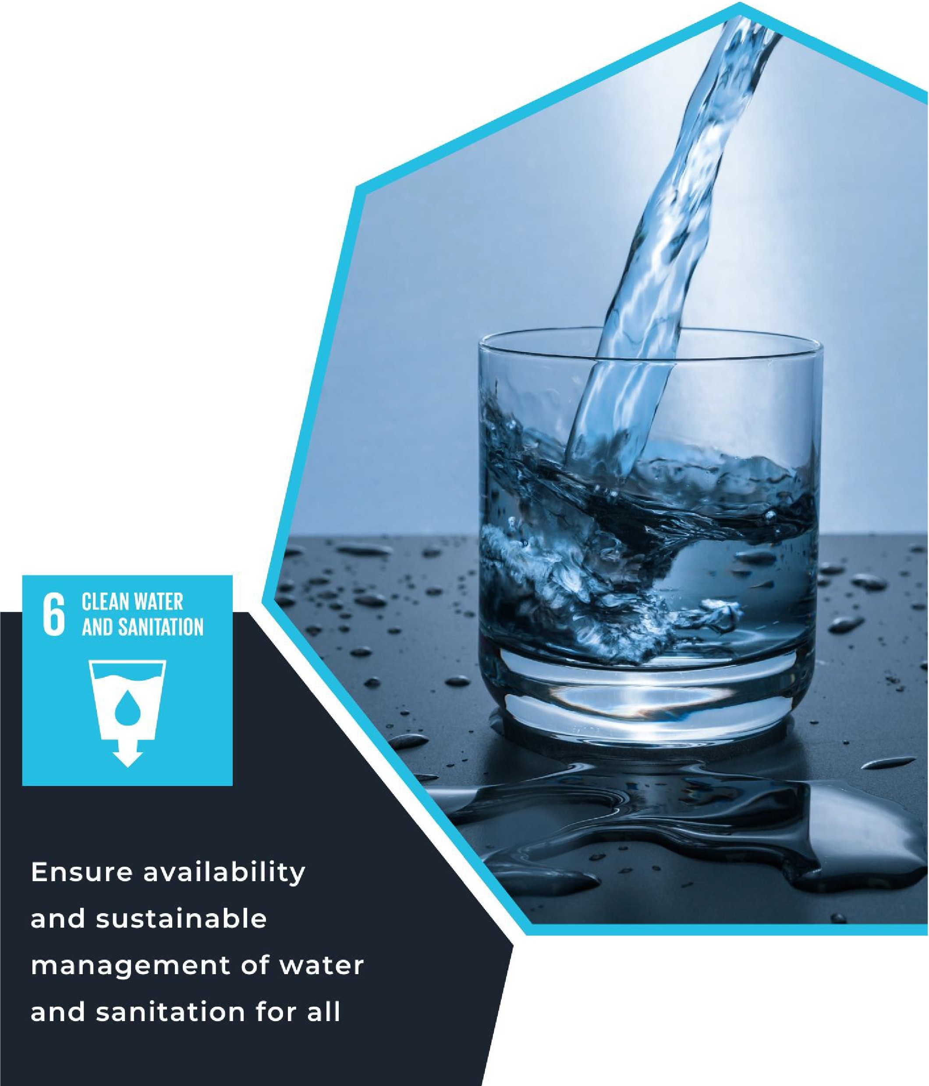
LESSON NINE
SUSTAINABLE DEVELOPMENT GOAL #6, CLEAN WATER AND SANITATION

For Educators

IMAGE BY PEXELS

Lesson 9: Sustainable Development Goal #6: Clean Water and Sanitation Student Handout
Module Driving Question: Lessons 7, 8, and 9 (choose one or both of these module questions)
- Do you believe local and global efforts to decrease hunger, achieve gender equality, and provide reliable access to clean water and sanitation are fundamental human rights? Why or why not?
- How have environmental factors affected local and global efforts to decrease hunger, achieve gender quality, and provide reliable access to clean water and sanitation?
Lesson Driving Questions
- How does the lack of access to clean water and sanitation impact individuals and communities around the world?
- How does the lack of access to clean water and sanitation specifically disproportionately impact women and children?
- What is being done to address clean water and sanitation challenges access locally and globally?
- Why is access to clean water and sanitation a fundamental human right?
Learning Targets – I Can:
- Explain why access to clean water, sanitation, and hygiene is a fundamental human right.
- Evaluate and explain how demand for water resources has contributed to water scarcity in some societies around the world.
- Analyze and explain how equitable access to clean water, sanitation, and hygiene is connected to good health and well-being.
Purpose
In this lesson, you will explore United Nations Sustainable Development Goal #6: Clean Water and Sanitation. You will examine readings, videos, and other online resources to learn about the importance of access to clean water, sanitation, and hygiene. As part of these activities, you will analyze how population growth, urbanization, and greater demand for water resources is a local and global challenge. You will evaluate and discuss how access to water, sanitation, and hygiene is a basic human right and analyze efforts to establish good health and well-being for all. Different hands-on activities and a summative project on water and/or sanitation will help you learn about how water and sanitation are connected to the other SDGs (good health, gender equality, etc.). Individually and as a class, you will investigate what civil society organizations are doing to support communities and how efforts by the UN through World Water Week and World Toilet Day are raising awareness. You will discover how individual and collective action can make a difference in improving the lives of people around the world. Overall, this lesson will allow you to apply what t have learned about equitable access to clean water and sanitation, develop innovative solutions, and use collaborative and critical thinking skills.

Lesson Vocabulary
Sanitation, human rights, water-scarcity, climate change, hygiene, capacity-building, innovation, water- management, water-related ecosystem, agriculture, industry, energy, population growth, urbanization, sustainability.

Lesson Steps
- Reflect and respond to the following questions in your notebook: How do you use water throughout the day? How does consistent, easy access to clean water improve a person’s quality of life? Why is access to sanitation facilities fundamental? Be prepared to share your ideas with a partner or the class.

- Watch video clips (one and two) as a class to better understand the SDGs and specifically SDG #6. Take notes using the video notes sheet on the connections between access to clean water/sanitation facilities and poverty and record any questions you have. Think about how this issue specifically impacts vulnerable populations like women and children. Share your observations and questions with the class.

- Divide into small groups and briefly research a community or region that has inadequate access to clean water or sanitation facilities. Focus on: why does this community not have access to clean water or sanitation (infrastructure, environment, history etc.)? How does this issue specifically impact women and children? Compile your group’s research onto a single slide (PowerPoint or Google Slides) and create a
~5-minute presentation. Each group should research a different region.

- Present your slide to the class. Use the presentation notes sheet to take notes on other presentations, document any questions that arise, and identify/analyze any similarities and differences you observe across presentations. After each presentation, ask the presenters questions about their content and share any analysis. Once all presentations are done, participate in a class-wide discussion about the similarities and differences observed between the topics.

- Next, build on your learning by finding 3-5 additional primary and/or secondary sources for organizations that are working in globally to address water and/or sanitation issues. Where are they working and why? What solutions have they proposed? What challenges have they experienced and how has their work positively impacted those communities? Take notes in your original small group.

Then, connect the global to the local by investigating local or in-state challenges with water scarcity or clean water by researching local organizations working towards solutions. Are there opportunities to volunteer for these organizations and in what capacity? How might water issues also be impactful for a stable ecosystem? As you research, consider other questions or inquiries that come in your group. Lastly, think about why students your age should care and what you and your peers can do to help solve these issues. Be prepared to synthesize your findings in step #6.

- Individually or in pairs, create a one-pager using either the templates provided or with your own creative layout that concisely summarizes all your research and can be easily digested by your peers. Include graphics/images to make it engaging. The goal is to create something that both informs your peers and serves as a call to action for them so include ways they can get involved in the effort to end water and sanitation facility scarcity.

- Post copies of your one-pager around your school in areas designated by your teacher. Educate your peers on all you’ve learned about SDG #6! Once you’ve returned to your classroom, take 5-10 minutes to reflect in your notebook on what you’ve learned about SDG #6 and how problems surrounding water and sanitation facility scarcity impact communities. What can you do to help accomplish SDG #6? Be prepared to share with your class.

- Optional Projects: Apply what you’ve learned about water and sanitation facility scarcity by completing one of the projects identified by your teacher. For example: Create an advocacy campaign for the UN’s World Water Week or World Toilet Day.

Pacing and Strategy: The following outline provides a guide for teaching this lesson including approximate times (may vary), teaching strategies, suggested information for teacher created slides, and options for additional enrichment activities/summative assessments can be found at the end of the modules. This curriculum model was designed with teaching and learning strategies that could be adapted for in-person or virtual learning.
Lesson Timing: 150 (approximate)
Teacher Preparation Notes
Standards

Content | Standards
WA Social Studies | SSS1.6-8.1: Analyze positions and evidence supporting an issue or an event.  SSS3.6-8.1: Engage in discussion, analyzing multiple viewpoints on public issues.  G2.9-10.1: Analyze human interaction with the environment across the world in the past or present.  E4.9-10.1: Evaluate how people across the world have addressed issues involved with the distribution of resources and sustainability
Next Generation  Science Standards | HS-PS4-4: Gather relevant information from multiple authoritative print and digital sources, using advanced searches effectively; assess the strengths and limitations of each source in terms of the specific task, purpose, and audience; integrate information into the text selectively to maintain the flow of ideas, avoiding plagiarism and overreliance on any one source and following a standard format for citation.  HS-ESS3-1. Construct an explanation based on evidence for how the availability of natural resources, occurrence of natural hazards, and changes in climate have influenced human activity  HS-ESS3-1: Cause and Effect: Empirical evidence is required to differentiate between cause and correlation and make claims about specific causes and effects.
C3 Framework | D2.Geo.4.9-12: Analyze relationships and interactions within and between human and physical systems to explain reciprocal influences that occur among them.  D2.Geo.9.9-12: Evaluate the influence of long-term climate variability on human migration and settlement patterns, resource use, and land uses at local-to-global scales.  D2.Eco.15.9-12: Explain how current globalization trends and policies affect economic growth, labor markets, rights of citizens, the environment, and resource and income distribution in different nations.

Lesson Resources

For Students | For Educators | Materials
- UN link to SDG #6 video  - Presentation notes sheet  - One pager template | - UN link to SDG #6 video  - Presentation notes template  - One pager template | - Presentation notes template  - One pager template
Lesson Overview
In this lesson, students will learn about United Nations Sustainable Development Goal #6: Clean Water and Sanitation. According to the UN, 2 billion people currently live in water stressed communities and 3.5 billion people lack safe sanitation access. This presents several challenges for individuals and societies in many parts of the world. In order to better understand this issue, students will investigate the causes of unequal access to clean water and sanitation facilities as well as the effects these problems have, paying special attention to how women and children are impacted. Students will also explore the current solutions to this problem that are being offered and what more needs to be done. Through research activities, mini presentations, class discussions and a project to engage their broader school community, students will not only expand their understanding of key issues, but also develop problem solving and collaboration skills. In addition, students will learn more about organizations that are working on water and sanitation issues and the interconnectedness of the different UN Sustainable Development Goals. As the UN promotes these issues through World Water Week and World Toilet Day, greater attention is being placed on these water and sanitation. Overall, students will walk away with a better understanding of SDG #6, the ability to clearly and concisely communicate on a complex issue and take action to support a fundamental human right.
Teacher Preparation

For Step 1: For context and background information, examine the UN website on Sustainable Development Goal #6. Please look at the targets and indicators for the specifics to ensure availability and sustainable management of water and sanitation for all. Think about how you would answer the questions posed in the warm-up activity to inform how you approach the initial discussion with students.
Check out this link for additional background information and resources

For Step 2: Preview the videos (one and two) that will be watched on SDG #6. Observe connections between access to clean water/sanitation facilities and poverty to prepare yourself to discuss the notes your students will take on this topic. Also review additional material on the greater impact these problems have on women and children so that you’re ready to discuss this topic and answer any questions that arise. Preview the notetaking handout and print copies of them for the class. Consider creating 3-5 discussion questions to guide conversation.

For Step 3: Briefly investigate a region that has inadequate access to clean water or sanitation facilities so you can share it as an example with your students. Make sure your example highlights the historical context for this issue as well as how women and children are specifically impacted in this region, topics your students are asked to focus on. If you’d like, compile a list of regions that are affected by this issue that groups can directly choose from to prevent overlap in topics. Review guidelines on “good sources” to share with the class so that their research is reputable.

For Step 4: Preview the presentation notes sheet that the students will be using and print copies for them. Take note of any connections between topics or otherwise interesting details as groups are presenting so that you can better facilitate a class-wide discussion after all the groups have gone. Feel free to formulate 3- 5 discussion questions to better guide conversation while students are presenting. You can also ask students to submit their single slides to you prior to the allotted presentation time so that you can review them and formulate discussion questions ahead of time.

For Step 5: Expand on the example you used in preparation for Step 3 to now include information on organizations that are working to solve the issue in that particular region as well as a local (in-community, in- state or in-country) example of water scarcity. This will serve as a guiding example for students on what their expanded research should encapsulate. Allow them to innovate and reflect on why their peers should care about this issue and what they can do to help by omitting this part of the assignment from your example.
For Step 6: Preview and print out copies of the one-pager templates. Also gather coloring supplies like markers for students to use. Find examples of one-pagers online to share with the class to better guide them. Be sure to remind them that the one-pager should grab people’s attention with colors and graphics and that text should be concise and easily digestible. Emphasize that this should serve as a call to action for their peers to act on SDG #6.

For Step 7: Ask school administration what wall space is available for students to post their one-pagers. Make copies of students’ one-pagers so that they can be posted in multiple places. Gather tape that can be used to hang up the one-pagers. Reflect on what you’ve learned through this lesson and changes you’ll make in your personal life to help accomplish SDG #6 so that you can also share during the class-wide discussion.

For Step 8: If you are going to assign one of the summative activities, review the options and see what options you would like to make available to students. Consider the project that offers opportunities for students to explore World Water Week or World Toilet Day. Students could organize activities around school during these times to raise awareness around the advocacy campaigns.

Lesson Plan in Detail

Step One: Reflection Activity: 5-7 minutes
Purpose: Students are asked to reflect on one or more of the questions identified in the teacher preparation notes. These questions are designed to get students thinking about the content, goals, and purpose of SDG #6.
Slide 1: Warm-Up Activity: Respond to the following questions in your notebook:
- How do you use water throughout the day?
- How does consistent, easy access to clean water improve a person’s quality of life?
- Why is access to sanitation facilities fundamental?
Be prepared to share your answer with a partner and the class.

Step Two: Video Clips and Discussion: 10 minutes
Purpose: Explain to students that they will be watching one or more video clips to give them greater context/background on the purpose of SDGs and more specifically SDG #6. Students will understand cause- and-effect relationships between water and sanitation facility scarcity and poverty and how this problem impacts women and children more. Facilitate a discussion for them to share their thoughts and ask any questions.
Slide 2: Embed video links on the slide for easy access and add discussion questions if you’ve created them.

Step Three: Group Research and Single Slide Creation: 30-40 minutes
Purpose: This activity is a precursor to the more in-depth research the students will conduct when they create their one pager and will allow them to share their initial findings with peers. You can review with students the importance of looking at 2 of 3 reliable sources and have students summarize their findings on the chart paper provided (or use a Google Doc).
Slide 3: Provide the directions for students to complete this activity, asking them to focus on:
Why does this community not have access to clean water or sanitation (infrastructure, environment, history etc.)? How does this issue specifically impact women and children?

Step Four: Single Slide Presentation: 5 minutes
Purpose: Students will present their single slides to the class creating an opportunity for them to share and discuss their ideas with each other. It also provides an opportunity for you to provide feedback on their topic.
Slide 4: Provide directions for students to complete this activity.

Step Five: Research Expansion: 30 minutes
Purpose: Students will expand on their single slide research and will now investigate solutions for the community they researched and begin to connect the global to local as they explore challenges within their communities surrounding water scarcity. This is an opportunity for students to understand that SDG #6 is relevant to their community and is not just an “other country” issue. Students will also gain an introduction to the research process and how it is a multi-step process that builds over time.
Slide 5: Provide directions for students on this slide, asking them to focus on:
What solutions have been proposed and which organizations are working in the researched community to solve these issues? Finding examples of either in-community, in-state, or in-country examples of water scarcity and organizations working to solve it. Why should people your age care about this problem? How can people your age get involved?

Step Six: One Pager Creation: 40 minutes
Purpose: Students will have an opportunity to create a one-pager summarizing all their research so that it can be easily understood by peers in their school. This is a chance for students to create a call to action for SDG #6.
Slide 6: Provide directions for students on this slide, asking them to focus on:
Using graphics so the one-pager is engaging. Minimizing text and keeping it concise so that it can be easily digested.

Step Seven: One Pager Distribution: 10 minutes
Purpose: Students will now share what they’ve learned about SDG #6 with their peers by distributing copies
of their one-pagers around the school.
Slide 7: Provide instructions for students to on where they’re allowed to post their one-pagers.

Step Eight: Summative Assessments: Time Will Vary
Purpose: There are different summative assessment options that allow students to demonstrate their learning in an innovative way. Students can choose from one of the project-based assessments identified in the appendix of this document. These projects allow students to further reflect on their understanding of SDG #6: Clean Water and Sanitation. Consider engaging students in World Water Week or World Toilet Day.
Slide 8: Give an overview of the summative assessment opportunities (project-based learning)

Enrichment Opportunity: Connecting the Local to the Global:
If students did not investigate local organizations doing water and/or sanitation work previously in the lesson, here is an opportunity to learn more (and take action). Students could contact local organizations and city/country/state representatives to become more involved in these efforts. In Washington State, the Bill & Melinda Gates Foundation has an exhibit in 2024 devoted to water and sanitation: “A Better Way to Go: Toilets and the Future of Sanitation.” You may also want to check out this Seattle-based organization, Water1st, and explore the work they are doing around the world.
Additional idea #1: Students could develop their own innovative design ideas for toilets and/or clean water technology. This could involve students examining technology that is currently available and the challenges in getting these services implemented into communities who need them. As an instructor, you could collaborate with across disciplines within your school to create new designs.
Additional Idea #2: Students could explore Washington Water Trust and investigate the work they are doing are water and environmental stewardship. Their “mission is to protect and restore healthy rivers and streams across Washington so that fish, farms and communities can thrive for generations. We craft smart, collaborative solutions to our freshwater challenges that will withstand the test of time in our rapidly changing world.” How is Washington Water Trust working in their local community? How are they collaborating with other community stakeholders? You could have a representative from the organization come into your class as a guest speaker.
Additional Idea #3: Have students explore Puget Sound Keeper. They have several priority areas to keep Puget Sound waters clean. You could have students learn about one or more of their priority areas: Upholding clean water standards, polluted stormwater runoff, fossil fuel transport, agricultural pollution, vessel pollution, marine debris, toxic clean-up, and wastewater pollution. Students could examine the challenges and solutions of their work. They could also consider how this work connects with many of the UN Sustainable Development Goals (for example, Life Below Water, Life on Land, or Climate Action ). Students could possibly take a field trip and learn more about their work in these different areas.

Attribution and License

Attribution
This Open Educational Resource, Cultivating Global Competence through the United Nations Sustainable Development Goals, was developed by Ryan Hauck, Julianna Patterson, Emma Hansen, Riya Kalra, and Global Classroom, World Affairs Council - Seattle.
Graphics:
- Cover image by Julianna Patterson from Canva.
- Sustainable Development Goals images copyright United Nations. All rights reserved. Used pursuant to fair use.

License

Except where otherwise noted, Cultivating Global Competence through the United Nations Sustainable Development Goals, by World Affairs Council of Seattle, is available under a Creative Commons Attribution- NonCommercial License. All logos and trademarks are property of their respective owners. Sections used under fair use doctrine (17 U.S.C. § 107) are marked.
This resource may contain links to websites operated by third parties. These links are provided for your convenience only and do not constitute or imply any endorsement or monitoring by the World Affairs Council. Please confirm the license status of any third-party resources and understand their terms of use before reusing them.

