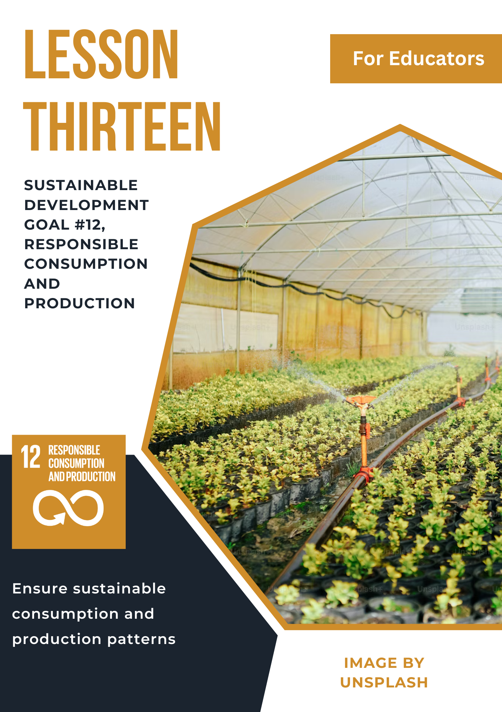

Lesson 13: Sustainable Development Goal #12:

Responsible Consumption and Production

Student Handout
Module Driving Questions: Lessons 13, 14, and 15:
(Note: Choose one or both of the following module driving questions depending on your goals)
- Why is it important for individuals and communities to create innovative and inclusive strategies for sustainable economic development and resilient communities?
- How can societies (locally, nationally, and globally) raise awareness and act to provide people with reliable work, responsible production and consumption, and sustainable cities or communities?

Lesson Driving Questions:
- What practices (and policies) would promote responsible consumption and production of resources essential for sustainable communities locally and globally? Why is this important?
- What is a “circular economy” and how do you think it would contribute to a reduction of waste and pollution in our society?
- How would the adoption of sustainable practices (individually and as a community) contribute to a reduction in local/global concerns such as climate change, plastic pollution, e-waste, and food insecurity?

Learning Targets – I Can:
- Identify and explain how consumption and production patterns can impact individuals and communities locally and globally.
- Identify and evaluate the role of individuals and organizations in addressing the goal(s) of SDG #12.
- Explain the purpose of a circular economy and analyze its impact on individuals and communities.
- Analyze and communicate the consequences of food waste and food insecurity in both local and global contexts.

Purpose
In this lesson, you will explore United Nations Sustainable Development Goal #12: Responsible Consumption and Production. You will engage in a series of individual and collaborative learning activities that emphasize sustainable practices that reduce waste, promote responsible manufacturing, and encourage effective natural resource management. Working in small groups, you will assess how local, national, and global communities are working to achieve the sustainable management and efficient use of natural resources, including the development of scientific and technological tools for reducing waste and implementing effective consumption and production patterns. You will evaluate the impact of plastic waste, recycling policies, consumption and production practices, food waste, corporate responsibility, and efforts to promote sustainable tourism. Therefore, you will engage in activities that require you to make connections between our local, national, and global consumption and production patterns and its impact on creating sustainable communities. In addition, you will explore various partnerships within and across local and national contexts to achieve SDG 12 in the future. Overall, this lesson will help you learn about current ideas and practices that will support the development of more sustainable lifestyles and communities around the world.

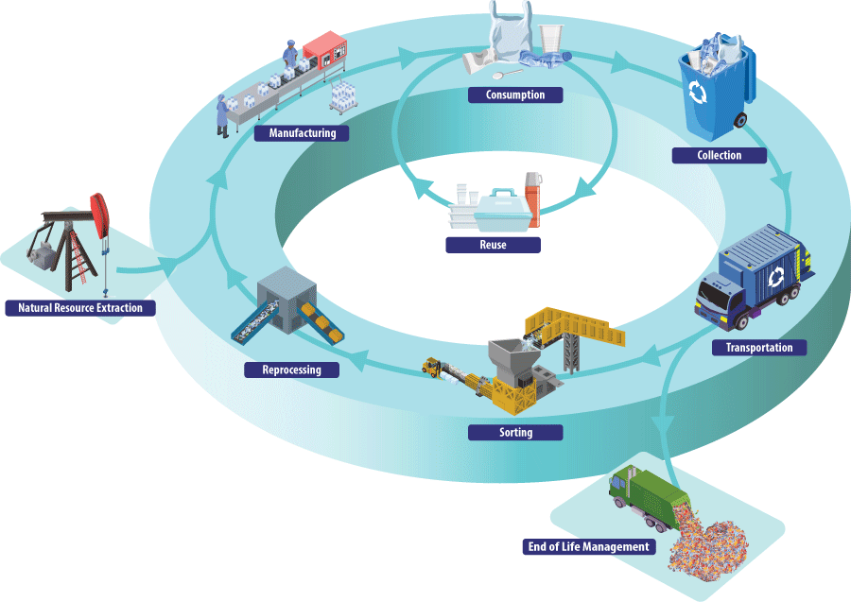
Lesson Vocabulary
Here is a sneak preview of an image representing a “circular economy.” This is a key concept that you will learn about in this lesson on responsible consumption and production. For now, look at this image be prepared to evaluate and discuss its components and overall design in lesson task #4 below. You will have an opportunity to reflect on how a circular economy is being implemented by local communities and government bodies to achieve elements of SDG #12. As you think of what you have learned by analyzing this image, consider its possibilities for improving our lifestyles. This is image is from King County, Washington.
plastic waste, circular economy, food insecurity, food waste, e-waste, recycling, domestic material consumption (DMC), fossil fuels, hazardous waste (chemicals), supply chain, sustainable tourism, gleaning, greenwashing, material footprint, sustainability, innovation, climate change, international agreements, resource depletion, composting
Lesson Steps
- Warm-Up Activity: Watch and reflect on the following video clip(s): Foster Sustainable Economic Growth and/or Responsible Consumption and Production. Think about the following question(s) prior to watching the videos: What is “responsible” consumption and production in our society (local, national, and/or global) and why does it matter? After watching the video(s), share one idea that you learned from the video with a classmate and/or in large group discussion.
2. After listening and sharing your idea with a partner, take a moment to reflect (in your notebook) on two ways you could individually address the challenges of over-consumption and/or unsustainable production in our local/national/global society. Briefly brainstorm and explain what actions you could take to have a positive impact in this area. Be prepared to share your reflection with a partner and/or in a larger group discussion.
3. Warm-Up Activity #2: Examine the following cartoon and describe what you notice and wonder in your notebook. What images do you see? What does the text tell you about the perspective of the cartoonist? Finally, write a one sentence synthesis (or summary statement) that expresses what you think the cartoonist wanted you to take away from viewing the cartoon. Be prepared to share your conclusion(s) with classmates.
Alternative: Examine the graphic provided by the UN for SDG #12. What do you notice about the information identified? What do you wonder? The graphic mentions 485 policies introduced by the EU and 62 other countries to ensure sustainable consumption and production patterns. Briefly, what do you think one of those policies could be? Discuss your analysis of the graphic and your ideas with your class.

4. Key Concept Exploration: The Circular Economy: Think about your idea(s) from the warm-up activities and consider how local governments or communities are applying the concept of a “circular economy” to address sustainable consumption and production goals. What do you think is an important component or factor in being a responsible consumer or producer that you believe local government, communities, and/or businesses should consider in promoting sustainability?

The World Economic Forum, has several short videos that examine different elements of the circular economy. Watch a couple of these short videos for more information on this concept and be prepared to share one of the main ideas you learned in a class discussion.

5. The Circular Economy: A Local Connection: After watching the videos, examine the King County, (Washington State) website that explains what is being in done to address sustainability through their circular economy strategic plan. The county says a “circular economy promotes investments in local sorting and processing infrastructure, addresses the climate crisis, and ensures everyone in King County has equitable opportunities to thrive.” Then, read about their focus on materials (paper, plastics, organics, salvaged lumber, and mattresses) and choose one of the products to explore in more depth.

As you investigate, analyze the process the material (or product) goes through and why local officials believe this is important. Do you think this could make a difference in the short term? Write a blog post of 150 words that describes what you learned about the product, how an individual could take action to address the issue in their own lives, and why this matters for achieving responsible consumption and production locally.

Note: If you are not in Puget Sound Region or in Washington State, consider researching your own local
context to evaluate what they are doing to promote a sustainable, circular economy.

6. Diving Deeper into SDG #12 Targets: SDG #12, Responsible Consumption and Production, encompasses a total of 10 critical targets. It’s now time to delve deeper into the remaining targets. Visit the SDG #12 UN site to explore the targets in more depth in small groups of 3 or 4. First, take some time to examine all the targets and their indicators. Are there one or two of the targets that you think would be most impactful? Why?

Next, conduct an in-depth exploration of one of the targets and prepare to share your findings in a large group discussion or a jigsaw activity. As part of this process, do a WebQuest to find one article on the topic of your specific target. Read the article and then write a brief, one to two sentence summary. Provide 2 or 3 supporting examples that support your statement. Use can use the provided graphic organizer to structure and collect your insights.

7. Food Waste Connection: After your discussion of the targets and indicators, let’s explore one of the issues connected to SDG #12: Food waste. In 2o22, for example, 19% of global food was wasted, totaling 1.05 billion tons. As you may have learned from other SDGs, such as No Poverty (1), No Hunger (2), or Good Health and Well-Being (3), food waste and food insecurity have become significant issues affecting individuals and communities throughout the world. Think about how we could address concerns around poverty, hunger, and good health by reducing the amount of food waste that occurs locally and globally. Watch this short UN video on food waste and with time, this 8 minute video from the SDG Academy. After viewing, write down 3 things you learned and one question the video brought up for you. Then, share your learning and question the student next to you.

8. Food Waste and Food Insecurity - A Global Perspective: Research Activity: Explore target 12. 3 and one of the following organizations (see below) and the work they are doing to address food waste. Working in pairs, read about the goals of the organization and how they are working to increase food security (and reduce food waste). As you examine these organizations, think about what you could do as an individual to reduce food waste and increase food security.

Organizations: Zero Food Waste Coalition, Food Waste Alliance, and The Global Food Banking Network

Then, choose a place in the world (see the column on the right hand side of the website under “emergencies”) where food insecurity is a significant concern and research what steps are being taken to provide the food individuals and communities need to live healthy lives. You will research the causes and effects of food insecurity and determine how addressing food waste in this specific location could make a positive difference in addressing several of the SDGS. See the essential research questions in #9 below and/or use the instructions sheet provided by your teacher.

9. Working in pairs, prepare a short presentation on what you learned about food insecurity and efforts to address the issue in your specific location. You can prepare a PPT slide, podcast, or video. Your presentation should be 5 to 7 minutes and include the following information:

Your Presentation Should:

  - Examine Key Topics: Discuss the chosen context for food insecurity and/or food waste, its social/economic/political causes and effects.
  - Local to Global Connection: Connect the issues in your chosen region to their global impact. Highlight why these issues matter locally and how they resonate globally.
  - Propose Action Steps: Provide actionable steps for your peers to raise awareness about these regional issues. Suggest ways they can take individual action to contribute to reducing food waste and food insecurity.

Consider These Key Questions in Your Research:

- Why is there food insecurity in this location? Briefly identify/explain the causes and their effects on the population.
- What local or international organizations are involved in attempting to address the issue? What actions are they taking?
- How do you think the lack of a reliable food source is impacting efforts to maintain or achieve other SDG goals, such as access to quality education or healthcare, ending poverty, and establishing sustainability efforts?
- Name and briefly describe one action (or policy) the government is implementing to solve the food crisis. Is it making a difference?
- What would you recommend for addressing the issue?

Take the time to craft a compelling and informative presentation that educates and inspires your classmates to act on food waste and food insecurity.

10. Presentation Time! Share your prepared presentation with the class. Ensure you pace yourself effectively, allowing a minute or two at the end for your peers to ask questions and engage in discussion.

11. Food: A Global to Local Connection: Now that you’ve had an opportunity to look at the global context, let us look at what is being done at the local level. Explore local organizations addressing food waste and food insecurity in Washington State. Working in pairs or small groups, investigate one or more of the organizations identified below and then create an advertisement (could be digital) or advocacy poster that highlights their work. You should aim to capture the importance of their efforts to address food waste and/or food insecurity and how others can get involved. Be ready to share your finished product in class. Harvest Against Hunger, Food Lifeline, National Gleaning Project (see Washington State), Seattle Public Utilities

Additional or Alternative Activity #1: What is your local school or school district doing to prevent food waste? Develop questions you would like to ask local school officials and interview them about their efforts to reduce food waste. Next, ask other students what they know about food waste and their ideas for addressing the issue. For a next step, create a school club that addresses food waste at your school and seek out opportunities to volunteer in your community.

Additional or Alternative Activity #2: What is gleaning and is it being used to address food waste and food insecurity? Gleaning aims to collect leftover or unharvested crops after the main harvest is finished. The idea of gleaning goes back thousands of years and has a purpose of reducing food waste and food insecurity, support local food systems, and provide a sustainable and ethical way of obtaining food. With this in mind, explore the following sites and determine how you could be involved in gleaning! After your investigation, create a mock social media post (Instagram, Facebook, TikTok) that highlights the intent of gleaning and how one could be involved in the process.

- National Gleaning Project, USDA: Let’s Glean,
- Harvest Against Hunger: Washington Gleaning Network,
- Washington State University Extension – Clallam County & Gleaning,
- Association of Gleaning Organizations (Washington),
- One Earth (Gleaning: No Produce Left Behind),
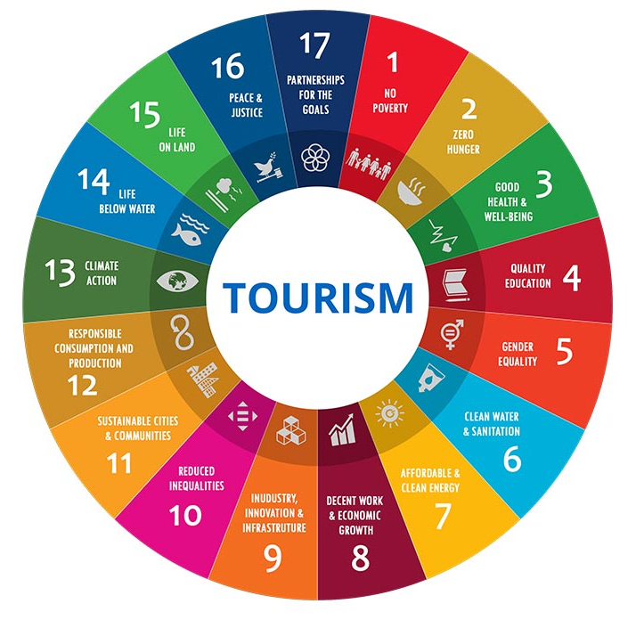
- The Borgen Project: How Gleaning Can End World Hunger

12. Apply what you have learned about the UN SDG #12 by completing one of the summative assessments identified by your teacher. For example, explore what businesses are doing in Washington State, United States, or around the world to address responsible consumption and production. There are project possibilities around the topic areas of plastic waste, e-waste, sustainable tourism, gleaning, recycling, climate change, etc.

Teacher Preparation Notes
Pacing and Strategy: The following outline provides a guide for teaching this lesson including approximate times (may vary), teaching strategies, suggested information for teacher created slides, and options for additional enrichment activities/summative assessments can be found at the end of the modules. This curriculum model was designed with teaching and learning strategies that could be adapted for in-person or virtual learning.

Lesson Timing: 5 hours (approximate)

Standards
Content | Standard
WA Social Studies | SSS1.6-8.1: Analyze positions and evidence supporting an issue or an event.  SSS3.6-8.1: Engage in discussion, analyzing multiple viewpoints on public issues.  G2.9-10.1: Analyze human interaction with the environment across the world in the past or present.  E4.11-12.3: Evaluate how individuals and different groups affect and are affected by the distribution of resources and sustainability.  E4.11-12.5: Explain how current globalization trends and policies affect economic growth, labor markets, rights of citizens, the environment, and resource and income distribution in different nations.
Next Generation Science Standards | HS-PS4-4: Gather relevant information from multiple authoritative print and digital sources, using advanced searches effectively; assess the strengths and limitations of each source in terms of the specific task, purpose, and audience; integrate information into the text selectively to maintain the flow of ideas, avoiding plagiarism and overreliance on any one source and following a standard format for citation.  HS-ESS3-1. Construct an explanation based on evidence for how the availability of natural resources, occurrence of natural hazards, and changes in climate have influenced human activity HS-ESS3-1: Cause and Effect: Empirical evidence is required to differentiate between cause and correlation and make claims about specific causes and effects.
C3 Framework | D2. Geo.4.9-12: Analyze relationships and interactions within and between human and physical systems to explain reciprocal influences that occur among them.  D2. Geo.9.9-12: Evaluate the influence of long-term climate variability on human migration and settlement patterns, resource use, and land uses at local-to-global scales.  D2. Geo.10.9-12. Evaluate how changes in the environmental and cultural characteristics of a place or region influence spatial patterns of trade and land use.  D2. Eco.15.9-12. Explain how current globalization trends and policies affect economic growth, labor markets, rights of citizens, the environment, and resource and income distribution in different nations.

Lesson Resources
For Students | For Educators | Materials
- Graphic Organizer  - Research Notes Worksheet  - UN Links to infographics and Videos  - Project Instructions | - Lesson Sixteen Slide Outline  - Graphic Organizer  - UN Links to infographics and videos (see lesson details)  - Project Instructions | - Graphic Organizer  - Research Notes Worksheet  - UN Links to infographics and videos (see lesson details)  - Summative Assessment Options  - Project Instructions Sheet

Lesson Overview
In this lesson, students will explore United Nations Sustainable Development Goal #12: Responsible Consumption and Production. They will engage in a series of individual and collaborative learning activities that emphasize sustainable practices that reduce waste (including food waste), promote responsible manufacturing, and encourage effective natural resource management. Working in small groups, students will assess how local, national, and global communities are working to achieve the sustainable management and efficient use of natural resources, including the development of tools and actions for reducing food waste, food insecurity, and the implementation of effective consumption and production patterns. Students will evaluate the impact of food waste locally and globally, and learn more about plastic waste, recycling policies, consumption and production practices, corporate responsibility, and efforts to promote sustainable tourism. Therefore, students will engage in activities that allow them to make connections between our local, national, and global consumption and production patterns and its impact on creating sustainable communities. In addition, you will explore various partnerships within and across local and national contexts to achieve SDG 12 in the future. Overall, this lesson will help you learn about current ideas and practices that will support the development of more sustainable lifestyles and communities around the world.
Teacher Preparation
For Step 1: Review the United Nations (UN) Sustainable Development Goals (SDGs) through the following link. Take time to delve into SDG #12: Responsible Consumption and Production and its targets, as this will prepare you to guide your students with their upcoming assignments and activities. Watch the video foster sustainable economic growth and any of these videos discussing responsible consumption and production on the UN website. These videos serve as brief warm-up videos that will get students thinking about the topic. Think about the examples of responsible consumption and production as you will lead a discussion with students to hear their initial ideas.
For Step 2: You will lead a discussion that based on step #1 that has students identify actions they and their classmates could take to have a positive impact on responsible consumption and production.
For Step 3: Examine the cartoon in preparation for a discussion about consumption and production patterns. Prepare how you will lead students in analyzing the cartoon, thinking about the perspective of the cartoonist and what they hoped to convey in their work. As an addition or alternative, you can have students analyze the image provided on the SDG 12 website. This will provoke discussion, and you can examine or considers some of the EU policies alluded to in the graphic.
For Step 4: Review the image on the student handout page (sneak-preview) and watch the videos on the circular economy to prepare for this discussion. Think about how you can get students to understand the concept in both local and global contexts. You can look at the World Economic Forum for more background and explore the King County site for more information about the circular economy locally in the Seattle area.
For Step 5: Analyze the work of King County and what they are doing with regards to a circular economy. Examine their focus and each of the different material items (paper, plastics, organics, salvaged lumber, and mattresses). Students will be writing a blog post as they complete this activity. Thinks about what you would like students to write about in their blog post. You may write an example of your own blog post to share with students.
For Step 6: If you have not already, please familiarize yourself with all 10 targets of SDG #12 and prepare the graphic organizer provided (alter as needed) for students to use during their research and small group discussions. Provide access to resources like the UN SDG #12 website for students to research one of the targets (you can assign different targets) and monitor each students’ progress to ensure understanding and synthesis of information. Divide students into small groups and have them to share their findings with their classmates in a jigsaw activity (or alternatively, in a large group class discussion. You can also look at the progress of each target here.
For Step 7: This part of the lesson is intended for students to explore one of the topics (food waste) within SDG #12 in more depth. Food waste and food insecurity is an issue that most students should find important on both a local/national and global scale. Watch the following UN video on food waste and this 8 minute video from the SDG Academy in preparation for your discussion with students. Start out my having a conversation with students about the issue of food waste locally and globally and what consequences exist. You may have students even think about possible food waste at their school to make a personal connection.
For Step 8: Prepare for the more in-depth student activity on food waste and food insecurity by exploring these organizations: Zero Food Waste Coalition, Food Waste Alliance, and The Global Food Banking Network. Next, you will have students choose a location around the world that is facing a challenge with food insecurity. They will be considering the questions outlined on their student handout page. After completing their research, students will be expressing their findings by creating a presentation (PPT slide, podcast, or video).
For Step 9: Provide clear guidelines, rubrics, and resources for creating presentations using platforms like PowerPoint, Canva, Prezi, Podcast, or video. Review the requirements and expectations for the presentations and offer guidance on structuring content effectively. Facilitate peer feedback sessions or rehearsals to refine presentations and organize the presentation day, ensuring each student has an opportunity to share their project effectively.
For Step 10: Set up the classroom for presentations with appropriate technology and seating arrangements. Allocate time for each presentation and Q&A sessions, ensuring a supportive and engaged audience. Introduce the presentation session, review the order of presentations, and facilitate the presentations, managing Q&A sessions to encourage classmates to ask questions and engage with presenters effectively.
For Step 11: There are several different activities you can implement. The first one, requires students to make meaningful connections between the local and the global by investigation organizations in Washington State (if you are using this lesson module outside of Washington State, feel free to locate local organizations or national organizations working in your community). In preparation for this activity, consider how you will convey the importance of making connections between the global and the local around issues such food waste and food insecurity. There are also two additional or alternative activities you could implement with students. One is an exploration of the food waste in your school community and the other is around the concept of gleaning. Prepare yourself for these activities by looking at your school district’s food waste policy and the different organizations involved in gleaning.
For Step 12: Think about what optional culminating project might be helpful for students to explore. These projects extend student understanding of the topics and targets of SDG #12, Responsible Consumption and Production, including sustainable tourism, plastic and e-waste, recycling efforts, natural resource management, climate change, etc. There are several interesting projects and resources you can use with students to extend and enrich their learning.

patterns. Prepare how you will lead students in analyzing the cartoon, thinking about the perspective of the cartoonist and what they hoped to convey in their work. As an addition or alternative, you can have students analyze the image provided on the SDG 12 website. This will provoke discussion, and you can examine or consider some of the EU policies alluded to in the graphic.
For Step 4: Review the image on the student handout page (sneak-preview) and watch the videos on the circular economy to prepare for this discussion. Think about how you can get students to understand the concept in both local and global contexts. You can look at the World Economic Forum for more background and explore the King County site for more information about the circular economy locally in the Seattle area.
For Step 5: Analyze the work of King County and what they are doing with regards to a circular economy. Examine their focus and each of the different material items (paper, plastics, organics, salvaged lumber, and mattresses). Students will be writing a blog post as they complete this activity. Think about what you would like students to write about in their blog post. You may write an example of your own blog post to share with students.
For Step 6: If you have not already, please familiarize yourself with all 10 targets of SDG #12 and prepare the graphic organizer provided (alter as needed) for students to use during their research and small group discussions. Provide access to resources like the UN SDG #12 website for students to research one of the targets (you can assign different targets) and monitor each students’ progress to ensure understanding and synthesis of information. Divide students into small groups and have them to share their findings with their classmates in a jigsaw activity (or alternatively, in a large group class discussion. You can also look at the progress of each target here.
For Step 7: This part of the lesson is intended for students to explore one of the topics (food waste) within SDG #12 in more depth. Food waste and food insecurity is an issue that most students should find important on both a local/national and global scale. Watch the following UN video on food waste and this 8 minute video from the SDG Academy in preparation for your discussion with students. Start out by having a conversation with students about the issue of food waste locally and globally and what consequences exist. You may have students even think about possible food waste at their school to make a personal connection.
For Step 8: Prepare for the more in-depth student activity on food waste and food insecurity by exploring these organizations: Zero Food Waste Coalition, Food Waste Alliance, and The Global Food Banking Network. Next, you will have students choose a location around the world that is facing a challenge with food insecurity. They will be considering the questions outlined on their student handout page. After completing their research, students will be expressing their findings by creating a presentation (PPT slide, podcast, or video).
For Step 9: Provide clear guidelines, rubrics, and resources for creating presentations using platforms like PowerPoint, Canva, Prezi, Podcast, or video. Review the requirements and expectations for the presentations and offer guidance on structuring content effectively. Facilitate peer feedback sessions or rehearsals to refine presentations and organize the presentation day, ensuring each student has an opportunity to share their project effectively.
For Step 10: Set up the classroom for presentations with appropriate technology and seating arrangements. Allocate time for each presentation and Q&A sessions, ensuring a supportive and engaged audience. Introduce the presentation session, review the order of presentations, and facilitate the presentations, managing Q&A sessions to encourage classmates to ask questions and engage with presenters effectively.
For Step 11: There are several different activities you can implement. The first one, requires students to make meaningful connections between the local and the global by investigation organizations in Washington State (if you are using this lesson module outside of Washington State, feel free to locate local organizations or national organizations working in your community). In preparation for this activity, consider how you will convey the importance of making connections between the global and the local around issues such food waste and food insecurity. There are also two additional or alternative activities you could implement with students. One is an exploration of the food waste in your school community and the other is around the concept of gleaning. Prepare yourself for these activities by looking at your school district’s food waste policy and the different organizations involved in gleaning.
For Step 12: Think about what optional culminating project might be helpful for students to explore. These projects extend student understanding of the topics and targets of SDG #12, Responsible Consumption and Production, including sustainable tourism, plastic and e-waste, recycling efforts, natural resource management, climate change, etc. There are several interesting projects and resources you can use with students to extend and enrich their learning.

rehearsals to refine presentations and organize the presentation day, ensuring each student has an opportunity to share their project effectively.
For Step 10: Set up the classroom for presentations with appropriate technology and seating arrangements. Allocate time for each presentation and Q&A sessions, ensuring a supportive and engaged audience. Introduce the presentation session, review the order of presentations, and facilitate the presentations, managing Q&A sessions to encourage classmates to ask questions and engage with presenters effectively.
For Step 11: There are several different activities you can implement. The first one, requires students to make meaningful connections between the local and the global by investigation organizations in Washington State (if you are using this lesson module outside of Washington State, feel free to locate local organizations or national organizations working in your community). In preparation for this activity, consider how you will convey the importance of making connections between the global and the local around issues such food waste and food insecurity. There are also two additional or alternative activities you could implement with students. One is an exploration of the food waste in your school community and the other is around the concept of gleaning. Prepare yourself for these activities by looking at your school district’s food waste policy and the different organizations involved in gleaning.
For Step 12: Think about what optional culminating project might be helpful for students to explore. These projects extend student understanding of the topics and targets of SDG #12, Responsible Consumption and Production, including sustainable tourism, plastic and e-waste, recycling efforts, natural resource management, climate change, etc. There are several interesting projects and resources you can use with students to extend and enrich their learning.

Lesson Plan in Detail

Step One: Introduction to SDGs and SDG #12: Responsible Consumption and Production: 10-12 minutes Purpose: Students are encouraged to think about the importance of responsible consumption and production on local, national, and global scales. They may already know some information related to this SDG and the videos help students to consider key points around the topic, brainstorm ideas, and develop relevance for their learning.

Slide 1: UN SDG overview slide of the 17 goals. Overview slide of SDG #12. Prompt for small group discussion.

Step Two: Personal Reflection and Partner Discussion: 10 minutes
Purpose: After sharing insights from the warm-up activity, students will individually reflect on the challenges they believe overconsumption and unsustainable production practices may have on society. Provide students with prompts to guide their reflection in their notebook. Students will then partner up to share and discuss their reflections, fostering a greater understanding of the causes and effects of overconsumption and unsustainable production.

Slide 2: Activity instructions and reflection prompts.

Step Three: Political Cartoon and SDG Image: 10 minutes
Purpose: Students will examine a political cartoon and an image from SDG #12 to provoke critical thinking and consider different points of view. Political cartoons are a great way to get students thinking about the topic and these image(s) will help students consider sustainable consumption and production patterns.

Slide 3: Have the cartoon ready for students to analyze. If students have not evaluated political cartoons before, you may provide some additional information on this slide about what to look for in the image. Also, include the image for SDG #12 that students can analyze and discuss.

Step Four: Key Concept Exploration: The Circular Economy: 10 minutes
Purpose: This activity enables students to enhance their knowledge of the one of the key concepts of this lesson (after the warm-up activities). The circular economy is a way for students to understand the process by which communities can address consumption and production challenges in a more sustainable way.

Slide 4: The World Economic Forum, has several short videos that examine different elements of the circular economy. Provide the links to students and show the image that was included as a part of the “sneak preview: on the student handout. You can also include this on slide #5.

Step Five: The Circular Economy: A Local Connection: 30 minutes
Purpose: This activity enables students to make a local connection on a global issue. Students can examine You should aim to capture the importance of their efforts to address food waste and/or food insecurity and how others can get involved. Be ready to share your finished product in class. If you are not in King County or Washington State, you can have students find out what is happening in their own region, city, and/or community.

Slide 5: Have students explore the image of King County’s circular economy and provide links to these organizations for their activity: Harvest Against Hunger, Food Lifeline, National Gleaning Project (see Washington State), Seattle Public Utilities

Step Six: Diving Deeper in SDG #12: 15-20 minutes
Purpose: This activity gives students the opportunity to delve more deeply into the targets and progress of the 10 targets on responsible consumption and production (SDG #12). They will explore one of the targets, find an article, and share their learning in small group discussions. In addition to communicating what they learned, they will also learn more about the other targets from peers.

Slide 6: Instructions for the activity, including how to write the synthesizing statements with examples.

Step Seven: Food Waste Activity: 20 minutes
Purpose: Students will explore one of the key issues related to responsible consumption and production (target 12.3) by examining organizations that are addressing food waste and food insecurity. The activity will provide students with greater context for the challenges associated with food waste and what is being done about it. Students should consider how this is connected to the success of other SDGs such as No Poverty (1). No Hunger (2), and Good Health and Well-Being (3).

Slide 7: Provide instructions and/or a prompt for watching on food waste and food insecurity.

Note: Time frames for steps 8, 9, and 10 may vary depending on the class and scope of the project.

Step Eight: Food Waste and Food Insecurity - A Global Perspective: Research Activity: 60 minutes
Purpose: Students will explore a few organizations to see how they are addressing food waste and/or food insecurity. They will choose a context with a partner to see the impact of food insecurity on a region, nation, or community. This will give students a chance to deepen their research skills, investigate food insecurity in another context (develop global competence knowledge and skills), and present their findings to other students. They will also learn about other contexts and can develop a comparative perspective.

Slide 8: Include clear guidelines, rubrics, and resources to support students in completing research.

Step Nine: Prepare Presentations: 30-45 minutes
Purpose: Students will prepare their presentations based on their research. This activity helps them to develop their media literacy and research skills as well as their content knowledge, critical thinking, and communication skills.

Slide 9: Instructions for the creation of student presentations.

Step Ten: Presentation Time! 45 minutes
Purpose: Students will present their findings to the class, ensuring they pace themselves effectively and leave time for questions and discussion. This step allows students to showcase their understanding, share insights, and engage with their peers on the importance of ocean conservation. Note: This could take more than one class period.

Slide 10: Presentation schedule and expectations.

Step Eleven: Food: From a Global to Local Perspective: 60-90 minutes
Purpose: Although students may have already explored some of the local organizations doing work on responsible consumption and production, this will allow students to examine organizations working on food waste and/or food insecurity. It is important that students recognize the SDGs are both local and global, making meaningful connections on how to assess and act. This activity gives students a chance to connect with a local organization, look for volunteer opportunities, and communicate their ideas in an advertisement or poster.

Note: There are also two alternative activities that would be interesting for students. You can do these in lieu of this activity or with more time, implement them during the module. You could also consider making them one of the summative assessment options. See #11 in the student handout and lesson step 11 for more specific details.

Slide 11: Instructions and links for the local organizations students will consult and the advocacy product.

Step Twelve: Summative Assessments: Time Will Vary
Purpose: There are different summative assessment options that allow students to demonstrate their learning in an innovative way. Students can choose from one of the project-based assessments identified in the appendix of this document. These projects allow students to further reflect on their understanding of SDG #12: Life Below Water and teachers can share this work with other students.

Slide 12: Give an overview of the summative assessment opportunities (project-based learning).

Attribution and License

Attribution
This Open Educational Resource, Cultivating Global Competence through the United Nations Sustainable Development Goals, was developed by Ryan Hauck, Julianna Patterson, and Global Classroom, World Affairs Council - Seattle.
Graphics:
- Cover image by Julianna Patterson from Canva.
- Sustainable Development Goals images copyright United Nations. All rights reserved. Used pursuant to fair use.

License

Except where otherwise noted, Cultivating Global Competence through the United Nations Sustainable Development Goals, by World Affairs Council of Seattle, is available under a Creative Commons Attribution- Noncommercial License. All logos and trademarks are the property of their respective owners. Sections used under fair use doctrine (17 U.S.C. § 107) are marked.

This resource may contain links to websites operated by third parties. These links are provided for your convenience only and do not constitute or imply any endorsement or monitoring by the World Affairs Council. Please confirm the license status of any third-party resources and understand their terms of use before reusing them.

