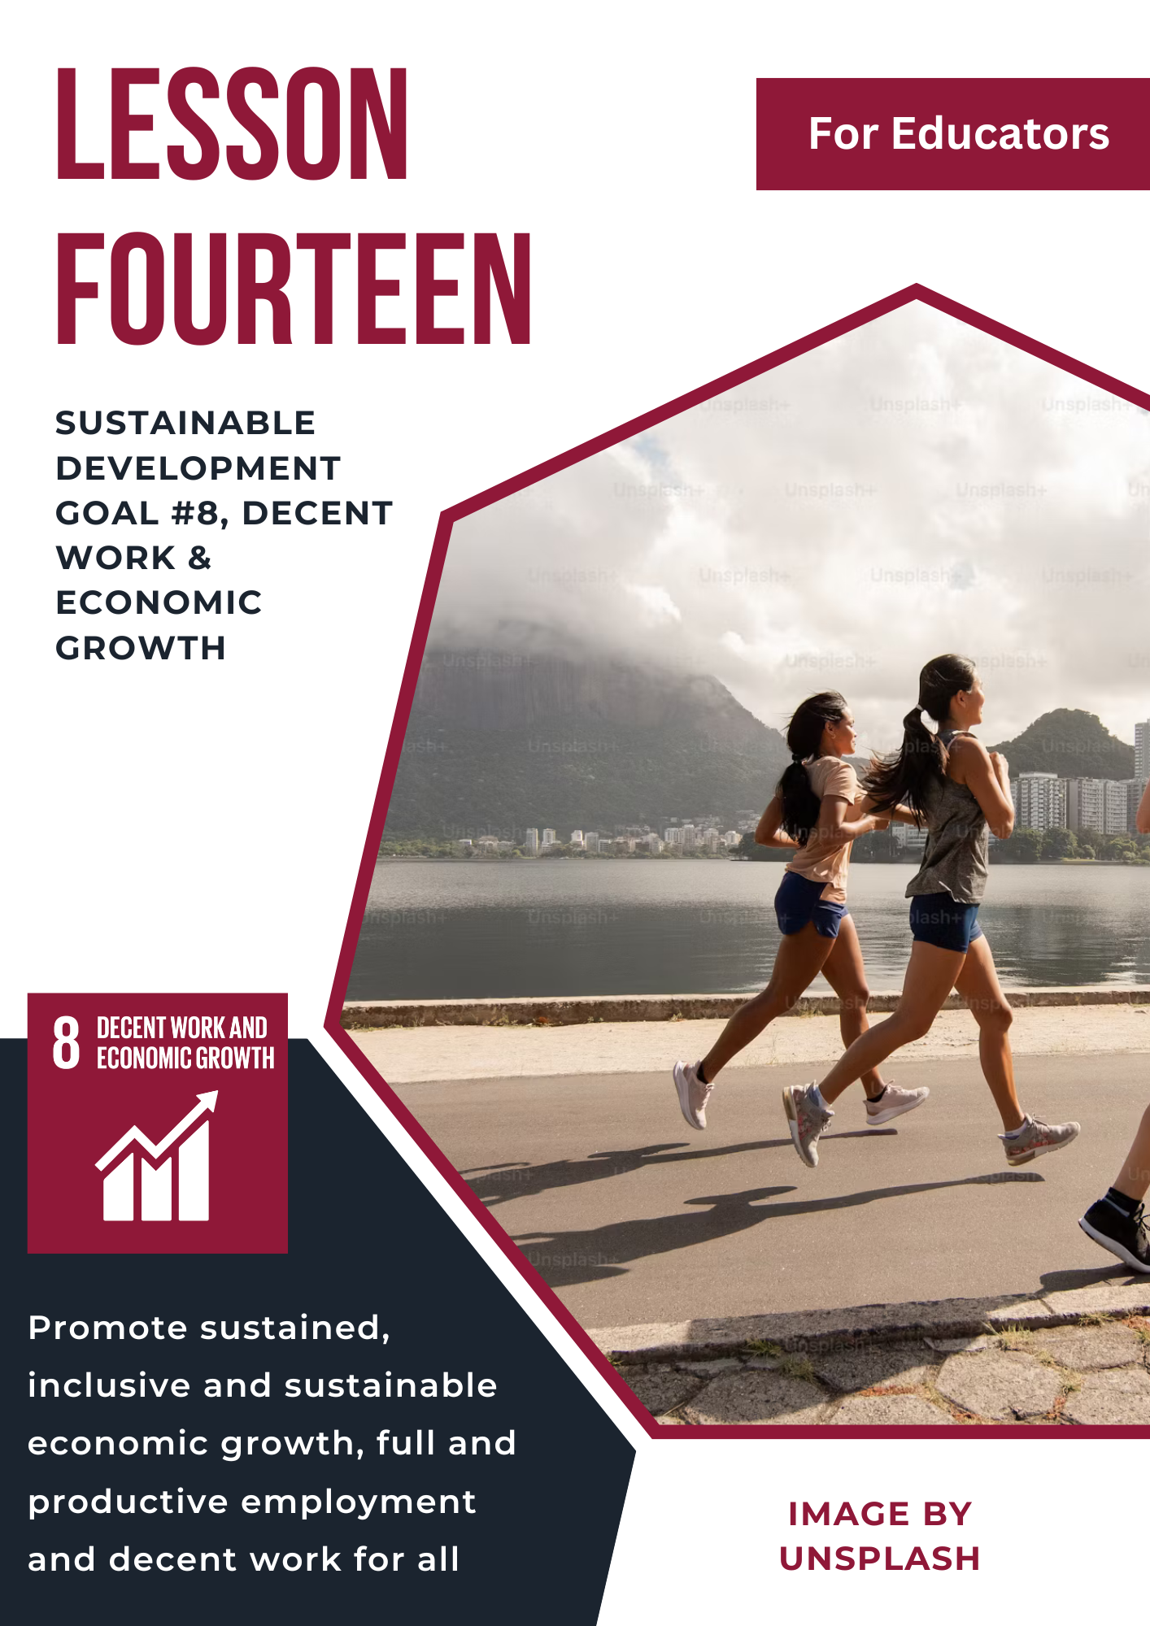

Lesson 14: Sustainable Development Goal #8: Decent Work and Economic Growth
Student Handout

Module Driving Question: Lessons 13, 14, & 15
(Note: Choose one or both of the following module driving questions depending on your goals)
- Why is it important for individuals and communities to create innovative and inclusive strategies for sustainable economic development and resilient communities?
- How can societies (locally, nationally, and globally) raise awareness and act to provide people with reliable work, responsible production and consumption, and sustainable cities or communities?

Lesson Driving Questions:
- What does “decent work” mean, what challenges exist for labor rights, and why is it important for people and communities around the world?
- How do economic growth and environmental sustainability connect, and can they coexist?
- Why is it important to end child labor and modern slavery, and what can we do to help?

Learning Targets – I Can:
- Identify, assess, and explain the challenges communities (local, national, global) face in providing decent work and sustainable economic growth.
- Identify, analyze, and explain the importance of providing fair wages and labor rights to people in all local, national, and global communities.
- Evaluate and explain the relationship between economic growth and environmental sustainability (and why it matters).
- Use my knowledge and critical thinking skills to evaluate real-world labor conditions and develop strategies for creating more inclusive and sustainable working communities.

Purpose
The purpose of this lesson is to provide students with a comprehensive understanding of global and local economic and labor challenges, with a focus on the importance of decent work and sustainable economic growth. Through exploration of the United Nations Sustainable Development Goal #8 (Decent Work and Economic Growth), students will examine issues such as fair wages, child labor, forced labor, employment equity, and the relationship between economic growth and environmental sustainability. By engaging in research, simulations, role-play, debates, and creative projects, students will develop critical thinking, empathy, and problem-solving skills to evaluate real-world labor conditions, analyze the impact of economic systems, and envision equitable solutions that support inclusive and sustainable development.

Lesson Vocabulary
decent work, economic growth, sustainability, fair wages, labor rights, child labor, forced labor, modern slavery, employment, informal economy, gig economy, unemployment, microenterprise, small and medium enterprises (SMEs), social protection, working conditions, human trafficking, gender equality in work, green jobs, productivity, ethical consumerism

Lesson Steps
1. Warm-Up Activity: What is Decent Work?
Begin by watching the video “Decent Work and Economic Growth.” Then, on the provided notes sheet or on a class discussion board, reflect on what “decent work” means to you. Why do you think the UN has made decent work and economic growth a global priority? What kind of work would you consider decent or not decent in your community or a specific country?

2. Introduction to SDG #8: Decent Work and Economic Growth
Watch the video “Sustainable Development Goal 8 – Decent Work and Economic Growth” to get an overview of SDG #8. Use the provided graphic organizer to note at least 5 major issues and goals associated with decent work and economic growth. After watching, in small groups of 3-4, discuss how these issues show up in both global and local contexts. Choose one issue to research further and share initial findings in a short roundtable discussion.

3. Exploring Labor Around the World: Decent vs. Exploitative Work
In pairs, choose one country to research using ILO data, Human Rights Watch reports, or other credible sources. Investigate what kinds of jobs are most common, and whether labor laws and worker protections are enforced. Compare this to working conditions in the U.S. or your community. Create a visual comparison chart and share your findings with the class.

4. Gallery Walk: Campaign Posters for Decent Work
Using your research from Activity #3, design a campaign poster that raises awareness about one labor issue (e.g., child labor, forced labor, low wages, lack of safety). Posters should include visuals, facts, and a clear call to action. Display your posters around the room and conduct a gallery walk. Use sticky notes to leave feedback or questions on classmates' posters.

5. Business Simulation: Starting a Fair Company
In teams of 3-4, create a business plan for a hypothetical company that supports decent work and economic sustainability. Decide what your business will sell, who your workers are, how you’ll ensure ethical labor practices, and how you’ll balance profit with people and planet. Present your pitch to the class. Consider how your company supports SDG #8 goals.

6. Forced Labor, Human Trafficking, and Modern Slavery
Read selected stories from the U.S. Department of Labor’s “List of Goods Produced by Child Labor or Forced Labor.” Then, visit the Walk Free Foundation website and explore the ways they are working to eradicate global slavery. In groups of 3-4, discuss the root causes of modern slavery. Create a “concept map” to show the connections between poverty, exploitation, and labor demand. Be prepared to share with the class.

7. Empathy in Action: Letters to a Worker or Lawmaker
Write a letter from the perspective of a worker experiencing unfair labor conditions, or to a policymaker advocating fair labor laws. Use research and facts from previous lessons to support your message. Exchange letters in class and respond as a peer or decision-maker. Reflect on what it means to advocate for change.

8. Local Labor Voices: Interview a Worker in Your Community
Choose someone in your community who has a job (this could be a family member, teacher, business owner, healthcare worker, etc.). Prepare a list of thoughtful interview questions that explore their daily work experience, job satisfaction, challenges, and how “decent” they feel their work is. Conduct the interview in person or virtually. Then, write a reflection or create a short presentation summarizing what you learned and how their experience connects to SDG #8.

9. Global vs. Local Labor Conditions: Case Study Comparison
Working in small groups, select a global labor issue and compare it to a similar issue in your community (e.g., wage inequality, job security, unsafe conditions). Use media, academic articles, or interviews to find evidence. Present your case study in a 3–5-minute presentation or infographic, highlighting key similarities, differences, and proposed solutions.

10. Apply What You’ve Learned: SDG #8 Showcase Project
Create a final project that showcases your understanding of SDG #8 and its importance. Choose from options such as:
- A public service announcement (video or audio)
- An infographic explaining one of SDG 8’s targets
- A children’s book or comic about decent work
- A zine or magazine article on labor rights

Present your project during a class showcase or community night.

Teacher Preparation Notes
Pacing and Strategy: The following outline provides a guide for teaching this lesson including approximate times (may vary), teaching strategies, suggested information for teacher created slides, and options for additional enrichment activities/summative assessments can be found at the end of the modules. This curriculum model was designed with teaching and learning strategies that could be adapted for in-person or virtual learning.

Lesson Timing: 4 hours (approximate)

Standards
Content | Standard
WA Social Studies | SSS1.6-8.1: Analyze positions and evidence supporting an issue or an event.  SSS3.6-8.1: Engage in discussion, analyzing multiple viewpoints on public issues.  E2.9-10.4: Analyze the relationship between the distribution of income and the allocation of resources in a variety of economies.  E2.11-12.5: Evaluate the effects of specialization, availability of resources, and technology on a variety of economies.  E2.11-12.7: Evaluate the relationship between the distribution of income and the allocation of resources in a variety of economies.
C3 Framework | D2.Geo.10.9-12: Evaluate how changes in the environmental and cultural characteristics of a place or region influence spatial patterns of trade and land use.  D2.Eco.15.9-12: Explain how current globalization trends and policies affect economic growth, labor markets, rights of citizens, the environment, and resource and income distribution in different nations.  D2.Eco.13.9-12: Explain why advancements in technology and investments in capital goods and human capital increase economic growth and standards of living.

Lesson Resources
For Students | For Educators | Materials
- Research Notes Worksheet  - UN Links to infographics and videos (see lesson details)  - Video and article links | - UN Links to infographics and videos (see lesson details)  - Video and article links | - Research Notes Worksheet  - Summative Assessment Options

Lesson Overview
In this lesson, students will gain a comprehensive understanding of SDG #8: Decent Work and Economic Growth, including its key targets and global relevance. The unit begins with an introduction to the foundational elements of SDG 8, focusing on the importance of inclusive and sustainable economic growth, full and productive employment, and decent work for all. Students will explore real-world economic challenges such as unemployment, informal labor, and economic inequality through interactive videos and group discussions. They will analyze issues like child labor, modern slavery, and the need for fair wages and safe working conditions, using global case studies to connect these concepts to the real lives of workers. Students will also investigate the role of small and medium enterprises and financial institutions in promoting economic development. By examining maps and data on global inequality, students will learn to identify disparities in access to decent work and economic opportunities. Through a hands-on worker interview, students will gain insight into local labor conditions and job experiences, fostering empathy and real-world connections. Additional creative activities, such as poster campaigns and gallery walks, encourage students to reflect on labor rights and become advocates for economic justice. By designing ethical businesses and participating in a "Build a Better World" gallery walk, students will synthesize their learning and propose sustainable, worker-friendly economic models. The unit concludes with a summative reflection on how students can take action toward creating more equitable economies. Through this lesson, students will build critical thinking, collaboration, empathy, and advocacy skills, equipping them to understand complex global labor systems and contribute to a fairer, more sustainable world.

Teacher Preparation
For Step #1: Begin by introducing the concept of “work” in both global and local contexts. Show the video “Decent Work and Economic Growth” to define SDG 8 and its significance. Facilitate a class discussion about what work means to students and the different forms it can take (e.g., formal, informal, self-employed). Provide a notes sheet or a class discussion board for students to reflect and distribute sticky notes or index cards for them to write down their definitions or thoughts, which can be shared aloud or posted on a classroom board.

For Step #2: Play the video “Sustainable Development Goal 8 – Decent Work and Economic Growth” to give students a broad overview of the goal. Provide a graphic organizer or notes sheet to capture key issues and targets from the video. After viewing, divide students into small groups to discuss the challenges highlighted, such as unemployment, labor rights, or economic growth. Have each group select one issue to explore more deeply and share brief insights with the class during a roundtable discussion.

For Step #3: Have students work in pairs to explore labor conditions in a country of their choice. Provide access to credible sources such as ILO databases, Human Rights Watch reports, or World Bank indicators. Share a visual chart template for students to compare common job types, wage equity, and labor protections in the chosen country versus their own community. Provide examples or guiding questions to help focus the comparison, then facilitate brief presentations.

For Step #4: Using the research from Step #3, ask students to create a campaign poster raising awareness about a labor issue such as child labor, low wages, or unsafe working conditions. Provide materials (paper, markers, or access to digital tools like Canva), as well as clear guidelines for including visuals, key facts, and a call to action. Set up a gallery walk in the classroom where students display their posters, then circulate and provide students with sticky notes and writing utensils to leave comments or questions on their peers’ posters.

For Step #5: Introduce the idea of socially responsible entrepreneurship by having student teams create a business plan that supports decent work. Provide a planning guide or worksheet that includes prompts about ethical hiring, fair wages, environmental practices, and global/local impact. Offer examples of mission-driven businesses and facilitate class pitches where each team shares how their company supports SDG 8 goals.

For Step #6: Prepare a selection of articles or story excerpts from the U.S. Department of Labor’s “List of Goods Produced by Child Labor or Forced Labor” and the Walk Free Foundation website. Guide students through reading and discussion of modern slavery and forced labor, emphasizing root causes such as poverty and inequality. Have students create a concept map to illustrate the connections among labor exploitation, demand for goods, and systemic injustice.

For Step #7: Facilitate a letter-writing exercise by first reviewing how to write from a specific perspective. Students can choose to write a letter from the point of view of an exploited worker or write directly to a policymaker or official advocating for fair labor practices. Provide sentence frames or sample letters to support students. After writing, arrange for peer exchanges or a read-aloud session, followed by reflective discussion about the power of advocacy.

For Step #8: Guide students in preparing for interviews with local workers. Provide sample interview questions and a consent form if students speak with someone outside the classroom. Help students identify potential interviewees, such as school staff, family members, or community workers. After conducting interviews, students should summarize what they learned in a reflection or short presentation that connects their findings to the concept of decent work.

For Step #9: Assign students to small groups to conduct a case study comparing a global labor issue to a local one. Offer topic ideas (e.g., gender wage gaps, workplace safety, or youth employment) and support students in accessing media, research articles, or community interviews. Each group should prepare a 3–5-minute presentation or infographic highlighting similarities, differences, and solutions related to both global and local labor contexts. Facilitate group presentations.

For Step #10: Review the final project options with students, such as creating a PSA, infographic, children’s book, zine, or article focused on a key SDG 8 issue. Provide rubrics and clear expectations for each option. Build in time for students to plan, create, and revise their projects. If possible, organize a class or school-wide showcase to present their work, and encourage students to reflect on their learning and action steps moving forward.

Lesson Plan in Detail

Step One: Warm-Up Activity – What is “Decent Work?” 20 minutes
Purpose: Introduce students to the concept of “decent work” as defined by the International Labour Organization (ILO), and why it matters locally and globally.

Slide 1:
- Prompt: Use a digital word cloud or whiteboard brainstorm – “What does decent work mean to you?”
- Embed: Video – “Decent Work and Economic Growth” (UN).
- Class Discussion: Review the ILO’s definition of decent work. Reflect on why the UN prioritized this as SDG #8.
- Question for Notes Sheet: What kind of work do you consider decent or not decent in your community?

Step Two: Introducing SDG #8 – Decent Work & Economic Growth: 20 minutes
Purpose: Understand the broader framework of SDG 8 and its relation to economic justice and sustainability.

Slide 2:
- Show: Overview of all 17 SDGs with focus on SDG 8.
- Embed: Video – “Sustainable Development Goal 8 – Decent Work and Economic Growth”
- Use: Guided notes worksheet to record key issues and goals.
- Small Group Discussion: How do SDG 8 challenges appear globally and locally?

Step Three: Global Labor Comparison: 60 minutes
Purpose: Students will compare labor conditions in another country with those in their own community.

Slide 3:
- Activity:
In pairs, students research a country of their choice using credible sources (ILO, Human Rights Watch, World Bank). Using a provided chart template, they compare:
  - Common job types
  - Wage equity
  - Labor protections
- Provide guiding questions to focus their analysis. Students give brief presentations on key findings and reflect on connections to their local context and SDG 8.
Step Four: Global Labor Conditions – Decent vs. Exploitative Work: 40 minutes
Purpose: Analyze how different countries enforce labor rights and compare to U.S. or local examples.

Slide 4:
- Research: In pairs, choose a country using ILO, Human Rights Watch, or Walk Free Foundation data.
- Create: Visual comparison chart of job types, labor laws, and protections.
- Present: Share comparisons with the class, highlighting equity or exploitation.

Step Five: Creative Campaigns – Gallery Walk for Decent Work: 40 minutes
Purpose: Synthesize research into an awareness campaign promoting fair labor.

Slide 5:
- Design: Create posters focusing on one labor issue (e.g., child labor, safety, wages).
- Include: Facts, visuals, and a call to action.
- Activity: Gallery walk with sticky-note feedback and peer questions.

Step Six: Business Simulation – Starting a Fair Company: 50 minutes
Purpose: Imagine ethical entrepreneurship that aligns with SDG 8.

Slide 6:
- In Teams: Create a business that supports decent work principles.
- Plan: What do you sell, who do you hire, how do you protect labor rights?
- Present: Give a short business pitch highlighting people, profit, and planet.

Step Seven: Forced Labor and Modern Slavery: 30 minutes
Purpose: Investigate root causes and consequences of global labor exploitation.

Slide 7:
- Read: U.S. Department of Labor’s “List of Goods Produced by Child Labor or Forced Labor.”
- Explore: Walk Free Foundation website.
- Group Work: Create a concept map connecting poverty, demand, and exploitation. Provide an example of a “concept map” and answer any questions students may have.

Step Eight: Empathy in Action – Letters for Change: 30 minutes
Purpose: Empower students to advocate for labor justice using empathy and evidence.

Slide 8:
- Write: A letter from a worker’s perspective OR to a policymaker.
- Use: Facts from previous lessons.
- Exchange & Reflect: Peer reviews in class; write brief reflection on the experience of advocating for decent work.

Step Nine: Local Labor Voices – Interview & Reflection: 45–60 minutes (over 2 sessions)
Purpose: Connect lessons to lived experiences in students’ communities.

Slide 9:
- Interview: A local worker (family member, business owner, etc.) about job satisfaction, challenges, and fairness.
- Prepare: 5–7 thoughtful questions.
- Reflect: Write a summary or create a short presentation on the interview and how it relates to SDG 8.

Step Ten: Global vs. Local – Labor Conditions Case Study: 60 minutes
Purpose: Explore parallels between global and local labor challenges and identify shared solutions.

Slide 10:
- Group Work: Choose one global labor issue (e.g., wage inequality) and compare it to your local context.
- Use: Articles, interviews, or data.
- Present: 3–5 min oral presentation or infographic showing comparisons and suggested solutions.

Step 11: Summative Assessment and Reflection: Time Will Vary
Purpose: There are different summative assessment options that allow students to demonstrate their learning in an innovative way. Students can choose from one of the project-based assessments identified in the appendix of this document. These projects allow students to further reflect on their understanding of SDG #8: Decent Work and Economic Growth and teachers can share this work with other students.

Slide 11: Give an overview of the summative assessment opportunities (project-based learning).

Students will demonstrate their understanding of the lesson's topics through a comprehensive exam based on their own questions. This exam will reflect their collective interests and learning, allowing them to showcase their knowledge and critical thinking skills.

Provide an overview of materials students will need for the exam and a reminder that this exam was inspired/developed by students.

Explore Further: Connecting the Local and the Global

The UN Sustainable Development Goals provide a great teaching opportunity to connect the “local” to the “global.” In this context, students can explore local organizations that are working toward SDG #8: Decent Work and Economic Growth in Washington State and the Pacific Northwest. Educators can use this opportunity to highlight the important role of NGOs, nonprofits, labor groups, and advocacy organizations in addressing workforce development, economic justice, and sustainable employment both locally and globally.

To start, here are some local organizations that support decent work, labor rights, and inclusive economic growth:

- Legacy of Equality, Leadership, and Organizing (LELO)
- GlobalWA
- Martin Luther King Jr. County Labor Council (MLKCLC)
- Career Connect Washington
- Landesa
- Northwest Labor Employment and Law Office (LELO)
- Greater Seattle Business Association (GSBA)
- Economic Opportunity Institute (EOI)
- Western Farm Workers Association (WFWA)

Attribution and License
Attribution
This Open Educational Resource, Cultivating Global Competence through the United Nations Sustainable Development Goals, was developed by Ryan Hauck, Julianna Patterson, and Global Classroom, World Affairs Council - Seattle.
Graphics:
- Cover image by Julianna Patterson from Canva.
- Sustainable Development Goals images copyright United Nations. All rights reserved. Used pursuant to fair use.
License

Except where otherwise noted, Cultivating Global Competence through the United Nations Sustainable Development Goals, by World Affairs Council of Seattle, is available under a Creative Commons Attribution-NonCommercial License. All logos and trademarks are the property of their respective owners. Sections used under fair use doctrine (17 U.S.C. § 107) are marked.
This resource may contain links to websites operated by third parties. These links are provided for your convenience only and do not constitute or imply any endorsement or monitoring by the World Affairs Council. Please confirm the license status of any third-party resources and understand their terms of use before reusing them.

