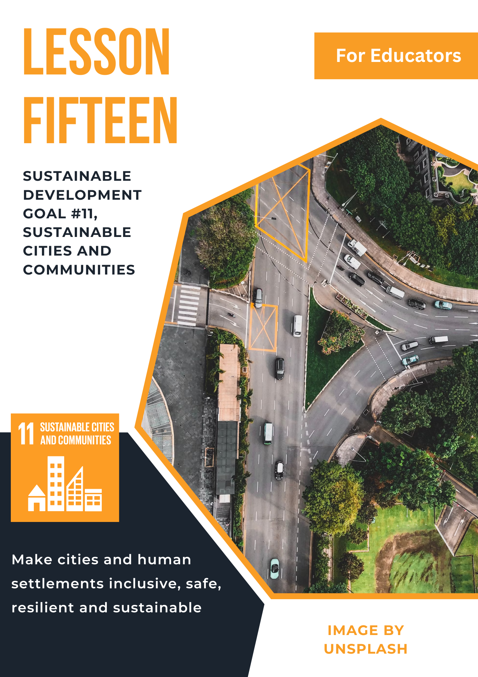

Lesson 15: Sustainable Development Goal #11: Sustainable Cities and Communities and Communities
Student Handout

Module Driving Question: Lessons 13, 14, & 15
(Note: Choose one or both of the following module driving questions depending on your goals)
- Why is it important for individuals and communities to create innovative and inclusive strategies for sustainable economic development and resilient communities?
- How can societies (locally, nationally, and globally) raise awareness and act to provide people with reliable work, responsible production and consumption, and sustainable cities or communities?

Lesson Driving Questions:
- What makes a city or community truly sustainable for everyone who lives there?
- How do global urbanization trends impact local communities and what can we do about it?
- How can we design cities that balance economic growth, environmental protection, and human well-being?

Learning Targets – I Can:
- Identify and explain the challenges cities or communities face in establishing sustainability for everyone living there.
- Identify and evaluate the factors that would lead cities or communities to be increasingly sustainable for their residents.
- Identify, analyze, and communicate urbanization trends and how they impact communities locally and globally.
- Use critical thinking skills and be innovative in designing a city or community that balances economic growth, environmental sustainability, and human well-being.

Purpose
The purpose of this lesson is to provide students with a comprehensive understanding of global and local challenges when it comes to urbanization and the sustainable development of good communities. Through exploration of the United Nations Sustainable Development Goal #11 (Sustainable Cities and Communities), students will examine issues such as affordable housing, public transportation systems, urban planning and sustainability, protection of cultural heritage, and the economic impact of cities. By engaging in research, simulations, role-play, debates, and creative projects, students will develop critical thinking, empathy, and problem-solving skills to evaluate real-world sustainability problems, analyze the impact of human settlements, and envision interconnected solutions that support inclusive and sustainable development.

Lesson Vocabulary
built environments, cities, clean safe water, climate change, community, development, energy, economy, ecology, ecological design, education, future proof, gentrification, geography, governance, gray/green divide, green space, housing, land rights, inequality, infrastructure, natural disasters, pollution, poverty, property rights/tenet rights, public health, public transportation, sanitation, security of tenure, settlements, slum, social equity, sociology, sustainability, redlining, regulation, retrofitting, traffic, urbanization, urban planning, urban development, urban renewal, urban resilience, urban sprawl, zoning
Lesson Steps
1. Introduction Video– The Story of Urbanization
Start by watching the video “Urbanization and the Future of Cities” from TED-Ed. After watching, reflect on how cities have changed over time and where they’re heading in the future. On a sheet of paper, write your thoughts about what cities will need to do to adapt as more people move into urban areas. Think about things like transportation, housing, green spaces, or new technologies. Can you see any of these issues already happening in a city like Seattle? Why do you think the United Nations chose sustainable cities as a global priority?

2. Identification Activity: What is a Slum?
Next, watch the video “What is a Slum?” to learn how the United Nations defines slums and why they exist. As you watch, complete the worksheet provided. This will help you understand the characteristics of slums and why some urban areas struggle to meet basic needs for their residents.

3. Understanding the Issues that Contribute to Slums
Read the article or watch the video titled, “The World's Largest Slums” to explore what daily life looks like in some of the world’s most overcrowded and underserved urban areas. Take notes on the challenges people face and think about what factors contribute to these conditions. Consider how poverty, government policies, and rapid population growth play a role.

4. Introduction to SDG #11: Sustainable Cities and Communities
Now that you’ve explored some of the problems cities face, it’s time to learn about the United Nations Sustainable Development Goal #11: Sustainable Cities and Communities. Read the “Goal-11_Fast-Facts.pdf” guide and complete the provided worksheet. Focus on understanding the key goals of SDG 11, including housing, transportation, resilience, and “future-proofing” cities to make them safer and more sustainable over time.

5. Exploring “Future-Proofing” Strategies
Working in small groups, your class will divide up the different “future-proofing” strategies from SDG 11. Each group will choose one strategy to research and present to the class. You will create visual or creative presentations (e.g. posters, slideshows, or brochures) that explain what the strategy is, why it matters, how it could be used in real cities, and what problems it helps solve.

6. Presenting Policy and Research
Each group will present their future-proofing strategy to the class or in small groups. As your classmates present, take notes on the provided graphic organizer to keep track of each solution. Try to understand how different strategies work together and which ones seem most important for cities like Seattle and others around the world. Be prepared to discuss with the class.

7. Understanding Urban Planning in the Context of History, Equity and Sustainability
Watch the Crash Course videos “What is Urban Planning?” and “Sustainable Cities” or read the article “Three Ways Urban Design Can Create Social Equity.” Use this information and engage in a class discussion or debate. You’ll explore questions like: What challenges do urban planners face? How can cities balance equity, sustainability, and cost? What are some trade-offs that happen when cities are designed and built? Try to connect what you learn to your own city or community.

8. Creative Solutions to Urban Development Questions
Watch the video “Urban Designer Answers City Planning Questions from Twitter” to hear a former New York City urban planner respond to common questions about how cities are built. Pay attention to ideas like building green cities, reducing traffic, and using smart technology. Take notes on strategies that could work in your city or that you’d want to include in a city you design yourself. Find a partner and share your ideas with each other.

9. What Do Urban Planners Actually Do?
Read the article “What is Urban Planning Today?” to learn about the profession of urban planning, the skills planners need, and how the government plays a role in shaping cities. Think about how this kind of planning is reflected in the cities you know. Where do you see good planning at work, and where might there be room for improvement? Be prepared to share your thoughts with the class.

10. Apply What You’ve Learned – SDG #11 Build a City Simulation
To bring everything together, you’ll design your own sustainable city using what you’ve learned throughout the lesson. You can work individually using Urban Planning Simulation Online Software or in small groups using posters, maps, or another creative format. Your city should reflect the goals of SDG #11 by addressing housing, transportation, sustainability, and equity. Think critically about how your city will meet the needs of its residents and grow responsibly into the future.

Teacher Preparation Notes
Pacing and Strategy: The following outline provides a guide for teaching this lesson including approximate times (may vary), teaching strategies, suggested information for teacher created slides, and options for additional enrichment activities/summative assessments can be found at the end of the modules. This curriculum model was designed with teaching and learning strategies that could be adapted for in-person or virtual learning.

Lesson Timing: 4.5 hours (approximate)

Standards
Content | Standard
WA Social Studies | SSS1.6-8.1: Analyze positions and evidence supporting an issue or an event.  SSS3.6-8.1: Engage in discussion, analyzing multiple viewpoints on public issues.  G2.9-10.1: Analyze human interaction with the environment across the world in the past or present.  E4.9-10.1: Evaluate how people across the world have addressed issues involved with the distribution of resources and sustainability.
Next Generation Science Standards | HS-PS4-4: Gather relevant information from multiple authoritative print and digital sources, using advanced searches effectively; assess the strengths and limitations of each source in terms of the specific task, purpose, and audience; integrate information into the text selectively to maintain the flow of ideas, avoiding plagiarism and overreliance on any one source and following a standard format for citation.  HS-ESS3-1. Construct an explanation based on evidence for how the availability of natural resources, occurrence of natural hazards, and changes in climate have influenced human activity.  HS-ESS3-1: Cause and Effect: Empirical evidence is required to differentiate between cause and correlation and make claims about specific causes and effects.
C3 Framework | D4.1.9-12: Construct arguments using precise and knowledgeable claims, with evidence from multiple sources, while acknowledging counterclaims and evidentiary weaknesses.  D2. Civ.14.9-12: Analyze historical, contemporary, and emerging means of changing societies, promoting the common good, and protecting rights.  D4.6.9-12: Use disciplinary and interdisciplinary lenses to understand the characteristics and causes of local, regional, and global problems; instances of such problems in multiple contexts; and challenges and opportunities faced by those trying to address these problems over time and place.  D2. Eco.15.9-12: Explain how current globalization trends and policies affect economic growth, labor markets, rights of citizens, the environment, and resource and income distribution in different nations.

Lesson Resources
For Students | For Educators | Materials
- Research Notes Worksheet  - UN Links to infographics and videos (see lesson details)  - Video and article links  - Simulation Platform | - UN Links to infographics and videos (see lesson details)  - Video and article links | - Research Notes Worksheet  - Simulation Platform

Lesson Overview
Through this lesson, students are meant to gain a comprehensive understanding of the UN’s Sustainable Development Goal 11: Sustainable Cities and Communities, including its key goals and its local and global importance. Students will learn about the challenges cities are facing to combat prevalent issues in cities today, such as climate change and slums, as well as what urban planning is and how it is connected to several other areas. Students will explore real-life issues such as pollution, the climate crisis, slums, poor living conditions, and social issues in city planning, such as gentrification. Students will engage in many different activities during this lesson to encourage different methods of learning, including group and independent work, projects, videos, reading, and hands-on simulations. To begin, students will be introduced to the concept of urbanization. From there, students will begin by understanding one of the most prominent issues the UN has identified: slums. Students will learn about the conditions that lead to the formation of a slum and how to begin to address this challenge. Then they will expand to understanding SDG 11, learning why the UN has identified this as an important issue and how it is being advised to address. Students will have the chance to explore one of the UN’s ‘future proofing’ goals by doing a mini research project to divide and conquer the class’s understanding of the goals as well as expand on their research and presentation skills. Next, students will shift to exploring how to address these issues through urban planning. Students will learn about the history and current environment of the field and the various perspectives and challenges involved in creating a city. Finally, using the knowledge they have gained and their own ideas, students will demonstrate their understanding of sustainable cities to build or revise their own city to create a clean, safe, and equitable space for all.

Teacher Preparation
For Step #1: Before beginning the lesson, preview the TED-Ed video “Urbanization and the Future of Cities” to ensure its age-appropriate and aligns with your learning goals. Prepare a few guiding reflection questions for students to consider while watching, such as: “What challenges do growing cities face?” or “What does urban sustainability mean to you?” Provide notebook paper or a digital reflection template for students to record their thoughts. After the video, be ready to lead a short discussion connecting the concept of urbanization to the students' local context such as changes they’ve noticed in Seattle or other nearby cities.

For Step #2: To prepare for this activity, queue up the short video “What is a Slum?” and print or distribute the corresponding worksheet. Introduce key terms like “slum,” “infrastructure,” and “informal housing” before the video to ensure students have the necessary vocabulary. Consider modeling one example from the worksheet together as a class to clarify expectations. You may also want to provide a brief explanation or visual of where slums are located globally to build geographic context.

For Step #3: Choose whether students will read the article “The World's Largest Slums,” watch the accompanying video, or use both, depending on time and learning needs. Provide students with a set of guided reading/viewing questions that help them focus on the causes of slums, daily challenges residents face, and any visible solutions. Introduce this activity with a reminder about class norms around empathy and respectful discussion, as the topic touches on global poverty and living conditions.

For Step #4: Download the UN’s “Goal-11_Fast-Facts.pdf” handout and review it ahead of time. Create a student-friendly worksheet to guide their reading and help them identify the main challenges and solutions outlined in SDG 11. Begin the activity with a short overview of the UN Sustainable Development Goals, highlighting the importance of SDG 11 and how urban sustainability connects to other goals. Encourage students to underline key terms or statistics in the factsheet.

For Step #5: Divide your class into small groups, assigning each group one of the future-proofing targets found in SDG 11, such as housing, transportation, disaster resilience, or access to green spaces. Provide a clear research framework that prompts students to define their topic, give real-world examples, explain why it matters, and propose solutions. Gather and share trusted online resources or printed materials in advance to support their research. Give students options for how they want to present their findings whether it’s a slideshow, poster, brochure, or another creative format.

For Step #6: Schedule time for presentations and decide whether students will present in front of the whole class or within smaller groups. Create a peer feedback form that students can use to document what they learn from each presentation. Before beginning, review expectations for respectful listening and ask students to prepare at least one follow-up question or compliment for each group. Consider modeling a sample presentation or rubric so students understand how they will be assessed.

For Step #7: Watch the two Crash Course videos (“What is Urban Planning?” and “Sustainable Cities”) ahead of time, and read the article “Three Ways Urban Design Can Create Social Equity.” Choose the resources that best suit your classroom time and student reading levels. Distribute the provide worksheet to help students identify the core ideas and trade-offs in urban planning. Prepare to lead a class discussion, seminar, or debate where students consider how to balance competing priorities such as equity, sustainability, and cost designing a city. You may want to provide local examples from your city or region to make the conversation more concrete.

For Step #8: Preview the video “Urban Designer Answers City Planning Questions from Twitter” and identify 2–3 main points or planning strategies to highlight during discussion. Prepare a short reflection sheet or think-pair-share questions for students to respond to after viewing. Review or pre-teach technical vocabulary terms used in the video, such as “zoning,” “density,” or “smart cities.” Encourage students to think of their own questions they would ask a city planner and share them with the class as a follow-up activity.

For Step #9: Print or share the article “What Is Urban Planning Today?” and decide how students will read it (independently, in small groups) or as a class. Review vocabulary words ahead of time and connect the reading to local or career-focused learning by discussing what skills urban planners need and how their work affects communities. You could extend the activity by highlighting job opportunities or educational pathways in urban planning, or by inviting a guest speaker to share about the profession.

For Step 10: Choose and test the Urban Planning Simulation online Software or hands-on activity you’ll be using in advance. Provide a clear project prompt and rubric that outlines essential elements students must include in their city designs—such as public transportation, green spaces, housing, and community services. Decide if students will work individually or in groups, and gather necessary materials like poster paper, markers, or laptops. Allow time for students to plan, build, and revise their cities before concluding with a gallery walk or presentations where students explain their design choices using what they’ve learned throughout the unit.

Lesson Plan in Detail

Step One: Warm-up Activity - What is Urbanization? 10 minutes
Purpose: Introduce students to the concept of urbanization as well as its historical background and begin to think about the future of cities and human societies.

Slide 1: Use a brainstorm prompt such as: “What is it like to live in a city?” Embed the TED Ed video “Urbanization and the Future of Cities” and see how students' perspective of cities changes.

Step Two: Exploring Slums: 10 minutes
Purpose: Students will learn the definition of a slum and understand what the conditions are like for the people who live there.

Slide 2: Overview of the 5 UN-designated characteristics that define a slum and how a community can fit the criteria to be designated as a slum. Embed Video: “What is a Slum?” Use the provided notes worksheet. Prompt discussion: What does life look like for people in slums?

Step Three: Understanding Slums: 10 minutes
Purpose: Students will examine what life is like inside a portion of the world’s slums. They will identify challenges the residents face, while also beginning to explore potential solutions to slums and urbanization.

Slide 3: Prompt: Understand what can be done to curb the growth of slums and improve the quality of life for people there based on what the article describes.

Step Four: Introducing SDG #11: 15 minutes
Purpose: Students will understand the context that led to the creation of SDG #11, why it is important, and what creating sustainable cities looks like.

Slide 4: Prompt: Read "What is Goal 11 – Sustainable Cities?" Compare worksheet responses with a partner.

Step Five: In-depth research into ‘Future-Proofing:’ 60 minutes
Purpose: Students will investigate one of the future-proofing goals in depth with a group and work together to decide on the best way to present their understandings and get the message of the importance of the goal and their solution across to the class.

Slide 5: Use future-proofing goals to create 6 groups and distribute the graphic organizer provided to support students in preparing for their strategy presentations.

Step Six: Presentations: 45 minutes
Purpose: Students will practice their presentation skills by sharing their research and proposal with the class or in small groups, depending on class needs.

Slide 6: Create an introductory slide for each group with an overview of the theme of their presentation.

Step Seven: Understanding Urban Planning: 40 minutes
Purpose: Students will explore the history and structure of urban planning and development and how urban planning can be made greener to create sustainable cities.

Slide 7: Embed Videos: “What is Urban Planning?” and “Sustainable Cities” and read “Three Ways Urban Design Can Create Social Equity.” Facilitate discussion on the challenges in urban planning.

Step Eight: Creative Solutions to Challenges in Urban Planning: 15 minutes
Purpose: Encourage students to think innovatively about addressing the issues in cities today as well as explore positive changes in urban areas today, while hearing insights from a real high-profile urban design expert.

Slide 8: Embed Video: “Urban Designer Answers City Planning Questions from Twitter”

Step Nine: What is Urban Planning Like: 10 minutes
Purpose: Students will learn about what it is like to work in urban design today, such as the government structure and interest groups that need to be represented.

Slide 9: Article: “What Is Urban Planning Today?” Discuss how there may be challenges to achieving sustainability in cities today, or how today’s society might facilitate sustainability.

Step Ten: Design or Revise a City: Time Will Vary
Purpose: Have students take the helm and demonstrate what they have learned by allowing them to explore the conflicting priorities in urban planning, the ways of making cities more sustainable and equitable and more.

Slide 10: Provide an overview of the project.

Students will demonstrate their understanding of the lesson's topics through their participation in rezoning or creating a city. Through the project, they will demonstrate understanding of the importance of sustainability in cities, and the process of urban planning and balancing crucial interests.

Explore Further: Connecting the Local and the Global

The UN Sustainable Development Goals provide a great teaching opportunity to connect the “local” to the “global.” In this context, students can explore local organizations that are working to build more sustainable, inclusive, and resilient communities in Washington State and the Pacific Northwest. Through this exploration, students gain insight into how cities are addressing global issues such as housing affordability, climate resilience, transportation, and equitable urban planning.

In addition, educators can use this opportunity to teach about the important role of NGOs, nonprofits, and community-based organizations in shaping sustainable development at both the local and global levels. These organizations play a vital role in driving policy change, engaging communities, and creating innovative solutions to the challenges that urban areas face.

To start, here are some local organizations that work towards a sustainable Seattle:

- Seattle's 2030 Vision - Personal Steps
- Sustainable Seattle
- Evergreen Sustainable Development Standard – WA Department of Commerce
- Urban League of Metropolitan Seattle
- Seattle Climate Action Plan
- Open Space Seattle 2100
- Puget Sound Partnership
- American Planning Association – WA Chapter

Attribution and License
Attribution
This Open Educational Resource, Cultivating Global Competence through the United Nations Sustainable Development Goals, was developed by Ryan Hauck, Julianna Patterson, Nadia Schwedrsky, and Global Classroom, World Affairs Council - Seattle.
Graphics:
- Cover image by Julianna Patterson from Canva.
- Sustainable Development Goals images copyright United Nations. All rights reserved. Used pursuant to fair use.
License

Except where otherwise noted, Cultivating Global Competence through the United Nations Sustainable Development Goals, by World Affairs Council of Seattle, is available under a Creative Commons Attribution-Noncommercial License. All logos and trademarks are the property of their respective owners. Sections used under fair use doctrine (17 U.S.C. § 107) are marked.
This resource may contain links to websites operated by third parties. These links are provided for your convenience only and do not constitute or imply any endorsement or monitoring by the World Affairs Council. Please confirm the license status of any third-party resources and understand their terms of use before reusing them.

