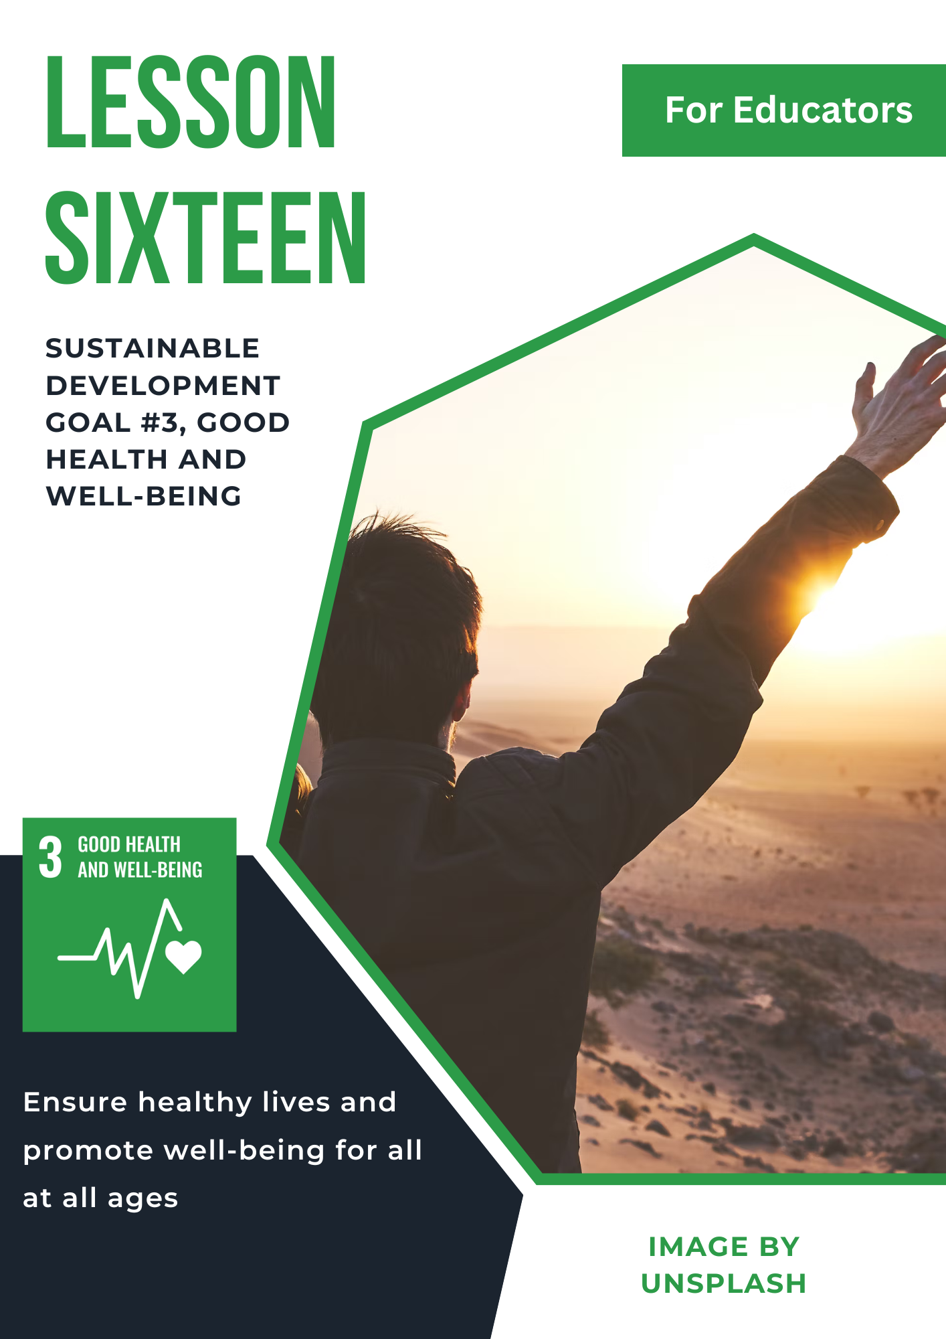
Lesson 16: Sustainable Development Goal #3: Good Health and Well-Being
Student Handout

Module Driving Question: Lessons 16 & 17
(Note: Choose one or both of the following module driving questions depending on your goals)
- What are global partnerships and why are they important in our increasingly interconnected and interdependent world?
- How can local and global partnerships address challenges around the world such as global health, economic development, climate change, and/or poverty?

Lesson Driving Questions:
- How can global efforts improve global healthcare systems and promote better living habits?
- What strategies can be used to adapt to changing technologies to make healthcare more affordable and accessible to all, with consideration to the main challenges facing health and well-being today?
- What are the main issues impacting global health coverage, including disparities in healthcare systems, accessibility barriers due to social and economic factors, technological gaps, or misinformation?

Learning Targets – I Can:
- Identify global health challenges and explain the historical and modern impacts of disease and pandemics.
- Analyze and explain how global health challenges such as access to medical care, spreading pandemics, or infectious diseases can impact communities in diverse local and national contexts.
- Identify and assess health care disparities around the world and develop potential solutions with my peers.
- Use critical thinking and research skills to evaluate sources of information on global health.

Purpose
The purpose of this lesson is to provide students with a comprehensive understanding of global and local health challenges, focusing on the historical and modern impacts of diseases and pandemics. Through exploration of the United Nations Sustainable Development Goal #3 (Good Health and Well-Being), students will analyze health challenges such as malnutrition, obesity, and health misinformation; social and economic disparities; healthcare systems; and the future of healthcare. By engaging in research, class discussions, and collaborative projects, students will develop critical thinking and problem-solving skills to evaluate real-world problems and analyze relevant health challenges and inequalities in a global context.

Lesson Vocabulary
pandemic, epidemic, vaccination, tuberculosis, malaria, HIV/AIDS, universal health coverage, vulnerable population groups, immunization, infectious diseases, maternal mortality, infant mortality, sustainable health systems, preventative care, obesity, pollution, healthcare worker shortage, life expectancy, malnutrition

Lesson Steps
- Warm-up Activity - History of Diseases and Pandemics: Learn about some of the diseases throughout human history in the video “The Diseases That Changed Humanity Forever” As a supplement, look at this timeline from the article “A Visual History of Pandemics” which highlights various pandemics throughout history. In a short reflection (written or verbal), answer: How have major pandemics changed healthcare systems and the way we live today?

- Introduction to SDG #3: Watch the following video “Sustainable Development Goal 3 – Good Health and Well Being” introducing the United Nations (UN) SDG #3: Good Health and Well-Being. Utilizing the provided notes sheet, document at least 5 global health challenges highlighted throughout the video. Think about how these challenges manifest in the United States. Have any of these challenges impacted your own life and community?

After the video, break into small groups of 3-4 and select one of the challenges introduced in the video to research in more depth. How has this challenge impacted healthcare and sustainable health systems, both locally and globally? What steps is the UN taking to provide solutions to this challenge? Be prepared to share your ideas in a large group discussion.

- Exploring SDG #3: Good Health and Well-Being in Depth: Now that you have a better understanding of the foundations of SDG #3, review all 13 targets within the goal that the UN is working to address. In your same groups, choose one target and examine its impact on a particular community, citing a real-world example, locally or globally.

Prepare a short presentation (3-5 minutes) to share with the class discussing your findings. Make sure to include at least 1-2 open-ended discussion questions at the end of the presentation for your classmates to consider. As a class, discuss why these targets are important to ensure better health outcomes.

- Understanding the US Healthcare System: Next, in small groups, research how health insurance works in the US and use the Health Insurance Coverage in the United States document for more detail. You can see the differences between Private Coverage and Public Coverage, or coverage type by household income. Examine some of the tables for more insights into different characteristics impacting insurance coverage. Consider how factors such as financial hardship or age may affect health coverage and access to healthcare. Share your insights with the class.

- The Effect of Social and Economic Inequality on Health Disparities: Consider how there might be health disparities in the US as a result of social and economic inequality. Please watch the following videos “Health and Healthcare Disparities in the US | Social Inequality | MCAT” from Khan Academy introducing the concept. This video “Health Inequity: America’s Chronic Condition? | Esteban López | TEDxSanAntonio” discusses health inequalities and their impact on health disparities in the US. This video from BBC “The Shocking Reality of Health Inequality” also examines racial inequality in the healthcare system in modern Britain. What are some insights you gained from these videos? If you could suggest one solution to decrease inequalities and health disparities, locally and globally, what would it be? Please be prepared to share with the class.

- Food Security & SDG #3: Watch this short video “The Reality of Malnutrition Among Children” about malnutrition among children, then read the article “Global Malnourishment: 1 in 8 People are Obese” discussing global malnourishment from Deutsche Welle. What are some interesting observations you can make from the obesity and/or underweight graphs? How do these trends seem to be similar or different across countries? What are the consequences of food insecurity on the health and well-being of communities worldwide? Discuss your observations in small groups of 3-4 and be prepared to share your group’s insights.

- Health Misinformation: Read the article “Medical Misinformation Harms People from Communities that are Marginalized” from Johns Hopkins Center for Health Equity about medical misinformation. This article “COVID: Top 10 Current Conspiracy Theories” lists some of the top conspiracy theories circling the Internet during the COVID-19 pandemic. Partner up with another classmate and discuss any myths you heard during the pandemic? How was misinformation exacerbated during the COVID-19 pandemic? How do educational levels and social characteristics impact mistrust and perceptions of health and potential conspiracy theories?

- Global Health Framework: Review the CDC Global Health Strategic Framework. Familiarize yourself with the four global goals and how the six core capabilities can impact and improve healthcare systems within the context of SDG#3 and the targets set by the UN.

- The Future of Healthcare: Explore the following article “How These Health Systems Are Transforming Chronic Disease Care” highlighting several health systems transforming chronic disease care for the better. Additionally, read about online care models in “The Future of Healthcare.” Using the provided notes sheet, identify 1-2 systems or innovative ways to deliver care in the future and highlight the pros and cons of each system in relation to achieving UN SDG #3.

- Apply what you have learned about the UN SDG #3 by completing one of the summative assessments identified by your teacher.

Teacher Preparation Notes
Pacing and Strategy: The following outline provides a guide for teaching this lesson including approximate times (may vary), teaching strategies, suggested information for teacher created slides, and options for additional enrichment activities/summative assessments can be found at the end of the modules. This curriculum model was designed with teaching and learning strategies that could be adapted for in-person or virtual learning.

Lesson Timing: 4 hours (approximate)

Standards
Content | Standard
WA Social Studies | SSS1.6-8.1: Analyze positions and evidence supporting an issue or an event.  SSS1.9-12.5: Explain the challenge and opportunities of addressing problems over place and time using disciplinary and interdisciplinary lenses.  C4.11-12.4: Evaluate citizens’ and institutions’ effectiveness in addressing social and political problems at the local, state, tribal, national, and/or international level.  E2.11-12.7: Evaluate the relationship between the distribution of income and the allocation of resources in a variety of economies.
Next Generation Science Standards | HS-PS4-4: Gather relevant information from multiple authoritative print and digital sources, using advanced searches effectively; assess the strengths and limitations of each source in terms of the specific task, purpose, and audience; integrate information into the text selectively to maintain the flow of ideas, avoiding plagiarism and overreliance on any one source and following a standard format for citation.  HS-ESS3-1: Cause and Effect: Empirical evidence is required to differentiate between cause and correlation and make claims about specific causes and effects.
C3 Framework | D1.2.9-12: Explain points of agreement and disagreement experts have about interpretations and applications of disciplinary concepts and ideas associated with a compelling question.  D2.Civ.13.9-12: Evaluate public policies in terms of intended and unintended outcomes, and related consequences.  D2.Eco.1.9-12: Analyze how incentives influence choices that may result in policies with a range of costs and benefits for different groups.  D2.His.14.9-12: Analyze multiple and complex causes and effects of events in the past.

Lesson Resources
For Students | For Educators | Materials
- Research Notes Worksheet  - UN Links to infographics and videos (see lesson details)  - Video and article links | - UN Links to infographics and videos (see lesson details)  - Video and article links | - Research Notes Worksheet  - Summative Assessment Options
Lesson Overview
In this lesson, students will gain a comprehensive understanding of SDG #3: Good Health and Well-Being, including its key targets and their significance. Students will begin by examining the historical impact of pandemics and diseases, connecting these events to the development of modern healthcare systems and societal changes. Students will then evaluate the 13 targets set by the UN related to SDG #3 and document key global health challenges while reflecting on how these challenges manifest in their own communities. By examining the structure and accessibility of the U.S. healthcare system, students will learn about health insurance coverage, disparities based on socioeconomic factors, and financial hardships. This analysis extends to the broader issue of health disparities, as students will explore social and economic inequalities and how these create inequities in healthcare systems both in the U.S. and globally. Additionally, they will explore the impacts of malnutrition, obesity, and food insecurity by analyzing trends across countries and discussing the consequences for community health. They will study the harmful effects of medical misinformation, particularly during the COVID-19 pandemic, while considering how educational and social factors shape perceptions and responses to health information. The lesson concludes with an exploration of global health frameworks and a forward-looking approach to emerging innovations in disease care and online healthcare models. Students will apply their learning by completing a summative assessment designed to integrate their insights on health challenges, disparities, and solutions while fostering critical thinking and collaboration. These takeaways will equip students with the knowledge, critical thinking skills, and collaborative mindset needed to contribute to environmental sustainability and restoration efforts.

Teacher Preparation
For Step #1: Show the video “The Diseases That Changed Humanity Forever.” As a supplement, use this timeline from the article “A Visual History of Pandemics” as this will provide students with a general idea of the various pandemics throughout history.

For Step #2: Play the video “Sustainable Development Goal 3 – Good Health and Well Being” to introduce SDG #3: Good Health and Well-Being. Provide students with the note sheet document for students to fill out as they are watching the video. After the video, break the students up into groups of 3-4 to discuss the challenges in the video and have a short discussion on how the challenges have had local and global effects.

For Step #3: Have students navigate to view all 13 targets within the goal that the UN is working to address. In the same discussion groups, students will research one target of their choosing and examine its impact on a particular community, citing a real-world example, locally or globally. Make sure there is no overlap between groups as they are choosing targets. Guide students as they make short 5-minute presentations on their research, and make sure they have included 1-2 discussion questions at the end for other students to respond to.

For Step #4: Students will research how health insurance works in the US and use the Health Insurance Coverage in the United States document for more detail. Provide an example of how they could analyze one of the graphs, such as Private Coverage vs. Public Coverage rates or coverage type by household income. Guide them to consider how factors such as financial hardship or age may affect health coverage and access to healthcare and have them share their insights.

For Step #5: Show the video “Health and Healthcare Disparities in the US | Social Inequality | MCAT” to introduce students to some of the disparities in the healthcare system. Next, play this video “Health Inequity: America’s Chronic Condition? | Esteban López | TEDxSanAntonio” and this video from BBC “The Shocking Reality of Health Inequality.” Both of these videos examine racial inequality in the healthcare system. Facilitate open-ended discussion about the social disparities in the healthcare system.

For Step #6: Play this video “The Reality of Malnutrition Among Children” to introduce another global health challenge. Afterwards, provide students with the article “Global Malnourishment: 1 in 8 People are Obese.” Encourage students to remark on trends and make observations from the graphs to reflect on the consequences of food insecurity on the health and well-being of communities worldwide.

For Step #7: Provide students with the article “Medical Misinformation Harms People from Communities that are Marginalized” to introduce the topic of medical misinformation. Show the article “COVID: Top 10 Current Conspiracy Theories.” Ask students if they had heard of any of these myths and how they noticed the spread of misinformation during the COVID-19 pandemic. Discuss factors that could impact the level of mistrust and perceptions people hold towards health authorities.

For Step #8: Show students the CDC Global Health Strategic Framework. Discuss the four global goals and the six core capabilities and how they can impact and improve healthcare systems within the context of SDG#3 and the targets set by the UN.

For Step #9: Provide the article “How These Health Systems Are Transforming Chronic Disease Care” and read about online care models in “The Future of Healthcare.” Ask students to reflect on how healthcare could look different in the future. Provide the notes sheet for students to explore 1-2 of the systems described and facilitate a discussion on the pros and cons of innovations in healthcare in relation to achieving SDG #3.

For Step 10: If you are going to assign one of the summative activities, review the options and see what options you would like to make available to students.

Lesson Plan in Detail

Step One: Warm-up Activity - History of Diseases and Pandemics: 20 minutes
Purpose: Students will get a brief introduction into various diseases and pandemics that have affected human society throughout history.

Slide 1: Embed article, “A Visual History of Pandemics.” Embed video, “The Diseases That Changed Humanity Forever.”

Step Two: Exploring SDG #3: Good Health and Well-Being: 20 minutes
Purpose: Students will gain an initial understanding of SDG #3: Good Health and Well-Being and its key targets. They will begin to recognize the challenges facing global health targets and the importance of adopting sustainable practices.

Slide 2: UN SDG overview slide of the 17 goals. Overview slide of SDG #3. Embed video, “Sustainable Development Goal 3 – Good Health and Well Being.” Use the provided worksheet for taking notes. Prompt for class discussion.

Step Three: Presentations – Exploring SDG #3 Targets Depth: 60 minutes
Purpose: Students will conduct in-depth research on additional targets of SDG #3, enhancing their understanding of various aspects of global health targets (3.1-3.D). They will develop skills in information gathering, critical thinking, and collaborative discussion by working in small groups and sharing their findings through a presentation.

Slide 3: Embed article, 13 targets. Presentations made by student groups.

Step Four: Understanding the US Healthcare System: 20 minutes
Purpose: Students will learn about the functions of the insurance industry in the US and how it works. They will evaluate different social and economic factors that correlate with insurance coverage and use critical thinking skills to analyze their findings.

Slide 4: Embed articles related to health insurance, “Health Insurance Coverage in the United States,” and “Aging and Health.”

Step Five: The Effect of Social and Economic Inequality on Health Disparities: 30 minutes
Purpose: Students will comprehend the social and economic inequalities that exist throughout the healthcare system, recognizing how demographics such as race can impact the care received by the patient. They will discuss insights from the video and explore the global community's role in addressing these challenges.

Slide 5: Embed video(s), “Health and Healthcare Disparities in the US | Social Inequality | MCAT,” “Health Inequity: America’s Chronic Condition? | Esteban López | TEDxSanAntonio,” and “The Shocking Reality of Health Inequality.”

Reflection prompt for discussing the connection between race and mortality rates.

Step Six: Present-Day Health Challenges, Locally & Globally: 20 minutes
Purpose: Students will enhance their knowledge of health challenges through malnutrition and obesity. They will reflect on what they have learned and share insights with peers, developing a nuanced understanding of the benefits and challenges associated with food insecurity across the world.

Slide 6: Embed video, “The Reality of Malnutrition Among Children.” Embed article, “Global Malnourishment: 1 in 8 People are Obese.”

Step Seven: Health Misinformation: 30 minutes
Purpose: Students will develop skills in digital communication with the analysis of medical misinformation. Students will also use critical thinking skills to understand the dangers of widespread conspiracy theories, myths, and mistrust.

Slide 7: Embed articles, “Medical Misinformation Harms People from Communities that are Marginalized,” and “COVID: Top 10 Current Conspiracy Theories.”

Step Eight: Global Health Framework: 20 minutes
Purpose: Students will evaluate the CDC’s Global Health Strategic Framework and how there are actionable solutions to address various health challenges. By doing so, students are able to relate what they have learned in class to potential real-world applications

Slide 8: Embed article, “CDC Global Health Strategic Framework.”

Step Nine: The Future of Healthcare: 20 minutes
Purpose: Students will examine the future of healthcare and healthcare systems. Using what they have learned about historical and current health issues, students will now take a forward-looking approach where they evaluate how patient care and hospital visits may look different in the future. Students should also incorporate SDG #3 targets in their analysis, highlighting the pros and cons of innovative approaches to the future of healthcare.

Slide 9: Embed article(s), “How These Health Systems Are Transforming Chronic Disease Care,” and “The Future of Healthcare.”

Step Ten: Summative Assessments: Time Will Vary
Purpose: There are different summative assessment options that allow students to demonstrate their learning in an innovative way. Students can choose from one of the project-based assessments identified in the appendix of this document. These projects allow students to further reflect on their understanding of SDG #3: Good Health and Well-Being and teachers can share this work with other students.

Slide 10: Give an overview of the summative assessment opportunities (project-based learning).

Students will demonstrate their understanding of the lesson's topics through a comprehensive exam based on their own questions. This exam will reflect their collective interests and learning, allowing them to showcase their knowledge and critical thinking skills.

Overview of materials students will need for the exam. Reminder that this exam was inspired/developed by students.

Explore Further: Connecting the Local and the Global

The UN Sustainable Development Goals provide a great teaching opportunity to connect the “local” to the “global.” In this context, students can explore local organizations that are working on improving global health in Washington State/the Pacific Northwest. In addition, educators can teach about the important role of NGOs or non-profit organizations in addressing local and global issues.

To start, here are some local organizations that work on a variety of global health initiatives:

- Bill & Melinda Gates Medical Research Institute
- Fred Hutch Cancer Center
- Life Science Washington
- GlobalWA
- Washington Global Health Alliance
- Refugee Women’s Alliance
- Team Survivor Northwest
- PATH Seattle
- NAMI Washington
- Feeding America
- Food Lifeline

Attribution and License
Attribution
This Open Educational Resource, Cultivating Global Competence through the United Nations Sustainable Development Goals, was developed by Ryan Hauck, Julianna Patterson, Lydia Tu, and Global Classroom, World Affairs Council - Seattle.
Graphics:
- Cover image by Julianna Patterson from Canva.
- Sustainable Development Goals images copyright United Nations. All rights reserved. Used pursuant to fair use.
License

Except where otherwise noted, Cultivating Global Competence through the United Nations Sustainable Development Goals, by World Affairs Council of Seattle, is available under a Creative Commons Attribution-Noncommercial License. All logos and trademarks are the property of their respective owners. Sections used under fair use doctrine (17 U.S.C. § 107) are marked.
This resource may contain links to websites operated by third parties. These links are provided for your convenience only and do not constitute or imply any endorsement or monitoring by the World Affairs Council. Please confirm the license status of any third-party resources and understand their terms of use before reusing them.

