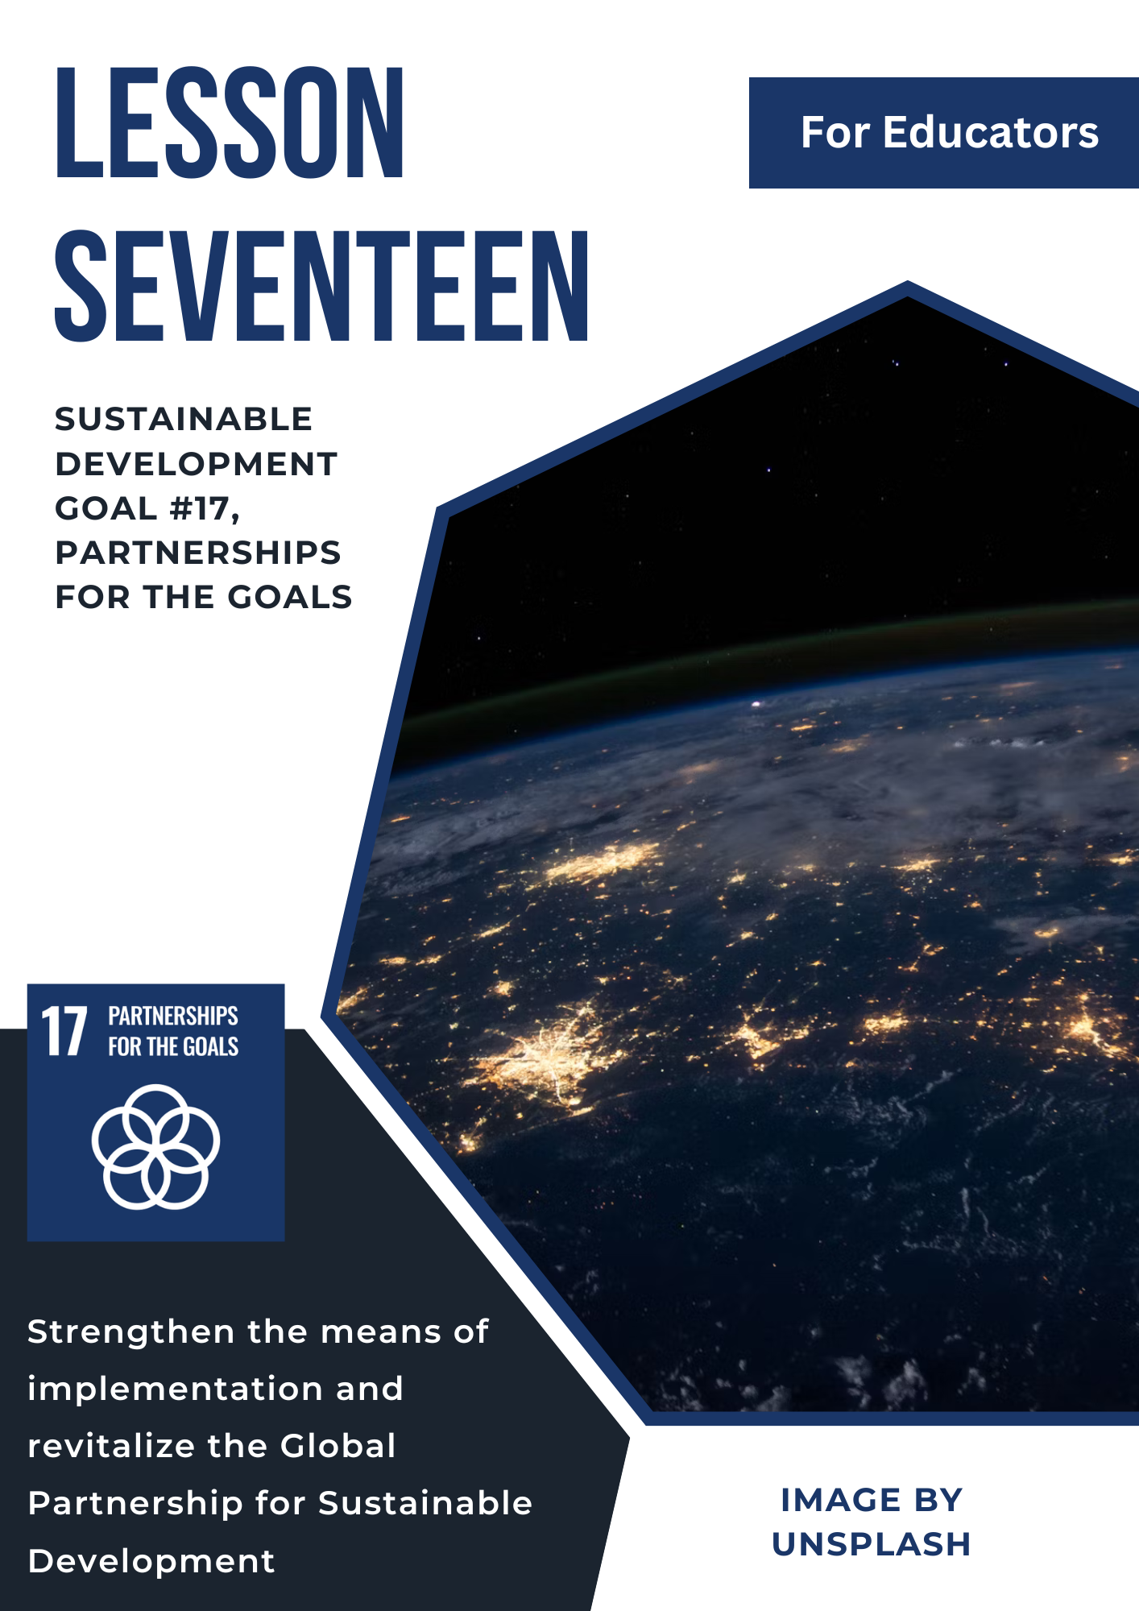
Lesson 17: Sustainable Development Goal #17:

Partnerships for the Goals

Student Handout
Module Driving Questions: Lessons: 16 & 17
(Note: Choose one or both of the following module driving questions depending on your goals)
- What are global partnerships and why are they important in our increasingly interconnected and interdependent world?
- How can local and global partnerships address challenges around the world such as global health, economic development, climate change, and/or poverty?

Lesson Driving Questions:
- Why are partnerships among local, national, and global communities important for developing policies or actions that can make progress toward achieving all the UN Sustainable Development Goals?
- How does investment in local, national, and international organizations strengthen global health care in countries around the world?
- What can individuals and groups do to educate themselves and act on local and global issues?

Learning Targets – I Can:
- Identify and explain how issues such as global health, economic development, climate change, and/or poverty are being addressed by local and global partnerships.
- Identify and evaluate the role of local and global partnerships in addressing the goal(s) of SDG #17.
- Analyze and explain how individuals and groups can work together to achieve progress on all 17 of the UN Sustainable Development Goals.

Purpose
In this lesson, you will explore United Nations Sustainable Development Goal #17: Partnerships for the Goals. You will engage in a series of individual and collaborative learning activities to better understand how all the UN SDGs can be better achieved through collaborative planning, investment, and action. In small groups, you will assess how local, national, and global communities are working together to address issues such as global health, economic development, climate change, and/or poverty reduction though institutions, organizations, and public-private partnerships. You will evaluate how partnerships, locally and globally, can improve the lives of billions of people around the world through effective and collaborative strategies. As the world becomes increasingly interconnected and interdependent, people within and outside of government must work together to make the communities around the world more sustainable. Therefore, you will engage in activities that require you to explore various partnerships within and across local and national contexts to achieve SDG 17. Whether in your own community or thousands of miles away, you have the capacity to make a difference in solving our most challenging issues. As you develop the knowledge and skills to face these challenges individually and collectively, you will do your part in making the world a better place. Overall, this lesson will enhance your understanding of the partnerships taking place to achieve the UN SDGS by 2030.

Lesson Vocabulary
resource mobilization, sustainability, capacity building, non-governmental organization (NGO), global health, climate change, food insecurity, gender equality, universal education, investment, Official Development Assistance (ODA), pandemic, inflation, debt relief, equitable trading system, United Nations, exports, innovation, sustainable technologies, environmental policies, economic stability, poverty eradication, World Trade Organization (WTO), multi-stakeholder partnerships, civil society, International Monetary Fund (IMF)

Pre-Lesson Context
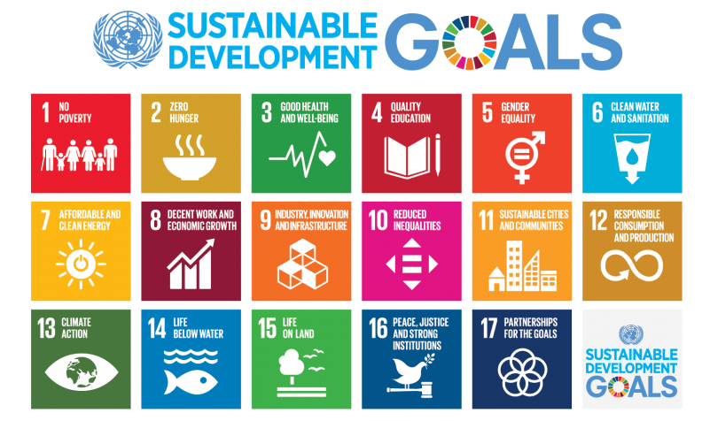
As you work through the lesson activities in this module, be thinking about all the UN Sustainable Development Goals shown in the image below. Which one are you most interested in exploring in more depth? How would you organize your classmates, friends or families to collectively make a difference in achieving progress on the goal? Are there local or global organizations you could volunteer to join to work on this goal?

Lesson Steps
- Warm-Up Activity #1: Think-Pair-Share: Examine the UN SDG 17 image and pick out key words and phrases that you think are important. Next, analyze the UN mini poster characterizing SDG 17. What is the illustrator trying to convey about the significance of SDG 17? In your notebook, write your take-aways or initial conclusions by looking at the two images and be ready to discuss your ideas with a classmate or during large group discussion.
2. Warm-Up Activity #2: After listening to and sharing your thoughts with classmates, look at the image of the 17 SDG categories. Which one(s) are you most interested in and why do you think the UN has identified that issue as important? How does the issue represent a challenge (for example, no hunger or climate action) locally, nationally, and/or globally. What is one question you have about the issue? Briefly, write down your thoughts in your notebook and be ready to share your ideas with your class.
3. “Speed-Dating” Activity: Your teacher will give you a statistic or topic related to the UN SDG #17: Partnerships for the Goals. Your task in this activity is to find your “match.” If you have a statistic, find your topic partner. If you have a topic, you need to find your statistical partner. Communicate with your classmates and look for the appropriate partner, and when you find that person, stand next to them and be prepared to share your connection.

4. Key Concept Exploration: Non-Governmental Organizations (NGOs) and their role in creating partnerships to achieve the UN Sustainable Development Goals. When you hear the word non-government organization (NGO), what do you think it means? What kind of role do NGOs play in addressing issues like climate change, ending hunger, promoting education for all, reducing inequalities, or supporting gender equality? If you worked for an NGO, what do you think you would do? Briefly, write down your ideas in your notebook and then share them with the class.

Next, consider the concept “capacity building.” What is capacity building and do you think NGOs or other organizations (and individuals) play a role in enhancing the ability of people to achieve local, national, and/or global goals (like the ones identified above). What would “capacity-building” look like (hint: one example could be promoting leadership development). Think about your school: How could you build the “capacity” of your school to achieve its goals? After you write down your ideas, your teacher will lead you through a class discussion on the importance of capacity build, the role of organizations or other groups in this process, and why this makes a difference in accomplishing the goals set out in the SDGs. Scroll down to “links” and see some of the organizations that are involved as UN partners on sustainable development.

*Additional Key Concept Suggestion: What does the term or concept “civil society” mean? NGOs play an important role in the development of civil society, both locally and globally. Civil society groups can include other organizations such as community groups, labor unions, foundations, think-tanks, or social movement groups that are involved in advocacy, development work, promoting the delivery of services (like health care), and monitoring government institutions. How are these groups involved in supporting “capacity building” around good health or any of the other United Nations Sustainable Development Goals?

5. NGOs, Capacity-Building, and Local Connections: You and a partner (or small group) will explore the work of a local NGO (or other organization) that is creating partnerships to address one of topics described in SDG 17 or one of the other 16 SDGs (your teacher will explain the options to you and provide more specific directions). As you research the organization, examine its mission, goals, activities or projects, and success they have had in addressing this issue. For example, perhaps you are looking at a local organization whose mission is to clean up water resources (“Life Below Water SDG connection) in the Pacific Northwest to promote environmental sustainability. Are they partnering with other organizations, government bodies, or individuals? If so, how? If not, how could they enhance their progress by creating collaborative partnerships? Are there opportunities to volunteer and take action with this group? Write down what you learned from your research in your notebook.

Next, you will engage in a Jigsaw Activity: When you are done, your teacher will mix you into small groups where you can share what you have learned about your organization and its efforts to create partnerships and “build capacity” for achieving their goals. As an extension activity, consider calling or emailing the organization (or having a class Zoom session) to learn more about their work.

Note: If you are not in Puget Sound Region or in Washington State, consider researching your own local
context to evaluate what they are doing to create partnerships around one or more of the 17 SDGs.

6. Diving Deeper into SDG #17 Targets: Partnerships for the Goals: There are a total of 17 critical targets. It’s now time to delve deeper into the targets. Visit the UN SDG #17 link to explore the targets in more depth in small groups of 3 or 4. First, take some time to examine all the targets and their indicators. Are there one or two targets that you think would be most impactful? Why?

Next, individually, conduct an in-depth exploration of one of the targets and prepare to share your findings in a large group discussion. Examine the progress being made here and think about what has been accomplished and what challenges remain. As part of this process, complete a WebQuest and find an article on the topic of your specific target. Read and analyze the article and then write a brief, one-to-two sentence summary. Provide 2 or 3 examples as evidence for your statement. Use the provided graphic organizer to structure and collect your insights.

7. Financial and Technological Challenges: One of the challenges facing the targets specified in SDG 17 are the financial costs and constraints facing many countries. According to the UN’s Sustainable Development Report 2023: Special Edition, “while official development assistance (ODA) flows continue to reach record peaks, the increase in 2022 is primarily attributed to spending on refugees in donor countries and aid to Ukraine.” Therefore, achieving progress on the SDG 17 targets can be impacted by debt crisis due to a lack of financial capacity, inflation, conflict, health costs (disease and effects of COVID-19), climate change, poverty, etc. The report also indicates despite progress in decreasing the digital divide between countries and more needs to be done to ensure more equitable access to the internet and other technologies for all people. Given these concerns, what would you recommend for addressing these financial and technological challenges? For more information, examine this overview by the International Monetary Fund (IMF) and United Nations Report on improving access to finance. You may also find this 2025 UN Report: Confronting the Debt Crisis: 11 Actions to Unlock Sustainable Financing helpful in identifying strategies for more stable economic stability.

After you have reviewed one or both reports, write down 3 important ideas you learned and be prepared to discuss your conclusions (and questions) with your class.

8. SDG #3: Local Good Health Connection: This part of the lesson will give you an opportunity to make a connection to local/global partnerships and global health. As described in UN SDG #3, good health and well-being are critical to achieving many of the other UN Sustainable Development Goals. If you are not in good health or do not have access to health care resources, you (and your family, friends, and fellow community members), may find it more difficult to address other important issues in society (such as decent work, economic growth, hunger, and education for all).

Note: If you have completed the lesson on Good Health and Well-Being (SDG #3) in this module, your teacher may modify or skip the following activity.

As a class, brainstorm ideas as to why good health and well-being are important and how local/global partnerships can enhance good health and well-being for their community members. Next, think about the COVID-19 pandemic and how it impacted individuals, communities, and nations around the world. How did local and international organizations, such as the World Health Organization (WHO), work to decrease its impact? Why do you think these partnerships would be important to finding ways to address the virus?

Next, find a local organization that is working to address good health and well-being in your own community, county, or state. Your teacher will provide you with some examples for you to choose from (or you may find your own). What are they doing to promote good health and well-being? What health challenges exist and why? Are there opportunities for individuals to get involved and/or collaborative partnerships to address health concerns. Take 15 minutes to complete this short research activity, take notes, and then record a 1-to-2-minute video (or write a solid paragraph that summarizes what you learned).

9. Good Health and Well-Being: A Global Connection: Now that you have more background on the role of a local organization working on supporting good health and well-being, find an international context that you would like to explore in more depth. You will use your research skills to identify and analyze the health (and well-being) challenges of this place (could be a nation, region, or city) and investigate the strategies (or policies) and partnerships working to enhance good health and well-being. After you learn more about the state of health in this context, what actions or policies would you recommend? How do you think local and global partnerships as identified and described in SDG #17 could make a difference?

Working individually or in pairs, choose a context (outside of the United States) and then research the following information consulting at least 3 credible sources. You may also want to examine the targets for SDG #3 (Good Health and Well-Being) and choose one or more to investigate as focus for your research.

Consider These Key Questions in Your Research:

- What are the health challenges for this community? Why?
- How are these health challenges impacting individuals and the local community? Do you think these challenges are impacting the achievement of other SDGs?
- What strategies and/or policies are being implemented to address the health and well-being challenges of this community? How could you “build capacity” for a more sustainable, healthy community?
- Are there local and/or global partnerships (NGOs, other groups, etc.) that are working to decrease these health challenges? What is their mission and what are they doing? What progress have they made so far? Are there opportunities for other individuals and groups to be involved? How could you be involved?
- What connections can you make from what you learned by exploring your local context (previous activity).

10. Based on your investigative research, take on the role of policymaker, leader of an NGO, journalist, documentary filmmaker and prepare a podcast or video on what you learned about good health (and its challenges) and well-being in this context and efforts to address the issue. Your presentation should be 5 to 7 minutes and include the following information:

Your Presentation Should:

  - Examine Key Topics: Discuss the chosen context for good health and well-being and include information that you learned from the research questions above.
  - Local to Global Connection: Connect the issues in your chosen region to their global impact. Highlight why these issues matter locally and how they resonate globally.
  - Propose Action Steps: Provide actionable steps for your peers to raise awareness about these regional issues. Suggest ways they can take individual action to contribute to increased good health and well-being for all.

Take the time to craft a compelling and informative presentation that educates and inspires your classmates to act on food waste and food insecurity.

11. Presentation Time! Share your prepared presentation with the class. Allow your peers to ask questions and engage in discussion.

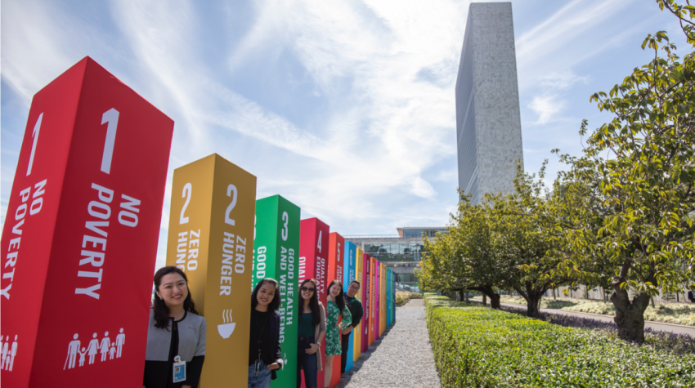
12. Apply what you have learned about the UN SDG #17 by completing one of the summative assessments identified by your teacher. For example, explore what local and international organizations are doing to address one of the UN Sustainable Development Goals. For example, you might explore collaborative partnerships to alleviate the impact of climate change, poverty, food insecurity, education, or life below water. The SDGs are meant to be a call to action for all nations and communities to make the world a more sustainable place for all inhabitants. Consider researching one of these partnerships (see some options below), their mission, and their achievements. Then, consider how you and your friends and family can get involved to make a positive difference. Check out the link and image below for ideas on what SDG you would like to investigate!
Teacher Preparation Notes
Pacing and Strategy: The following outline provides a guide for teaching this lesson including approximate times (may vary), teaching strategies, suggested information for teacher created slides, and options for additional enrichment activities/summative assessments can be found at the end of the modules. This curriculum model was designed with teaching and learning strategies that could be adapted for in-person or virtual learning.

Lesson Timing: 5 hours (approximate)

Standards
Content | Standard
WA Social Studies | SSS1.6-8.1: Analyze positions and evidence supporting an issue or an event.  SSS3.6-8.1: Engage in discussion, analyzing multiple viewpoints on public issues.  SSS1.9-12.5: Explain the challenge and opportunities of addressing problems over place and time using disciplinary and interdisciplinary lenses.  C4.11-12.4: Evaluate citizens’ and institutions’ effectiveness in addressing social and political problems at the local, state, tribal, national, and/or international level.  E4.11-12.3: Evaluate how individuals and different groups affect and are affected by the distribution of resources and sustainability.  E4.11-12.5: Explain how current globalization trends and policies affect economic growth, labor markets, rights of citizens, the environment, and resource and income distribution in different nations.
Next Generation Science Standards | HS-PS4-4: Gather relevant information from multiple authoritative print and digital sources, using advanced searches effectively; assess the strengths and limitations of each source in terms of the specific task, purpose, and audience; integrate information into the text selectively to maintain the flow of ideas, avoiding plagiarism and overreliance on any one source and following a standard format for citation.  HS-ESS3-1. Construct an explanation based on evidence for how the availability of natural resources, occurrence of natural hazards, and changes in climate have influenced human activity.  HS-ESS3-1: Cause and Effect: Empirical evidence is required to differentiate between cause and correlation and make claims about specific causes and effects.
C3 Framework | D1.2.9-12: Explain points of agreement and disagreement experts have about interpretations and applications of disciplinary concepts and ideas associated with a compelling question.  D2.Civ.13.9-12: Evaluate public policies in terms of intended and unintended outcomes, and related consequences.  D2.Eco.1.9-12: Analyze how incentives influence choices that may result in policies with a range of costs and benefits for different groups.  D2.His.14.9-12: Analyze multiple and complex causes and effects of events in the past  D2. Geo.9.9-12: Evaluate the influence of long-term climate variability on human migration and settlement patterns, resource use, and land uses at local-to-global scales.  D2. Eco.15.9-12. Explain how current globalization trends and policies affect economic growth, labor markets, rights of citizens, the environment, and resource and income distribution indifferent nations.
Lesson Resources
For Students | For Educators | Materials
- Graphic Organizer  - Research Notes Worksheet  - UN Links to infographics  - Project Instructions | - Lesson Slide Outline  - Graphic Organizer  - UN Links to infographics and videos (see lesson details)  - Project Instructions | - Graphic Organizer  - Research Notes Worksheet  - UN Links to infographics  - Summative Assessment Options  - Project Instructions Sheet

Lesson Overview
In this lesson, students will explore United Nations Sustainable Development Goal #17: Partnerships for the Goals. Students will engage in a series of individual and collaborative learning activities to better understand how all the UN SDGs can be better achieved through collaborative planning, investment, and action. In pairs or small groups, students will assess how local, national, and global communities are working together to address issues such as global health, economic development, climate change, and/or poverty reduction though institutions, organizations, and public-private partnerships. Students will evaluate how partnerships, locally and globally, can improve the lives of billions of people around the world through effective and collaborative strategies. As the world becomes increasingly interconnected and interdependent, people within and outside of government must work together to make the communities around the world more sustainable. Therefore, students will engage in activities that require you to explore various partnerships within and across local and national contexts to achieve SDG 17. Whether in their own community or thousands of miles away, students have the capacity to make a difference in solving our most challenging issues. As students develop the knowledge and skills to face these challenges individually and collectively, they will do their part in making the world a better place. Overall, this lesson will enhance students’ understanding of the partnerships taking place to achieve the UN SDGS by 2030.

Teacher Preparation
For Step 1: Review the United Nations (UN) Sustainable Development Goals (SDGs) through the following link. Take time to delve into SDG #17 and its targets, as this will prepare you to guide your students with their upcoming assignments and activities. Examine the image provided in the previous link (see student handout as well). There is also PPT that is accessible on the SDG #17 poster and other SDG posters that you can use (created by Margreet Deheer). You can find additional resources for SDG 17 and the other SDGs at this link. Read about the progress made on SDG #17 here.

Note: See the initial lesson brainstorming questions for you and your students to consider and the pre-lesson context image.
For Step 2: Prepare for leading a discussion on the SDG topics. Think about what students may be interested in and how they connect to SDG #17. As indicated in the student handout, progress and achievement on the SDGs usually relies on collaborative local, nations, and/or global partnerships.
For Step 3: Examine the UN SDG #17 Fact Sheet” and prepare for the speed-dating activity. Decide which statistics you would like to use and what information (or topic point) they connect with. For example, “60 percent of low-income countries are at risk of debt distress or already experiencing it.” Place 60% on a notecard and the description on another notecard. Do this for 12 to 15 (depending on size of the class) stats and descriptions. You

For Step 3: Examine the “UN SDG #17 Fact Sheet” and prepare for the speed-dating activity. Decide which statistics you would like to use and what information (or topic point) they connect with. For example, “60 percent of low-income countries are at risk of debt distress or already experiencing it.” Place 60% on a notecard and the description on another notecard. Do this for 12 to 15 (depending on size of the class) stats and descriptions. You could also include additional stats from other resources that might apply. Mix up the cards in preparation for the activity. Think about what you would like to emphasize about the stats during the post-activity discussion. For instance, how do these data points help us to better understand the economic stability of some countries or the number of people with internet access – and why that matters for SDG #17 and the other 16 goals.
For Step 4: This next part of the lesson requires students to learn more about key concepts related to the targets of SDG #17. Prepare to lead this activity on non-governmental organizations (NGOs) and capacity building. Think about how NGOs play an essential role in achieving many of the different UN Sustainable Development Goals. There is also list of the different NGO or other partnerships for SDG 17 on the UN website. Examine a few of them to familiarize yourself with the work they are doing in collaboration with the United Nations. Next, consider the concept of “capacity-building” and how it is important to achieve SDG 17 goals (and other goals). You will have students identify examples of “capacity-building” and you might start by looking at your school builds capacity to provide quality education for all students.
In addition to these two concepts, you can have students learn more about “civil society” and why it matters to achieving the UN SDGs. In preparation for this discussion, look at the student handout and come up with examples you can use with students. Think about why civil society plays an important role in creating a society where all people can have their voices heard (and ultimately, their needs met).
For Step 5: In this activity, students will build on what they have previously learned and investigate a local organization (or NGO) that is doing work on one of the SDGs. You could have students work on one of the topics identified in SDG #17 or choose any of the UN Sustainable Development Goal categories (no hunger, no poverty, climate change, education, gender equality, etc.). As this lesson module includes SDG #3, Good Health and Well-Being, you could have students look at organizations doing this work locally. Examine the questions provided in the student handout and prepare how you will lead a discussion.
For Step 6: If you have not already, please familiarize yourself with SDG #17 Targets and Indicators. Use the graphic organizer provided (alter as needed) for students to use during their research and small group discussions. Next, students will work individually on one of the targets and find an appropriate article. Consider whether you will let students choose their own target or if you will assign. Give clear directions and an example of an article that would apply to one of the targets. Provide access to resources like UN SDG #17 site for students to research one of the targets (you can assign different targets) and monitor each students’ progress to ensure understanding. Divide students into small groups and have them share their findings with their classmates in a jigsaw activity (or alternatively, in a large group class discussion. You can also look at the progress of the targets here.
For Step 7: One of the challenges facing the targets specified in SDG 17 are the financial costs and constraints facing many countries. According to the UN’s Sustainable Development Report 2023: Special Edition, “while official development assistance (ODA) flows continue to reach record peaks, the increase in 2022 is primarily attributed to spending on refugees in donor countries and aid to Ukraine.” Therefore, achieving progress on the SDG 17 targets can be impacted by debt crisis due to a lack of financial capacity, inflation, conflict, health costs (disease and effects of COVID-19), climate change, poverty, etc. Explore this report so that you help students better understand the concern around financial support, debt relief, and access to reliable technology in achieving SDG #17 (and the other goals). Look at the student handout and for more information, examine this overview by the International Monetary Fund (IMF) and United Nations Report on improving access to finance.

You may also find this 2025 UN Report: Confronting the Debt Crisis: 11 Actions to Unlock Sustainable Financing helpful in identifying strategies for more stable economic stability.
For Step 8: Prepare to have students look at local organizations that are doing work to support SDG #3, Good Health and Well-Being (the other lesson in this module). This is a good topic that will help students better understand how local partnerships can make a difference in achieving progress on one of the UN Sustainable Development Goals (#3). Prepare to have students consider the impact of COVID-19 and how local (and global) partnerships played an important role in addressing the pandemic (and other health-related issues). In Washington State, consider the following links for more background information for you and students: Washington State Public Health Association, Washington Global Health Alliance, American Indian Health Commission. If you are outside of Washington State, find appropriate resources for your local context.
For Step 9: This activity will allow students to learn about global context. Think about how you will have students choose the location they would like to research and examine the research questions provided to students in advance. Set the purpose for students and have them think about their prior learning. Emphasize the importance of making local to global connections and review how to find credible sources of information. This activity is intended for pairs, but you could modify it for individuals or small groups of three.
For Step 10: Provide clear guidelines, rubrics, and resources for creating presentations for podcast, video, etc. Review the requirements and expectations for the presentations and offer guidance on structuring content effectively. Consider how much time will be needed for students to complete their research and then create their presentation.
For Step 11: Consider the expectations you will convey to students regarding their finished product (podcast, video, etc.). You can provide links to sites that will help students make their podcasts, videos, etc. You may also consider showing previous examples of finished products and presentations.
For Step 12: Consider having students go more in-depth on SDG #17 or one of the UN Sustainable Development Goals by completing one of the summative assessment options. You can find additional ideas by looking at the student handout in this lesson and/or the identified summative assessment enrichment options included in the OER SDG Modules Resource Download.

Lesson Plan in Detail

(Note: See Student Handout and Teacher Pacing Guide for Additional Details)

Step One: Introduction to SDGs and SDG #17: Partnership for the Goals: 7 minutes
Purpose: Students are encouraged to think about the importance of collaborative partnerships to achieve all the United Nations Sustainable Development Goals. The images (UN graphic and poster) will provoke discussion, activate prior learning, and engage students in initial conversations about the topic.

Slide 1: Overview slide of SDG #17, including the graphic and poster identified in the student and educator lesson details.

Step Two: Connecting SDG #17 to the other 16 UN Sustainable Development Goals: 7 to 1o minutes
Purpose: After sharing insights from activity #1, students will engage in a discussion around all the UN Sustainable Development Goals. Emphasize that in order to achieve the other SDG goals, partnerships are necessary locally, nationally, and globally. Ask students to consider the other goals they are currently interested in exploring in more depth and how partnerships would play a role in meeting their targets.

Slide 2: UN Sustainable Development Goal image and discussion question.

Step Three: Using Data to Stimulate Discussion and Context: 10-12 minutes
Purpose: Students are given a statistic (or data point) or a description of the statistic. In an interactive “speed-dating activity,” students will be tasked with finding their match. This will stimulate discussion on SDG #17 and provide details that can be used to provide relevance to the topic. This activity also requires students to use their critical thinking and communication skills.

Slide 3: Directions for the “speed-dating activity.”

Step Four: Key Concept Exploration: Non-Governmental Organizations (NGOs) and Capacity Building: 10 minutes
Purpose: This activity allows students to enhance their knowledge of two or three key concepts in this lesson. As described in the student and educator background information, NGOs play an important role in supporting capacity building for achieving many of the SDGs. You may also include a discussion of “civil society” and how NGOs are a part of this important framework in society. While this concept can often be abstract for students, this activity provides a tangible way to provide examples for students.

Slide 4: Provide an explanation of the key concepts and discussion questions.

Step Five: NGOs and Capacity Building: A Local Connection: 20 minutes
Purpose: This activity enables students to make a local connection by researching a local NGO. Students will learn more about their work by addressing one of the SDGs and be able to discuss their work with their class.

Slide 5: Provide instructions for the mini-research activity of a local NGO.

Step Six: Diving Deeper into SDG 17: 15-20 minutes
Purpose: This activity gives students the opportunity to delve more deeply into the targets and progress of the 10 targets on responsible consumption and production (SDG #12). They will explore one of the targets, find an article, and share their learning in small group discussions. In addition to communicating what they learned, they will also learn more about the other targets from their peers.

Slide 6: Instructions for the activity, including how to write the synthesizing statements with examples.

Step Seven: Investigating How Economic Factors Impact Nations and Progress on the UN SDGs
Purpose: Students will be introduced to the financial factors that may impact a nation’s ability to achieve one or more of the UN Sustainable Development Goals. By considering these financial burdens and other organizations like the IMF (and their role), students will get a better understanding of the significant challenges that exist. However, students will also recognize some of the progress that is being made and what economic measures could be taken to mitigate these challenges.

Slide 7: Provide details for the economic or financial factors that affect nations (and the instructions for discussing these factors and the role of organizations such as the International Monetary Fund (IMF).

Step Eight: Local Partnerships for Achieving Progress on Good Health and Well-Being: 25 minutes
Purpose: Students will explore an organization to see how they are addressing good health and well-being locally. This activity provides local relevance and provides an opportunity to apply previously learned concepts in this lesson.

Slide 8: Provide instructions to students and specify the purpose of the lesson.

Step Nine and Ten: From the Local to the Global: Partnerships to Achieve Progress on the UN SDGs: 50-60 minutes (Note: time will vary depending on the class and scope of student research)
Purpose: This activity is intended to have students learn more about a global issue in a specific context and the strategies used to address the issue. Students should be able to research the issue using credible sources, identify specific organizations/partnerships that are invested in addressing the issues, and analyze specific strategies (or policies) that are currently implemented. See student and educator background information for more specific details and student expectations for this more in-depth activity. Students will communicate what they learned to the rest of the class through the completion of a project (podcast, video, etc.).

Slide 9/10: Provide clear instructions for this project and expectations for student use of time, etc.

Step Eleven: Presentation Time! 45 minutes
Purpose: Students will present their findings to the class, ensuring they pace themselves effectively and leave time for questions and discussion. This step allows students to showcase their understanding, share insights, and engage with their peers on the importance of ocean conservation. Note: This could take more than one class period.

Slide 11: Presentation schedule and expectations.

Step Twelve: Summative Assessments: Time Will Vary
Purpose: There are different summative assessment options that allow students to demonstrate their learning in an innovative way. Students can choose from one of the project-based assessments identified in the appendix to this document. These projects allow students to further reflect on their understanding of SDG #17: Global Partnerships for the Goals and teachers can share this work with other students.

Slide 12: Give an overview of the summative assessment opportunities (project-based learning).

Attribution and License

Attribution
This Open Educational Resource, Cultivating Global Competence through the United Nations Sustainable Development Goals, was developed by Ryan Hauck, Julianna Patterson, and Global Classroom, World Affairs Council - Seattle.
Graphics:
- Cover image by Julianna Patterson from Canva.
- Sustainable Development Goals images copyright United Nations. All rights reserved. Used pursuant to fair use.

License

Except where otherwise noted, Cultivating Global Competence through the United Nations Sustainable Development Goals, by World Affairs Council of Seattle, is available under a Creative Commons Attribution- Noncommercial License. All logos and trademarks are the property of their respective owners. Sections used under fair use doctrine (17 U.S.C. § 107) are marked.
This resource may contain links to websites operated by third parties. These links are provided for your convenience only and do not constitute or imply any endorsement or monitoring by the World Affairs Council. Please confirm the license status of any third-party resources and understand their terms of use before reusing them.

